Deggendorf Institute of Technology
Faculty of Applied Natural Sciences and Industrial Engineering
Applied AI for Digital Production Management
Master's Thesis
Entwicklung und Evaluation eines NLP-basierten Konzepts zur strukturierten Extraktion von Informationen und zur Unterstützung der Planung in Instandhaltungsaufträgen
Development and Evaluation of an NLP-Based Concept for Structured Information Extraction and Planning Support in Maintenance Work Orders

Master thesis to obtain an academic degree:
Master of Engineering (M.Eng.)
submitted by
Ravi Virani
Matriculation number: 22307118
supervisor: Prof. Dr.-Ing. Ralph Hensel-Unger
Submission date: 15.09.2026

Declaration
Name of student: Ravi Virani
Matriculation number: 22307118
Name of supervisor: Prof. Dr.-Ing. Ralph Hensel-Unger
Title of the Master’s thesis: Development and Evaluation of an NLP-Based Concept for Structured Information Extraction and Planning Support in Maintenance Work Orders

1. I hereby declare that this Master’s thesis is my own independent work. It has not been submitted in whole or in part for any other examination. No sources or aids other than those acknowledged have been used, and all direct and indirect citations have been properly credited.
Deggendorf, 15.09.2026 Signature of student: ______________________
2. I give my consent for my Master’s thesis to be made accessible to the wider public through the university library. To enable this, I am providing one additional bound copy of the Master’s thesis.

Yes ☒ No ☐
Deggendorf, 15.09.2026 Signature of student: ______________________
I declare and guarantee that I am the sole holder of all rights to the Master’s thesis, including the right of disposal over templates for attached figures, plans, or similar materials, and that making it publicly accessible violates neither third-party rights and claims nor statutory provisions.
To be completed by the supervisor if the author consents to making the Master’s thesis publicly accessible:
3. I declare that the inclusion of a copy of the Master’s thesis in the library holdings and the lending of this copy is:
Approved ☐ Not approved ☐
Deggendorf, 15.09.2026 Signature of supervisor: ____________________

Statement on the Use of AI
Were artificial intelligence (AI) or AI tools used in the course of this work?
☒ Yes ☐ No
1. In what form and which AI tools?
Claude (Anthropic) and ChatGPT were used during the preparation of this thesis.
2. What were they used for, and how?
Claude (Anthropic) was used as a supporting tool during the preparation of the written thesis. Its use covered language editing and restructuring of selected passages, the preparation and formatting of figures and tables, and the cross-checking of reported values against the frozen experimental artefacts produced by the pipeline. Every suggestion was reviewed by the author before it was accepted, and all reported values were confirmed against the frozen result files before being retained in the thesis.
ChatGPT (OpenAI) was used during the development of the software as a programming support tool. Its use covered debugging and error resolution, the optimization of existing code, and guidance on the containerization and deployment of the planning dashboard to Microsoft Azure. It was particularly helpful in diagnosing configuration and runtime problems encountered during deployment. All code suggestions were reviewed, tested, and verified by the author before being incorporated into the system, and the resulting implementation and its behaviour remain the responsibility of the author.
The research design, the annotation schema and gold corpus, the implementation of all pipeline components, the execution of the experiments, the generated data and results, and their interpretation are the independent work of the author. The evaluation protocol, the frozen splits, and the reported measurements were produced by the author’s own code and were not generated by an AI tool.
Reflection
The use of AI tools was helpful for improving the clarity of the written text and for checking that reported values agreed with the underlying result files. The suggestions produced were not always correct, however, and in several cases proposed wording that altered or weakened a technical claim. Each suggestion therefore had to be assessed against the implemented system and the frozen evidence before it could be used. Such tools are useful in academic work only when their use is declared openly and responsibility for verification and interpretation remains with the author.
Final Declaration
☒ I hereby declare that the information I have provided regarding the use of AI is complete and truthful.
Declaration of Consent

☒ I agree that my details regarding the use of AI may be stored and analysed anonymously for research purposes and for the quality management of the NUW degree programmes.
Deggendorf, 15.09.2026 Signature: ______________________

Acknowledgement
I would like to thank my supervisor, Prof. Dr.-Ing. Ralph Hensel-Unger, for supervising this thesis and for the freedom to pursue the problem in the direction the evidence required, including the decision to discard an unsuitable dataset and rebuild the work on a corpus that could be defended.
I am grateful to Deggendorf Institute of Technology and to the Faculty of Applied Natural Sciences and Industrial Engineering for the academic environment and the resources that made this work possible.
I also wish to acknowledge the authors of the MaintNet, MaintNorm, and MaintIE resources. Their decision to release maintenance-language data and benchmarks openly is what allowed a study of this kind to be carried out on real aviation records rather than on synthetic text.
Finally, I thank my family and my friends for their patience and encouragement throughout this work, and particularly during the period in which the thesis had to be started again from the beginning.
Ravi Virani

Abstract
Maintenance work orders contain valuable knowledge about faults, affected components, inspections, and corrective actions, but their short and inconsistent language makes automated analysis difficult. This thesis develops and evaluates an NLP pipeline that transforms noisy aviation maintenance narratives into structured and retrievable historical evidence. The pipeline covers text normalization, information extraction, silver knowledge graph construction, case retrieval, and evidence presentation. Normalization was examined as a supporting step using raw text, frequency-based replacement, deterministic rules, ByT5, Selective ByT5, and a combined rules-ByT5 method. The central information-extraction experiment compared a feature-based CRF with logistic regression, a neural BiLSTM-CRF pipeline, DistilBERT, and the span-based SpERT transformer. On the frozen internal test set, SpERT achieved the strongest performance, with an entity micro-F1 of 0.9520 and a relation micro-F1 of 0.8537. However, the matched representation experiment showed that improved normalization accuracy did not automatically improve downstream extraction, as raw text retained the highest extraction micro-F1. Extracted entities and relations were subsequently organized into a silver knowledge graph and a provenance-preserving collection of complete historical cases. The retrieval stage evaluated lexical, dense, and structured representations together with fusion and reranking methods. Under the locked final protocol, cluster-safe BM25 retrieval achieved Hit@1 of 0.7899 and Hit@5 of 0.9952 across 828 evaluable queries, although results remained weaker for rare action families. These components were integrated into AviMaint-DSS, a prototype that presents related historical problems, recorded actions, outcomes, alternatives, and source evidence. The system supports qualified personnel in locating and comparing previous maintenance experience; it does not determine technical applicability, regulatory approval, safety, or aircraft release decisions.

Keywords: aviation maintenance; natural language processing; text normalization; information extraction; SpERT; knowledge graph; case retrieval; decision support
Table of Contents
Declaration ii
Statement on the Use of AI iii
Acknowledgement iv
Abstract v
List of Figures xi
List of Tables xi
Index of Abbreviations xiii
List of Symbols xiv
1 Introduction 1
1.1 Context and motivation 1
1.2 Problem statement 2
1.3 Aim, objectives, and research questions 3
1.4 Scope and safety boundary 5
1.5 Contributions 6
1.6 Thesis structure 7
2 Literature Review 9
2.1 Review scope and comparison criteria 10
2.2 Maintenance language and technical NLP 10
2.3 Lexical normalization for noisy technical text 12
2.4 Information extraction from maintenance narratives 13
2.5 Knowledge representation and case-based reasoning 15
2.6 Historical-case retrieval and evaluation 16
2.7 Selective and human-centred decision support 17
2.8 Critical synthesis of prior work 18
2.9 Research gap and connection to RQ1–RQ5 19
2.10 Chapter summary 20
3 Data and Research Design 21
3.1 Data sources and evidence layers 21
3.2 MaintNet corpus profile 22
3.3 End-to-end research design 23
3.3.1 Separation of estimands across the pipeline 23
3.4 Leakage controls and data partitions 23
3.4.1 Why record-level random splitting is insufficient 24
3.5 Evaluation principles 25
3.6 Reproducibility and governance 25
4 Text Normalization 26
4.1 Motivation and task definition 26
4.2 Experimental conditions 26
4.3 Data preparation and reference construction 27
4.4 Rule-based normalizer 27
4.4.1 Rule ordering and protected forms 28
4.5 ByT5 normalizer 28
4.5.1 ByT5 optimization and model selection 28
4.6 Evaluation measures 29
4.6.1 Sequence-level error measures 29
4.6.2 Change detection and preservation 30
4.7 Results 31
4.8 Error analysis and interpretation 34
4.8.1 Formal selective-normalization rule 35
4.9 Normalization threats to validity 35
5 Information Schema and Gold-Corpus Construction 37
5.1 Schema design principles 37
5.2 Entity inventory 37
5.3 Relation inventory 37
5.4 Annotation workflow 38
5.4.1 Formal annotation object 38
5.5 Active learning and frozen evaluation sets 39
5.6 Gold-corpus composition 39
5.7 Annotation limitations 41
5.7.1 Agreement that should be measured in follow-up work 41
6 Information Extraction Methods and Results 42
6.1 Extraction task 42
6.2 CRF and logistic regression 42
6.2.1 CRF decoding and relation baseline 42
6.3 BiLSTM CRF and neural relation classifier 43
6.3.1 Bidirectional context 43
6.4 Transformer and joint span models 44
6.4.1 Span and relation representations 44
6.5 Training and evaluation protocol 45
6.5.1 Micro, macro, and uncertainty measures 45
6.6 Overall performance 47
6.7 Per-class performance 48
6.8 Internal and external comparison 50
6.9 Learning-curve analysis 51
6.10 Operational SpERT layer 51
6.11 IE findings 52
7 Silver Knowledge Graph and Historical Case Library 53
7.1 From extraction output to cases 53
7.2 Knowledge-graph construction 53
7.2.1 Typed, weighted, provenance-bearing graph 54
7.3 Case representation 55
7.3.1 Case object and evidential completeness 55
7.4 Provenance, duplicates, and outcome policy 56
7.5 Silver-layer statistics 57
7.6 Limitations of the silver layer 57
8 Evidence-Grounded Recommender and Planning Dashboard 58
8.1 Decision-support contract 58
8.2 Query structuring 58
8.3 Candidate retrieval 60
8.3.1 Sparse and dense similarity 60
8.3.2 Rank fusion and reranking 61
8.4 Evidence clustering and aggregation 61
8.5 Outcome-aware filtering and selective abstention 62
8.5.1 Promotion rule and negative outcomes 62
8.6 Planning workspace 63
8.7 Evaluation design 63
8.7.1 Ranked-retrieval measures 64
8.8 Locked final Selective retrieval results 65
8.9 Robustness, calibration, and evidence review 66
8.9.1 Perturbation robustness and paired comparison 67
8.9.2 Calibration quantities 69
8.10 Software verification 70
8.11 Interface walkthrough 71
9 Discussion 73
9.1 Answers to the research questions 73
9.1.1 RQ1 Normalization accuracy and preservation 73
9.1.2 RQ2 Downstream effects of normalization 74
9.1.3 RQ3 Information extraction architectures 74
9.1.4 RQ4 Retrieval performance and robustness 75
9.1.5 RQ5 Auditable planning support 75
9.2 What the results do and do not establish 76
9.3 Design trade-offs 76
9.4 Safety, governance, and human oversight 77
9.5 Threats to validity 78
9.6 Future evaluation plan 78
10 Conclusion 80
10.1 Summary 80
10.2 Contributions revisited 80
10.3 Final conclusion 81

List of Figures
Figure 1.1 Chapter structure and the flow of evidence towards one bounded planning-support claim
Figure 2.1 Five literature strands and the end-to-end evidence gap this thesis addresses
Figure 3.1 Five evidence layers and the claims each population is permitted to support
Figure 4.1 Cluster-safe normalization experiment and the one-way gate to the locked test
Figure 4.2 Word error rate, exact match and protected-token retention of six representations on the locked 741-record test
Figure 4.3 Entity and relation F1 of five representation-matched SpERT models on the frozen 225-record test
Figure 5.1 Distribution of entity mentions across the nine types in the 1,600-record gold corpus
Figure 6.1 Entity and relation F1 of four extraction architectures on the frozen 225-record test
Figure 6.2 Per-class entity F1 of the four architectures against gold test support
Figure 6.3 Per-class relation F1 of the four architectures against gold test support
Figure 7.1 One work order represented as a case and as a silver subgraph of typed entities and directed relations
Figure 8.1 Fields that enter a retrieval query and fields withheld from it under the frozen protocol
Figure 8.2 Offline historical extraction and the two separate online query paths
Figure 8.3 Risk against coverage and the reliability of the calibrated historical-agreement estimate
Figure 8.4 Fields shown with a historical action option and the provenance behind each one
Figure 8.5 Eligibility gate that decides between displaying an option and abstaining
Figure B.1 Distribution of relation instances across the eleven types in the 1,600-record gold corpus

List of Tables
Table 2.1 Mapping from literature gaps to the thesis research questions
Table 3.1 Data and evidence inventory
Table 4.1 Normalization conditions
Table 4.2 Locked normalization-test results
Table 4.3 Representation-matched SpERT ablation
Table 5.1 Gold-corpus entity support
Table 5.2 Gold-corpus relation support
Table 6.1 Information-extraction model tiers
Table 6.2 Overall frozen-test information-extraction results
Table 6.3 External MaintIE benchmark results
Table 6.4 Span-based against BIO entity extraction on the MaintIE benchmark
Table 7.1 Silver knowledge-graph statistics
Table 8.1 Retrieval and ranking stages
Table 8.2 Locked final-protocol retrieval results
Table 8.3 Fixed-protocol robustness results
Table 8.4 Calibration and one-reviewer evidence assessment
Table 8.5 Per-family locked-test Hit@1
Table 8.6 Reporting thresholds and evidence-tier agreement
Table 9.1 Consolidated answers to the research questions
Table 9.2 Principal threats to validity and mitigations
Table A.1 Entity catalogue with inclusion and exclusion guidance
Table A.2 Relation catalogue with binding signatures
Table B.1 Per-class entity F1 and support
Table B.2 Per-class relation F1 and support
Table C.1 Frozen final Selective retrieval contract
Table C.2 Recommender claim boundary
Table C.3 All retrieval modes scored on the locked test at τ_rank = 0.15
Table D.1 Artifact register

Index of Abbreviations
Abbreviation | Meaning
AI | Artificial intelligence
BERT | Bidirectional Encoder Representations from Transformers
BIO | Begin-Inside-Outside sequence tagging scheme
BiLSTM | Bidirectional long short-term memory network
BM25 | Best Match 25 lexical ranking function
ByT5 | Byte-level Text-to-Text Transfer Transformer
CER | Character error rate
CI | Confidence interval
CRF | Conditional random field
DistilBERT | Distilled version of BERT
DIT | Deggendorf Institute of Technology
DSS | Decision-support system
EASA | European Union Aviation Safety Agency
ECE | Expected calibration error
FN | False negative
FP | False positive
IDF | Inverse document frequency
IE | Information extraction
KG | Knowledge graph
LSI | Latent semantic indexing
LSTM | Long short-term memory network
MaintIE | Maintenance information-extraction benchmark
MaintNet | Maintenance language-resource library
MaintNorm | Maintenance lexical-normalisation corpus
MRR | Mean reciprocal rank
MultiLexNorm | Multilingual lexical normalisation shared task
nDCG | Normalised discounted cumulative gain
NER | Named-entity recognition
NIST | National Institute of Standards and Technology
NLP | Natural language processing
OOV | Out of vocabulary
RE | Relation extraction
RQ | Research question
RRF | Reciprocal rank fusion
SpERT | Span-based entity and relation transformer
TF-IDF | Term frequency-inverse document frequency
TN | True negative
TP | True positive
WER | Word error rate

List of Symbols
Symbol | Meaning
P | Precision, strict and micro-averaged
R | Recall, strict and micro-averaged
F1 | Harmonic mean of precision and recall
S, D, I | Substitutions, deletions and insertions in an edit alignment
N | Reference length in words or characters, and the size of an evaluated population
n | Number of evaluable queries or annotated records
k | Rank cutoff in Hit@k and nDCG@k, and the stabilising constant in rank fusion
q | A single retrieval query
f | An action family
F | The evaluated set of action families
H(f) | Queries of family f with a hit at the stated cutoff
N(f) | Number of evaluable queries of family f
n_f(q) | Distinct retrieved evidence clusters supporting family f for query q
π_f | Smoothed training prior of action family f
H_f(q) | Historical patterns retrieved for family f
E(h) | Binary positive-outcome eligibility of a historical pattern
τ_rank | Prior-tempering exponent in the family-ranking key, fixed at 0.15
θ_norm | Normalisation confidence threshold, fixed at 0.90
relⱼ | Relevance grade at rank j
IDCG@k | Discounted cumulative gain of the ideal ordering at cutoff k
M | Set of retrieval channels
rₘ(d) | Rank of candidate d in channel m
V, E | Node set and directed edge set of the knowledge graph
ℓV, ℓE | Node-type and edge-type functions of the knowledge graph
w | Evidence-support weight on a graph edge
pi | Provenance mapping from a graph element back to its source records
B | Number of calibration bins
I(j) | Set of predictions falling in calibration bin j
acc(I(j)) | Observed agreement rate in bin j
conf(I(j)) | Mean predicted confidence in bin j
Q | Empirical quantile of the bootstrap distribution
α | Tail probability of a confidence interval

Introduction
Maintenance work orders serve two important purposes. They document completed activities for operational traceability. When viewed together, they also preserve practical experience about recurring faults, affected components, inspection findings and corrective actions. Their value for analysis is limited by the way this information is written. Entries are usually short, produced under time pressure and shaped by local abbreviations, inconsistent spelling, compressed grammar and legacy field limits. As a result, records of closely related events may use different wording, while the same abbreviation may carry different meanings in different contexts. These characteristics make direct search unreliable and complicate structured information extraction.
Historical records may support planning, but they do not provide technical authority. A previous action can draw attention to a comparable case and show what was recorded at that time. It cannot establish that the same action applies to another aircraft, component configuration or operating condition. Maintenance work remains governed by current approved data and qualified judgement. Both 14 CFR 43.13 and European continuing-airworthiness requirements reflect this distinction by requiring applicable maintenance instructions and acceptable methods [1, 2]. This thesis does not automate maintenance approval. It makes past evidence easier to locate, interpret and audit before a human decision is made.

Context and motivation
MaintNet is an open resource for predictive-maintenance language from several industrial domains, including aviation [3]. The aviation subset used in this thesis contains 6,169 paired problem and action records. These data are difficult for natural language processing because punctuation often separates content, casing is inconsistent, specialized abbreviations are frequent and expressions may be incomplete because the source fields are short. In the supplied representation, the problem and action fields are limited to 60 and 55 characters, respectively. Surface correction can reduce variation in the recorded text, but it cannot recover information that was never present. Every later stage inherits this limitation, so normalization cannot be treated as reconstruction of a complete maintenance narrative.
Research on technical language processing shows that maintenance text can support classification, entity recognition, similarity analysis and knowledge discovery [4]. MaintNorm and MaintIE address the two central linguistic tasks studied here. MaintNorm provides maintenance-specific data and a benchmark for lexical normalization, while MaintIE defines a fine-grained schema and benchmark for information extraction from short maintenance text [5, 6]. These studies show why domain-specific data and evaluation matter. In a planning-support workflow, however, the outputs must also remain connected. A normalized phrase must still point to its source wording. An extracted action must remain linked to its component and issue. A retrieved action must belong to one complete historical case rather than a fragment assembled from unrelated records.
This thesis addresses the integration problem through an evidence-grounded pipeline. Normalization examines and reduces lexical variation. Information extraction turns short narratives into typed entities and directed relations. The model predictions are then organized as a silver knowledge graph and as complete historical cases with record-level provenance. During evaluation, retrieval ranks cases from the problem description alone and does not see the query record's action. AviMaint-DSS presents the ranked evidence together with alternative cases, outcome information and uncertainty. The design favours traceability over unrestricted free-form generation. Every displayed action can be traced to a source record, and the system may abstain when the evidence is weak.

Problem statement
The research problem contains four related but distinct forms of uncertainty. Lexical uncertainty occurs when spelling variants, abbreviations and compressed expressions prevent equivalent terms from matching. Structural uncertainty arises when the text does not clearly show which issue belongs to a component, which action targets an item or which observation follows an intervention. Evidential uncertainty appears when an extractor is applied to the full corpus because the resulting entities, relations, graph and case attributes are model-derived silver data rather than verified gold annotations. Applicability uncertainty remains after a relevant historical case has been retrieved because its recorded action may be incomplete, unsuccessful, outdated or unsuitable for the current aircraft configuration.
No single end-to-end score can evaluate all four forms of uncertainty. Strong agreement with an expert-normalized reference does not necessarily improve entity or relation extraction. High entity recognition performance does not guarantee that the directed relations between entities are correct. A high retrieval score under an action-family proxy measures whether historically associated evidence was recovered, not whether that evidence is technically correct. Confidence calibrated against historical agreement must not be read as the probability of maintenance success. Each stage is therefore evaluated using evidence suited to its function, and the status of that evidence is retained when the results are interpreted.
Information leakage creates a further methodological risk. A retrieval system could appear accurate if the query's recorded action, a near-duplicate from the same cluster or a parameter informed by the test set influenced the ranking. The evaluation design limits this risk through cluster-safe partitions, problem-only queries, validation-based selection, locked test sets and a clear separation between development results and final evidence. These controls support reproducibility and restrict the claims to what the experiments actually measure.

Aim, objectives, and research questions
This thesis aims to design and evaluate an auditable natural language processing pipeline that converts noisy aviation maintenance work orders into structured and retrievable historical evidence. The pipeline presents this evidence as bounded support for human maintenance planning.
The following objectives translate this aim into the experimental work.
- Compare six text representations using validation data for system selection and a locked normalization test for final evaluation.
- Define a compact aviation-maintenance schema and construct frozen gold data for entity and relation extraction.
- Determine whether normalization changes downstream SpERT performance when training and evaluation use the same text representation.
- Compare feature-based, recurrent-neural, transformer-pipeline and joint span-based extraction models on frozen internal data and the separate MaintIE benchmark.
- Construct a provenance-preserving silver graph and historical-case library from predictions over the full corpus.
- Evaluate problem-only case retrieval, ranking, robustness, calibration and manually reviewed evidence without using the query's hidden action.
- Demonstrate how historical evidence can be presented with alternative cases, recorded outcome status, uncertainty and an explicit point for human decision-making.
The five research questions follow the order of the pipeline. Each question is accompanied by the population used for evaluation, the concise answer supported by that evidence and the boundary within which the answer can be interpreted. This structure keeps the questions readable and makes their connection to the research aim, experiments and later conclusions clear.
RQ1 - Lexical normalization
Research question. Which of the six text representations gives the lowest lexical error against the expert-cleaned reference while still preserving protected aviation tokens?
Evidence and concise answer. The official system was selected on 926 validation records. All six representations were then evaluated once on a locked test of 741 records. ByT5 gave the strongest descriptive agreement with the reference at WER = 0.0147. The validation-selected Selective ByT5 system recorded WER = 0.0219 and preserved 100% of the protected aviation tokens.
Interpretation boundary. These figures measure agreement with the available normalized reference. They do not establish that a rewritten expression is technically complete or operationally correct. Chapter 4 reports the complete evaluation.
RQ2 - Normalization and downstream extraction
Research question. How does the selected text representation affect entity and relation extraction when SpERT is trained and evaluated on frozen data matched to that representation?
Evidence and concise answer. Every representation used the same frozen split of 1,275 training records, 100 development records and 225 test records. Raw text produced the highest entity and relation micro-F1 scores, while Selective ByT5 improved relation macro-F1. Lower normalization error therefore did not lead to a general improvement in downstream extraction.
Interpretation boundary. This result comes from an internal representation-matched comparison on one frozen test population. It should not be generalized to every extractor or maintenance corpus. Chapter 6 reports the complete evaluation.
RQ3 - Information-extraction architectures
Research question. How do feature-based, recurrent-neural, transformer-pipeline and joint span-based models compare, and does the same ranking pattern appear on the MaintIE benchmark?
Evidence and concise answer. The four model families were evaluated on the frozen internal test of 225 records. Separately trained systems were also assessed on the MaintIE test of 108 records. Joint SpERT achieved the highest entity and relation micro-F1 in both evaluations. Results for rare entity and relation labels remained less certain because those labels had little support.
Interpretation boundary. The MaintIE experiment is a separately trained benchmark evaluation and not a zero-shot transfer. The internal and MaintIE test sets are different populations and should not be treated as interchangeable. Chapter 6 reports the complete evaluation.
RQ4 - Historical-case retrieval
Research question. To what extent does problem-only, cluster-safe retrieval recover recorded action evidence, and how well does the fixed protocol withstand plausible degradation of the query text?
Evidence and concise answer. The final evidence includes 828 evaluable locked test queries, a manual review of 100 queries and a supplementary robustness study using the fixed protocol. The final BM25 configuration achieved Hit@1 = 0.7899 and Hit@5 = 0.9952. Its performance remained comparatively stable under the tested spelling and truncation perturbations, although macro action-family recall was only 0.2802.
Interpretation boundary. The experiment measures the recovery of historically associated evidence. It does not prove action applicability, technical correctness or statistically secure superiority over the majority baseline. Chapter 8 reports the complete evaluation.
RQ5 - Auditable planning support
Research question. How can retrieved historical cases support planning while preserving provenance, alternative evidence, uncertainty and human maintenance authority?
Evidence and concise answer. The answer is based on the prototype functions, evidence contract, calibration results, manual review and stated limitations of the implemented workflow. AviMaint-DSS shows that ranked historical cases can be presented with their source records, alternative cases, recorded outcomes, confidence information and an abstention path. They are not presented as an automatically approved procedure.
Interpretation boundary. The prototype has not undergone operational usability, safety, cybersecurity, regulatory or deployment validation. Qualified personnel and current approved maintenance data remain authoritative. Chapter 8 reports the complete evaluation.

Scope and safety boundary
The empirical scope is limited to English aviation problem and action records from the supplied MaintNet data and their annotated and reference-normalized subsets. The technical work covers lexical normalization, entity and relation extraction, silver knowledge-graph and case construction, lexical, dense and structured retrieval, fusion and reranking, outcome-aware filtering, diversification, confidence presentation and a local decision-support prototype. ByT5 is used only for lexical normalization. Dense encoders and cross-encoders are used only for retrieval or ranking. The study excludes direct generation of maintenance procedures by a large language model and does not construct new procedures by merging steps from different historical cases.
Each evidence type has a defined meaning and limit. Expert-cleaned or manually annotated data support benchmark claims only for the corresponding frozen population. Development results support model or threshold selection and are not final performance estimates. Entities, relations, graph links and case attributes produced for the full corpus are silver outputs that remain subject to model error. Retrieval labels and calibration targets represent agreement with historical records or reviewer judgements under the study protocol. They do not prove technical applicability, safety or regulatory acceptability.
AviMaint-DSS is an evidence-navigation prototype and not an approved source of maintenance procedures. It cannot establish airworthiness, choose an authorized maintenance instruction, verify aircraft effectivity, certify a component, calculate an operational failure rate or release an aircraft to service. Planning fields such as parts, tools, time, cost, due date, applicability and reference status are workflow information entered or confirmed by the user. Qualified personnel remain responsible for checking aircraft identity and configuration, current approved maintenance data, authorization requirements and release-to-service conditions.

Contributions
The first contribution is a controlled comparison of six text representations under a transparent selection policy. Validation results determine the official system, while a locked test of 741 records is reserved for final evaluation. This separation allows ByT5 to be reported as the descriptive test leader while Selective ByT5 remains the preselected system because it preserved all protected aviation tokens.
The second contribution is a representation-matched downstream experiment. Five SpERT conditions use the same split of 1,275 training, 100 development and 225 test records. The results show that lower normalization error does not automatically produce higher extraction micro-F1. They also show that selective normalization can affect relation performance at the macro level.
The third contribution is a task-specific schema with nine entity types and eleven relation types, together with a controlled comparison of four extraction architectures. These are a CRF with logistic regression, a BiLSTM-CRF with neural relation classification, a DistilBERT pipeline and joint span-based SpERT. The study reports frozen internal results, class-level behaviour and a separately trained evaluation on MaintIE. This design supports comparison across model families while keeping uncertainty for rare classes visible.
The fourth contribution is a provenance-preserving route from extraction output to planning support. Model-derived structure remains labelled as silver evidence, complete cases stay linked to their source records and retrieval is evaluated using cluster-safe problem-only queries. The final protocol combines quantitative ranking measures with robustness tests, calibration analysis and manual review. AviMaint-DSS uses this evidence to present historical alternatives and uncertainty without claiming to generate approved maintenance decisions.

Thesis structure
The thesis follows the flow of evidence shown in Figure 1.1. It uses an integrated experimental structure in which each relevant chapter presents its method, evaluation protocol, results, error analysis and interpretation for the corresponding research question. The results are therefore not collected in one separate chapter. Chapter 9 brings the findings from each stage together and examines their meaning for the complete pipeline.
Foundations and research design (Chapters 1-3). Chapter 1 defines the research problem, research questions, scope, safety boundary and contributions. Chapter 2 develops the theoretical and empirical background for maintenance-language normalization, information extraction, retrieval and decision support. Chapter 3 documents the corpus lineage, annotation process, cluster-safe partitions, frozen evaluation populations, metrics and evidence-status vocabulary used throughout the experiments.
Controlled language-processing studies (Chapters 4-6). Chapter 4 evaluates the six normalization representations and answers RQ1. Chapter 5 defines the aviation-maintenance entity-relation schema and documents how the gold corpus was constructed and checked. Chapter 6 presents the representation-matched downstream experiment for RQ2 and the comparison of four information-extraction model families for RQ3, including the separate MaintIE benchmark.
Evidence integration (Chapter 7). The strongest verified extraction configuration is applied to the full aviation corpus. Its model-derived entities and relations remain labelled as silver evidence and are converted into a lightweight knowledge graph and a provenance-preserving library of complete historical cases. The case library provides source-linked candidates, while the silver graph supports inspection and exploratory structured matching. The frozen RQ4 ranking is lexical and does not use graph features. Neither the case library nor the graph represents expert-verified facts.
Retrieval and prototype evaluation (Chapter 8). Cluster-safe problem-only retrieval is evaluated under the frozen protocol. Robustness, calibration and manual-review analyses then examine the behaviour of that protocol in more detail. The chapter also explains how AviMaint-DSS presents retrieved cases, alternative evidence, recorded outcomes, uncertainty and abstention. These results answer RQ4 and RQ5 within the stated safety boundary.
Cross-stage synthesis (Chapters 9-10). Chapter 9 compares the findings from normalization, extraction, case construction and retrieval. It discusses limitations and threats to validity and identifies the validation still required before operational use. Chapter 10 gives the final answers to RQ1–RQ5 and summarizes the contributions and future work. The appendices retain the detailed schema, class-level results, evidence contract and artifact register needed for reproducibility.
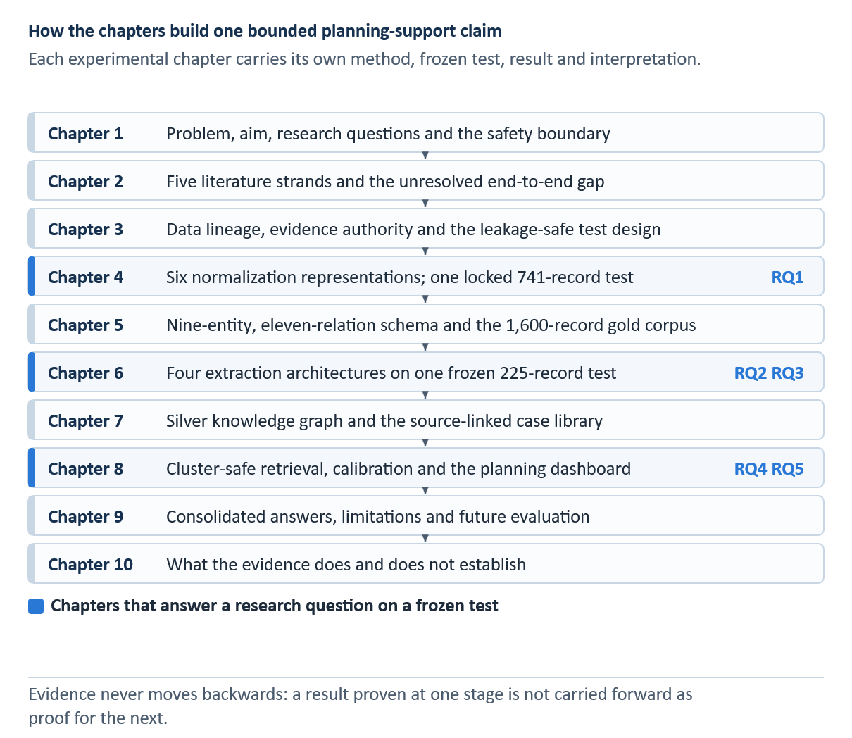
Figure 1.1 Chapter structure and the flow of evidence towards one bounded planning-support claim

Literature Review
This chapter reviews the research that frames the thesis rather than describing its implementation. Its purpose is to compare what previous work has established about maintenance language, lexical normalization, information extraction, knowledge representation, retrieval, and selective decision support. Detailed model mechanics, equations, training settings, and the experiments conducted for this thesis are presented in Chapters 3 to 8. Keeping this material outside the literature review makes the distinction between prior knowledge and the present contribution explicit.
The review follows the same chain through which operational information becomes retrievable evidence. The sequence begins with interpreting a brief maintenance record despite abbreviations and damaged spelling. Relevant entities and relations must then be recovered, the extracted content must be organized as a case, and a retrieval method must return comparable historical material without presenting it as an approved instruction. The literature is therefore evaluated not only by its headline performance, but also by its data provenance, evaluation population, treatment of uncertainty, and suitability for an integrated, traceable human-review workflow. Figure 2.1 sketches the sequence of research traditions and the gap addressed by this evaluation.
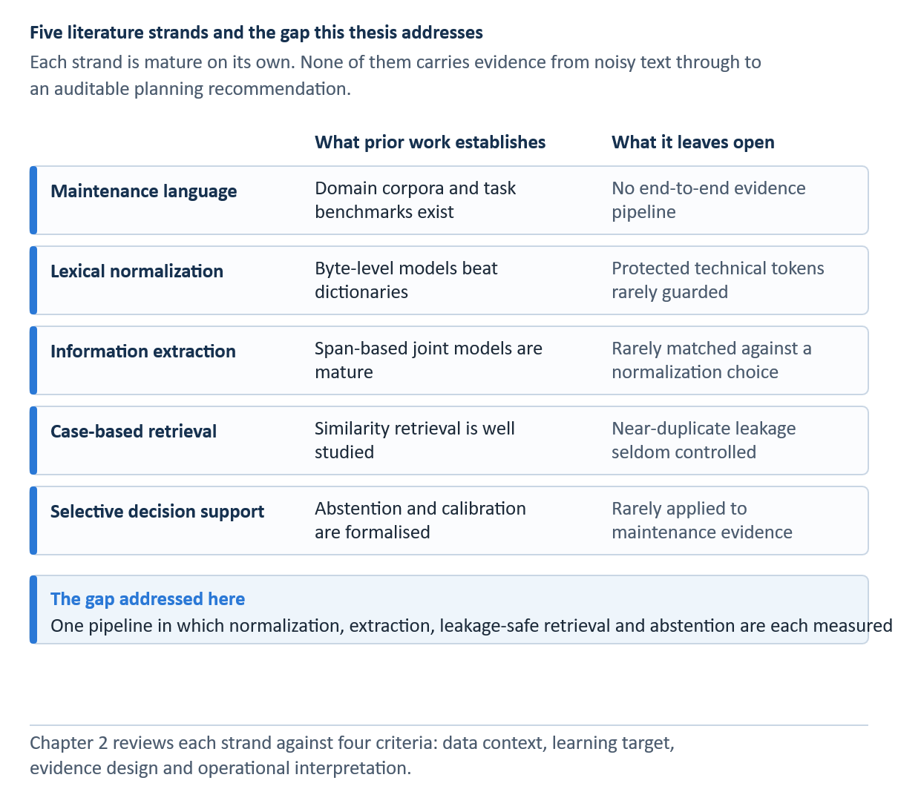
Figure 2.1 Five literature strands and the end-to-end evidence gap this thesis addresses

Review scope and comparison criteria
The selected literature combines foundational methods with studies that directly address industrial or aviation maintenance text. Foundational works are included where they define a model family or evaluation principle used later in the thesis, such as conditional random fields, transformer encoders, span-based joint extraction, case-based reasoning, probabilistic ranking, rank fusion, calibration, and selective prediction [7, 8, 9, 10, 11]. Domain-focused work is then used to assess whether these methods transfer to short, noisy, and safety-relevant records [3, 4, 5, 6, 12, 13].
Four comparison criteria guide the review. First, the data context determines whether a method was studied on general language, noisy user text, or industrial maintenance records. Second, the learning target distinguishes reference normalization, entity recognition, relation extraction, similarity estimation, and case retrieval. Third, the evidence design determines whether reported results are based on development data, a held-out test, an external benchmark, silver labels, or human review. Fourth, the operational interpretation asks whether the output is merely predictive or whether it exposes provenance, uncertainty, and an option to withhold a suggestion. These criteria are especially important because evidence produced at one stage cannot be treated as validation of the entire pipeline.
The review is intentionally selective rather than encyclopedic. It prioritizes methods implemented or meaningfully tested in this thesis and studies that clarify the main design choices. Regulatory sources are used only to define the system boundary: continuing-airworthiness and maintenance-performance rules reinforce that approved data and authorized personnel remain decisive [1, 2]. They are not used to claim regulatory conformity of the prototype.

Maintenance language and technical NLP
Maintenance work orders are written to ensure operational continuity rather than for natural-language processing. They typically compress an observed condition, location, component, action and outcome into a few fragments. A single line may also contain local abbreviations, omitted function words, part identifiers, capitalization shifts and repeated templates. Brundage et al. [4] describe this setting as technical language processing: the challenge is not simply informal grammar, but a specialized register in which meaning is conveyed through domain conventions and asset-specific vocabulary.
Earlier maintenance keyword-extraction benchmarks [14] and aviation entity-recognition studies [15] show that the choice of labels, domain, and target text matters as much as the encoder. A later aviation-maintenance model combines a BERT encoder, bidirectional sequence modelling, and CRF decoding [16]. This informs the architectural context here, rather than providing a score-to-score comparison with the distinct AviMaint data.
MaintNet provides one of the clearest open research contexts for this problem. Akhbardeh et al. [3, 12] assembled language resources and tools around predictive-maintenance records, making it possible to study recurring technical expressions at a scale that smaller proprietary collections do not permit. The cleaned MaintNet aviation repository used in the present project improves access to this material, but it does not eliminate the need to document subsequent filtering, duplicate control, annotations, or split construction [17]. Therefore, a publicly available corpus is a starting point rather than a complete experimental protocol.
The same shorthand may be useful to an experienced engineer while posing difficulties for an automated system. Although some code may appear to be noise to a general-language model, it may identify a component or procedure. Similarly, a seemingly harmless spelling correction may alter that identifier. Conversely, leaving all text unchanged can fragment retrieval because equivalent defects may appear under several spellings. The literature therefore supports two simultaneous requirements: models must reduce lexical variation while preserving forms whose technical meaning cannot safely be inferred from surface regularity alone [4, 5].
Many maintenance-language researchers are also investigating similarity and topic structure as entry points for reusable operational knowledge. For example, Sundaram and Zeid [13] apply text similarity and topic modelling to work orders in a prognostics and health-management context. This work shows that maintenance narratives can support grouping and search, but it does not identify which phrase describes the problem, which describes an action, or whether the retrieved action is applicable to a new aircraft state. This distinction motivates the structured extraction and evidence-bound retrieval stages discussed later in the thesis.
Taken together, prior studies establish that maintenance narratives contain reusable information but resist direct reuse. Their central limitation is not a lack of individual algorithms, but the absence of a common evaluation chain that follows evidence from noisy text through extraction into a traceable historical case. The thesis consequently treats record identity and its provenance as persistent objects across the three stages, rather than viewing normalization, extraction, and retrieval as independent demonstrations.

Lexical normalization for noisy technical text
Lexical normalization is the process of changing a non-standard expression into a regular form while preserving its meaning. In general noisy-text research, system output is commonly compared with a reference string for evaluation, and shared tasks such as MultiLexNorm demonstrate that the problem occurs across a variety of languages and noise types [18]. General benchmarks, however, do not reproduce the risk profile of maintenance data. Although replacing an informal spelling and rewriting a component identifier are both string transformations, errors in these operations have very different operational consequences.
The MultiLexNorm study also examined fine-tuning ByT5 for multilingual lexical normalization [19]. These results motivate the byte-level candidate, but industrial tokens and protected aircraft identifiers require a separate local test. The final representation is selected on validation data rather than borrowed from a different corpus.
Rule-based and dictionary-based systems remain useful because their decisions can be inspected. A curated mapping can expand a known abbreviation or correct a frequent local misspelling, while a protected list can prevent changes to specified technical forms. Their main limitation is coverage. Rules written for observed patterns may not generalise to new variants, and frequency-based replacement lacks the context needed to resolve an ambiguous token. These methods therefore provide useful baselines and safeguards, but broader dictionary coverage does not necessarily produce better text.
Sequence-to-sequence models frame normalization as conditional generation. T5 unifies language tasks by expressing them as text-to-text transformations, while ByT5 performs transformations directly over bytes rather than relying on a fixed token vocabulary [20, 21]. Byte-level modeling is attractive for corrupted spellings, rare symbols, and unseen technical forms because every input can be represented. The same generative freedom creates a preservation problem: a model may confidently rewrite a string that was already correct or technically significant.
MaintNorm is particularly relevant as a precedent because it was designed for this domain [5]. It provides a corpus and benchmark for industrial maintenance short text rather than social media noise. Its contribution is both empirical and methodological: most importantly, it makes normalization and masking decisions explicitly observable within a domain corpus. However, its scope remains limited to a benchmark for a defined dataset and task. It is not yet clear whether the representation with the best reference agreement will also maximize entity or relation extraction on a different aviation corpus.
This downstream question is often overlooked. Reference metrics reward similarity to a cleaned target, whereas an extractor may benefit from regular patterns already present in the raw record or may be disrupted by generated wording. The effect can also differ by task: normalization might reduce entity recall while improving consistency for a rare relation class. A defensible study therefore needs a matched comparison in which only the input representation changes, while the extraction split, labels, and model remain fixed.
The literature suggests that preservation should be treated as a separate objective rather than concealed within an average edit score. Selective processing offers one solution: accept a learned transformation only when the evidence is sufficient and a safety rule is satisfied; otherwise, retain the original input. This design does not interpret confidence as a probability of correctness. Instead, it creates an explicit trade-off between coverage and intervention, which can be selected using validation data and then evaluated once on a sealed test set [22].

Information extraction from maintenance narratives
Information extraction converts free text into labeled spans and specified relations. In maintenance records, useful entities include the affected item, location, abnormal condition, action, observation and outcome. Relations express how these elements belong together. The task differs from document classification because the system must recover boundaries and links within a short record. It also differs from generic named-entity recognition because many labels are functional roles rather than conventional names.
The sequence-tagging lineage extends from chunk-label encodings [23] to LSTM memory cells [24], subword-aware embeddings [25], and transformer self-attention [26]. Domain-adaptive pretraining [27] is relevant when technical vocabulary differs from a general-language corpus, although this thesis did not evaluate it as another extraction tier. These sources provide the methodological background; they do not supply the results of the local CRF, BiLSTM, DistilBERT, and SpERT comparisons.
Generative extraction surveys and zero-shot entity-recognition experiments describe alternatives to supervised span-and-relation extraction [28, 29]. Generation may produce plausible material that the source does not support [30], and REBEL is an example of generation-based relation extraction [31]. This thesis instead retains source spans, relation direction, and case provenance. Its frozen IE metrics are not attributed to these unevaluated alternatives.
Conditional random fields provide a strong structured baseline for entity recognition. A CRF scores complete label sequences instead of classifying tokens independently, allowing transition constraints to favour coherent BIO tag patterns [8]. With lexical, orthographic, affix, shape, and neighbouring-token features, it can exploit regularities in templated work orders. The model is inspectable, but its coverage depends on the selected features and the amount of context they represent. Chapter 6 explains the scoring function, feature groups, regularisation, and Viterbi decoding used here. Table 6.1 compares the four evaluated extraction families.
Neural sequence models reduce reliance on manually specified features. Bidirectional LSTMs combine left and right context, while a CRF output layer can preserve sequence consistency [32, 33]. They learn task-specific patterns from the labelled corpus but remain sensitive to sample size and class balance. With limited supervision, a recurrent model may not acquire the broader contextual knowledge available to a pretrained transformer.
BERT was a major improvement over classic feature-based methods. Its deep bidirectional pretraining incorporates self-attention mechanisms and masked language modelling, enabling task-specific fine-tuning from contextual representations [10]. DistilBERT builds on this approach by transferring much of BERT’s capability into a smaller student model through knowledge distillation [34]. For maintenance extraction, this provides a useful middle ground between a feature-based baseline and a larger joint architecture. Although pretraining improves contextual coverage, it does not eliminate domain shift, boundary ambiguity, or the limited availability of certain relation types.
Pipeline extraction first predicts entities, and then candidate pairs are classified. Its modularity makes errors easy to trace. However, if an entity is missed or mistyped, all its dependent relations are also lost. SpERT addresses these dependencies differently by enumerating candidate spans and jointly scoring span types and relations using transformer representations [11]. It allows the two tasks to share evidence and enables direct reasoning over span pairs. These advantages come with higher computational costs, sensitivity to the maximum span width and negative sampling, and a larger candidate space.
MaintIE provides a domain benchmark and fine-grained schema for maintenance short texts, offering a stronger point of comparison than general named-entity datasets [6]. It demonstrates that maintenance information can be represented through detailed entities and relations, but external transfer must be interpreted carefully. A model trained and tested on MaintIE measures performance under that benchmark, whereas a model separately trained on a local aviation schema addresses a different question. The present thesis therefore reports an internal frozen comparison and a separately trained external benchmark rather than describing the latter as zero-shot validation.
Annotation design is inseparable from model evaluation. Boundary conventions, overlapping concepts, relation direction, and the treatment of implicit information determine what counts as a correct output. Fort et al. [35] emphasise the need for an explicit named-entity annotation methodology, while Bayerl and Paul [36] show that agreement depends on the task and annotation conditions. A single-reviewer correction workflow can produce a usable gold corpus, but without independent double annotation, it cannot support a claim of inter-annotator agreement. This limitation must remain visible even when model-level scores are high.
The current framework cannot be adequately evaluated with a single aggregate F1 score. Micro-F1 is dominated by frequent labels because of the skewed label distribution, whereas macro-F1 gives every class equal weight and exposes weaknesses on rare types. Exact span matching is stricter than partial overlap. A relation is correct only when its argument spans, types, and direction match the evaluation criteria. Confidence intervals and class support are also necessary, because a perfect score for a relation with only one or two instances does not indicate stable performance on a common class [37].

Knowledge representation and case-based reasoning
Organizing extracted entities and relations into a stable representation makes them easier to inspect, link, and reuse. A knowledge graph provides typed nodes and edges, whereas a case representation groups the problem, historical action, outcome, and provenance associated with a single record. These structures serve different purposes: the graph supports aggregation and exploration across records, while the case preserves a retrievable unit of experience.
Provenance models distinguish between a record and an inference derived from that record [38]. In this study, the graph’s typed nodes and edges remain silver predictions linked to source identifiers; graph traversal does not independently verify the engineering validity of a proposed action.
Case-based reasoning frames problem solving as the retrieval and adaptation of earlier cases [7]. Its appeal in maintenance is practical: a reviewer can inspect what happened in a comparable historical record instead of accepting a generated answer without provenance. The classical cycle also includes reuse, revision, and retention. The prototype implemented in this thesis supports retrieval and evidence presentation, but it does not validate the application of technical adaptation primitives or automatically retain a new approved case. Therefore, it would overstate the implemented scope to describe it as a complete autonomous case-based reasoner that comprehensively realizes the full cycle. Lin et al. applied case-based reasoning with latent semantic indexing (LSI) to the structural repair of civil aircraft in a different aircraft-maintenance context [39]. Their work serves as a domain precedent rather than an evaluation baseline for these short work-order narratives; consequently, a direct comparison is not applicable.
Graph construction from model predictions introduces a further layer of evidence. Canonicalisation can merge lexical variants, and support counts can reveal repeated relations. Nevertheless, a repeated silver edge is still derived from model output. A high frequency may increase confidence that a pattern is common in the corpus, but it does not prove that the underlying maintenance action was correct, applicable, or authorised. Therefore, tracing the evidence graph back to the source records is more important than presenting it as a verified engineering knowledge base.
The literature does not provide a universal maintenance ontology that can be transferred unchanged to every fleet and documentation environment. A schema reflects its task, source language, and intended decisions. A defensible local schema should define entity boundaries, permitted relation pairs, and relation direction, while reporting support for rare classes. External benchmarks can test portability, but they cannot replace an internal schema audit based on the actual work-order narratives.

Historical-case retrieval and evaluation
Historical-case retrieval can be approached lexically, semantically, or through a combination of rankers. BM25 remains a strong lexical baseline because it balances term frequency, document length, and inverse document frequency [9]. In short technical records, exact component codes and distinctive fault phrases can be highly informative. Lexical ranking is also interpretable, as a reviewer can often understand why a shared term produced a match.
Dense retrieval represents queries and cases as vectors. Sentence-BERT produces fixed-dimensional sentence embeddings that make semantic comparison practical [40]. This approach can connect paraphrases with little exact word overlap, but embedding similarity may also blur operationally important differences. A semantically related record is not necessarily a relevant precedent when the asset state, location, or action context differs.
Structured retrieval does not treat every word of a case as an interchangeable bag of terms. In a field-aware ranker, a problem description receives a different weight from an item, location, or fault field. Robertson et al. [41] describe a BM25 extension for multiple weighted fields. A knowledge-based alternative compares typed entities and links, making a shared issue–item configuration visible even when the wording differs. In AviMaint-DSS, structure-aware matching is an exploratory channel built from model-predicted historical fields. Missing or incorrect silver relations can therefore suppress an otherwise relevant match. These features support inspection and experimentation, but the locked RQ4 result comes from canonical BM25 without a structural contribution to its score.
Hybrid systems combine complementary evidence so that the weaknesses of one evidence source can be offset by the strengths of another. Reciprocal rank fusion, a type of fusion method, merges ranked lists without requiring their raw scores to be on a common scale [42]. Although reciprocal rank fusion can improve robustness when lexical and semantic rankers fail on different queries, each additional component introduces tuning choices and can make the final ranking more difficult to explain. A hybrid method should therefore be adopted only when it improves a fixed evaluation target on development data and maintains clear provenance at presentation time.
The assessment should match the retrieval claim. Hit@k evaluates whether a relevant historical family appears within the first k positions, mean reciprocal rank rewards a relevant item that appears early, and nDCG accounts for graded relevance and position [43]. These metrics do not establish that the retrieved maintenance action is correct. They measure agreement with the relevance definition and population used in the experiment.
The relevance definition is especially consequential in a silver case library. If action-family labels are obtained from historical records or assisted labeling, Hit@k measures the recovery of that historical family rather than engineering correctness. A high micro-level score can also conceal weak coverage of rare action families; macro family recall gives each family equal influence and therefore exposes this imbalance. The two views answer different questions and should be reported together.
Robustness analysis examines whether a fixed protocol remains stable under plausible input degradation. Truncation represents incomplete narratives, while controlled spelling noise represents typographical variation. These tests are informative only when the clean result reproduces the frozen evaluation and no ranking parameter is changed after the perturbations are observed. A post-hoc robustness study must be labelled supplementary rather than presented as preregistered confirmatory evidence.
Sundaram and Zeid [13] demonstrate the practical value of text similarity and topic modelling for maintenance work orders. Their work supports the feasibility of retrieving related technical records; however, a substantial gap remains between similarity-based retrieval and decision support. An operational interface should present the original evidence, its source, alternative records, and associated uncertainty. Otherwise, a ranking metric may be mistaken for a capability to generate instructions.

Selective and human-centred decision support
Decision support should distinguish between making a prediction and deciding when to present it. Selective prediction introduces a reject option, allowing the system to withhold an output when its confidence or evidence is insufficient [22]. The relevant trade-off is between coverage and conditional risk. Increasing the threshold may reduce the number of displayed cases and improve the average reliability of those retained, but only when the score is meaningfully ordered.
Selective classification formalizes the choice to withhold an answer when the risk is too high for the available coverage [44]. Conformal prediction offers a different route to statistical coverage under its assumptions [45], but no conformal guarantee is claimed for this system. Research on human interaction with AI-enabled automation warns that apparent fluency can invite misuse or overreliance [46]. The EASA machine-learning concept paper and the NIST AI Risk Management Framework provide governance context [47, 48]; neither is treated as proof that this prototype is certified.
Modern neural scores are often poorly calibrated. Guo et al. [49] demonstrate that high predictive accuracy does not guarantee that stated confidence corresponds to empirical correctness. Calibration measures such as expected calibration error compare confidence bins with observed outcomes, while the Brier score evaluates squared probabilistic error [50]. In this thesis, these measures concern historical retrieval agreement and must not be interpreted as probabilities that a maintenance action is safe or approved.
Human-centred presentation therefore requires more than a confidence badge. A reviewer should be able to inspect the original problem description, the retrieved historical action, its outcome, the source identity, and competing alternatives. Low-support cases should be clearly distinguished from stronger evidence. These design choices make the system auditable and discourage automation bias, although interface transparency cannot compensate for an invalid model or an unrepresentative corpus.
The aviation setting imposes firm limits on the claims. Maintenance must be performed using current, approved data and in accordance with the applicable continuing-airworthiness and performance rules [1, 2]. A research prototype that retrieves historical work orders is therefore an evidence browser for qualified review, not a source of approval or a substitute for manuals, engineering instructions, or authorised judgement.

Critical synthesis of prior work
Across the reviewed literature, each technical stage is well motivated in isolation. Maintenance-language research establishes the value and irregularity of the source material; normalization work offers rules and generative models; information-extraction research supplies structured baselines and joint transformers; case-based reasoning and retrieval research provide mechanisms for reuse; and selective prediction provides a principled way to withhold weak outputs. The unresolved problem is the disciplined connection of these stages.
Three recurring weaknesses are particularly relevant. First, data populations are often difficult to compare across studies, and duplicate or near-duplicate records can inflate apparent generalisation. Second, upstream intrinsic improvements are sometimes assumed to benefit downstream tasks without a matched experiment. Third, accurate retrieval labels can be presented too readily as decision quality, even when relevance is silver, proxy-based, or established by a single reviewer. These weaknesses shape the experimental controls used in Chapters 3–8.
The literature also reveals a tension between generalisation and preservation. Neural models can cover variants missed by rules, but controlled vocabularies and exact identifiers reward deterministic safeguards. Joint extractors can exploit wider context, but their predictions become silver evidence when applied to the full corpus. Dense retrieval can bridge paraphrases, but lexical matches may be easier to audit. The thesis treats these as empirical trade-offs rather than assuming that the most complex model is always preferable.
A further gap concerns the continuity of interpretation. Published work often reports a model metric without following how that output is transformed, aggregated, and presented to the user. In the present study, record IDs, split assignments, and provenance are retained throughout the pipeline. This enables a reviewer to trace a displayed case back to the historical narrative and allows the thesis to state exactly which layer, whether gold, locked test, silver extraction, calibration, or manual review, supports each claim.

Research gap and connection to RQ1–RQ5
The research gap is therefore an evidence-controlled, end-to-end study of noisy aviation maintenance narratives. Rather than developing an autonomous maintenance recommender, the project examines how normalization affects reference agreement and extraction, how alternative extractors recover the local schema, how their predictions can form a traceable silver case library, and how a fixed retrieval protocol can present useful historical evidence with explicit uncertainty and abstention.
RQ1 investigates which of the six representations best matches the expert-cleaned normalization reference while preserving protected aviation terms. System selection uses the 926 validation records, and the selected representation is evaluated once on the locked 741-record test set. Downstream extraction is addressed as a separate question so that intrinsic string agreement is not treated as its answer. Table 2.1 maps each gap to its corresponding research question and evidence population.
RQ2 examines how text representation affects downstream extraction when the same SpERT design is trained and evaluated on each version of the same 1,275/100/225 record partition. Strict entity and relation micro-F1 scores address the main question, while macro-F1 reveals whether the effect differs across the less frequent relation types.
RQ3 compares feature-based CRF, recurrent BiLSTM-CRF, distilled-transformer pipeline, and joint SpERT extraction under the same local schema and frozen split, with a separately trained MaintIE benchmark providing architectural context. The downstream silver graph and historical case library are research outputs of the selected extractor, not an unmeasured sixth research question. Their provenance and prediction status are documented in Chapter 7.
RQ4 evaluates whether problem-only queries can recover a matching historical action family near the top of a frozen ranking. Although the action is hidden from the query, all ranking parameters are fixed before final evaluation. Results are reported for the 828 evaluable queries, with macro action-family recall and supplementary perturbation tests included to expose imbalance and assess robustness limits.
RQ5 concerns evidence presentation rather than maintenance approval. It evaluates calibrated display rules, abstention behaviour, and a single-reviewer manual assessment of whether the returned cases provide usable evidence of historical actions. The answer remains bounded by the reviewer, corpus, and rubric, and does not establish technical correctness or safety.
Table 2.1 Mapping from literature gaps to the thesis research questions
Literature gap | Research question and test | Evidence boundary
Noisy records versus preservation | RQ1: six representations, 926 validation; 741 locked normalization test. | Reference agreement and protected tokens, not semantic proof.
Upstream scores versus IE | RQ2: five matched SpERT representations on one 225-record test. | Matched descriptive comparison; test not used for selection.
Architecture comparison | RQ3: four IE families on 225 records; separate MaintIE test of 108. | Separately trained models; schemas and populations differ.
Historical evidence retrieval | RQ4: fixed problem-only BM25 on 828 evaluable queries. | Action-family agreement; robustness post-hoc.
Human-facing evidence | RQ5: calibrated agreement and one-reviewer assessment of 100 queries. | Not action correctness, safety, or regulatory approval.
Note. Each row names an evaluated construct and its evidence population.

Chapter summary
Domain-specific text requires domain-aware preservation; normalization requires both intrinsic and downstream assessment; extraction requires class-level evidence; silver structures require provenance; retrieval requires a fixed relevance contract; and confidence must be separated from safety. Chapter 3 turns these conclusions into the data lineage, split rules, evidence vocabulary, and leakage controls used throughout the experiments.

Data and Research Design

Data sources and evidence layers
The project contains evidence layers with different levels of authority. The 6,169 source records are observed historical texts, while the 5,124-record paired normalization subset supports the cluster-safe 3,457/926/741 split. The 1,600-record IE corpus consists of manually corrected gold data. Full-corpus SpERT output and the graph are silver data, while the 828-query retrieval test and 100-query manual review form a separate historical-evidence layer. Figure 3.1 visualizes the permitted derivations and claims, while Table 3.1 records the corresponding datasets, roles, and statuses.
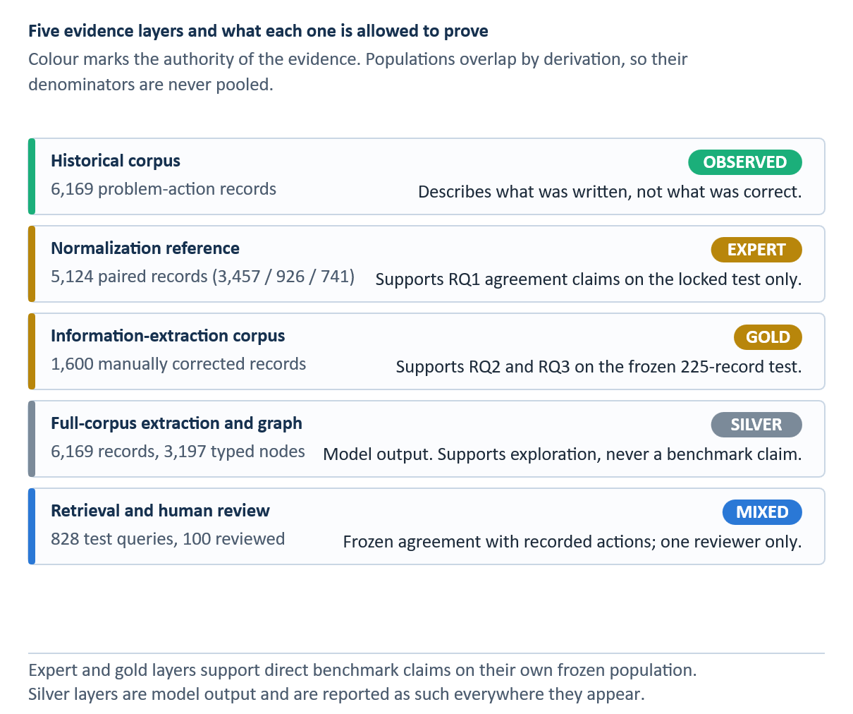
Figure 3.1 Five evidence layers and the claims each population is permitted to support
Arrows indicate derivation rather than increasing certainty. Each successive modelling layer retains the limitations of its source and introduces its own modelling assumptions.
Table 3.1 Data and evidence inventory
Evidence layer | Population | Status and legitimate use
Historical corpus | 6,169 problem-action rows | Observed source text for operational case construction.
Normalization reference | 5,124 paired rows; 3,457 / 926 / 741 | Expert-cleaned target; validation selection then locked test.
IE gold | 1,600 annotated rows; 1,275 / 100 / 225 | Manually corrected typed spans and relations; test frozen.
MaintIE | 860 / 108 / 108 | Separate external benchmark; models retrained on its training split.
Operational silver IE and KG | 6,169 rows; 3,197 typed nodes | Model-derived predictions for exploration, not gold claims.
Retrieval and human review | 828 evaluable test queries; 100 reviewed queries | Frozen historical-action agreement; single-reviewer supplemental judgment.

MaintNet corpus profile
The supplied aviation corpus contains 6,169 rows, 3,595 distinct problem strings, and 2,881 distinct action strings in the normalization analysis. Repetition is operationally useful because recurring problems and actions reveal common patterns, but it is also statistically hazardous. Exact and near-duplicate records can leak between training and evaluation, inflate frequency-based support, and make retrieval appear stronger than it is. The project therefore retains record counts for descriptive analysis while using evidence clusters for recommender splitting and support aggregation.
The source fields are short. The problem field is limited to 60 characters and the action field to 55, with 405 problem strings and 945 action strings reaching those exact widths. A final token may therefore be complete, abbreviated, or physically truncated. The corpus also contains punctuation artifacts, apostrophe tokenization, directional shorthand, numbers written as words, and many records with closely related component and issue descriptions. These features motivate byte-level normalization and character-level retrieval.
The downstream system uses a 6,169-record structured export containing source identifiers, combined text, extracted item strings, issue strings, and action strings. Because several columns are derived from model output, this export is not treated as an independent ground truth. It is used to construct the silver case layer and support dashboard indexing. The original text and identifiers remain the provenance anchors.

End-to-end research design
The research follows a staged design. Normalization selection is completed using the validation data, and the result is evaluated once on the locked 741-record test set. Representation effects are tested through a matched SpERT ablation. Four IE architectures are compared on the same frozen 225-record test set and separately on MaintIE. Operational SpERT predictions are then converted into a silver graph and case library. Final retrieval uses problem-only queries, cluster-safe evidence, canonical BM25, τ_rank = 0.15, and cluster-expanded aggregation, while the query action remains hidden.
The stages remain distinct in interpretation. Agreement with the references cannot establish semantic correctness; matched ablation measures downstream IE rather than assuming it; gold-test IE F1 does not validate every silver graph record; and retrieval metrics concern recorded action families or reviewer-rated usable evidence rather than technical applicability, repair correctness, or authorization.

Separation of estimands across the pipeline
Each experiment estimates a different quantity. The normalization study measures agreement between a transformed string and an expert-cleaned reference. The IE study measures recovery of annotated spans and relations. The graph stage reports how much silver structure the operational extractor produces. The retrieval study measures whether a historical action family associated with a held-out problem appears near the top of a ranked list. The software pipeline connects these quantities, but they are not interchangeable measures of system quality.
This separation prevents a strong upstream score from being used as evidence for a downstream claim. Lower WER does not prove better relation extraction, high relation F1 does not mean that every full-corpus edge is correct, and high Hit@5 does not establish technical applicability. The thesis therefore reports the population, target, and evidence status beside every principal result.
System choices and negative results were retained after test inspection rather than rewritten. Selective ByT5 remains the official RQ1 system because it was selected during validation before the 741-record test. The Selective retrieval protocol and prior-tempering exponent τ_rank = 0.15 were likewise fixed before the 828-query evaluation. Later robustness analysis uses the same protocol and is labelled supplementary.

Leakage controls and data partitions
In the reference-based normalization experiment, 5,124 paired records were collected and assembled into 1,840 clusters. Using seed 42, the clusters were split into 3,457 training records, 926 validation records, and 741 locked-test records. A cluster similarity threshold of 0.90 prevented near-duplicate leakage. Selective ByT5 was chosen using validation data only. After the test set was opened, the six systems were evaluated without further training or retuning.
Active learning can prioritize informative cases for annotation, but sampling decisions must remain separate from frozen evaluation [51]. Inter-annotator agreement addresses a different quality question from a model's F1 against the resulting reference [35, 36, 52]. Because the current gold corpus has no independently double-annotated subset, no inter-annotator agreement estimate is reported.

Why record-level random splitting is insufficient
Maintenance corpora are typically constructed by collecting repeated and near-duplicate examples. When both the training and test sets contain two lexical variants of a single underlying case, a model might gain credit by memorizing the shared wording rather than generalizing to a new case. Cluster-safe splitting assigns every member of an equivalence or near-duplicate group to the same split. This makes the unit of independence closer to the operational case than to the database row. Lee et al. [53] illustrated how duplicated text can contaminate held-out evaluations in language modelling. Their task differed from ours, but the shared leakage mechanism supports assigning near-duplicate maintenance records to the same split.
The normalization selection used 926 validation records, while the 741-record test set remained sealed. The downstream representation experiments used the same 1,275/100/225 train/development/test identities for every representation. The retrieval evaluation used 4,319/925/925 records, of which 828 test queries had evaluable historical evidence. These populations answer different questions and must not be pooled or described as a single test set.
The IE corpus begins with a random pilot. Additional random rounds expand coverage to approximately 1,100 records, after which rare-class and uncertainty sampling enrich only the training data. The development set of 100 records and test set of 225 records are frozen before enrichment, while the final training set contains 1,275 records. This design prevents active-learning selection from changing the evaluation distribution and leaves the test set with its naturally occurring class imbalance.
The recommender uses a separate cluster manifest to group exact and near-duplicate cases. Query clusters are held out to evaluate the recommender’s performance, and candidates must come from the allowed training partitions. Fingerprints record the case library and split assignments used to map the cases. Tests ensure that recomputed near duplicates do not cross splits, that changes to the case library invalidate the cluster manifest, and that query solutions do not augment the problem graph. These controls are necessary because a conventional random record split would allow nearly identical work orders to appear on both sides of the evaluation.

Evaluation principles
Each object is evaluated with measures suited to its role. Normalization uses WER, CER, exact match, change F1, and protected-token preservation. IE uses strict typed entity and relation micro-F1 and macro-F1 together with per-class results. Retrieval uses Hit@k, MRR, nDCG@5, macro action-family recall, manual-review evidence rates, calibration error, and fixed-protocol degradation deltas.
Support is always reported alongside per-class F1. A rare class can achieve a high F1 score from just a few examples, whereas a frequent class determines much of the micro-F1. Macro-F1 gives each class equal weight but becomes unstable when support is small. Bootstrap intervals capture test-sample variation, conditional on the trained model. Seed experiments capture some training variation but are available only for selected IE tiers. None of these replaces external validation.
The final retrieval reports include Hit@1, Hit@3, Hit@5, MRR, nDCG@5, and macro action-family recall. The top-k metrics indicate whether the recorded evidence is recovered. Macro recall ensures that the dominant Replace family does not obscure weak performance on rare families. Calibration and manual review are conducted on separate populations and should not be interpreted as safety probabilities or action approval.

Reproducibility and governance
The reproducibility package includes configuration files, frozen manifests, data fingerprints, out-of-sample predictions, metric tables, evaluation splits, robustness results, screenshots, source code, and verification scripts. The verification scripts confirm the locked normalization and retrieval artifacts without training or retuning. These records distinguish validation selection, frozen-test evidence, and silver output.
Reproducibility does not replace governance obligations. MaintNet is a research corpus; however, operational deployment would require a data protection impact assessment, organisation-specific access controls, retention rules, model and dataset versioning, integration of approved data, human-factor assessment, and monitoring for distribution shift. Past actions may reflect obsolete procedures, local practices, or incomplete records. Provenance makes these risks visible, but it does not eliminate them.

Text Normalization

Motivation and task definition
Surface variation affects tokenization, exact matching, retrieval terms, and learned representations. This effect is pronounced in short MaintNet records, where a single abbreviation or spelling error can determine much of the lexical signal. Aggressive rewriting also poses a significant risk by removing technical distinctions or extending the text beyond the truncated source field. The normalization task is therefore defined as conservative lexical repair against an expert-cleaned reference, with protected-token preservation measured separately.
The experiment is reference-based and uses 5,124 records, with each record containing a source string paired with an expert-cleaned string under a frozen, cluster-safe manifest. All six systems receive the same shared preprocessing. The full corpus contains 6,169 records and supports operational inference and case construction, but it is not the RQ1 test population.

Experimental conditions
Table 4.1 Normalization conditions
System | Method | Evaluation role
Raw | Shared minimal preprocessing only | Control
Most-frequent replacement | Training-derived token replacement | Frequency baseline
Rules | Deterministic domain resources and protected forms | Transparent baseline
ByT5 | Fine-tuned google/byt5-small | Unconstrained learned normalizer
Selective ByT5 | Validation-selected selective use of ByT5 | Official preregistered RQ1 system
Rules then ByT5 | Deterministic rules followed by ByT5 | Composed hybrid
Note. All six conditions share one preprocessing path and one locked scorer.
All six normalization conditions use the same scorer. Selective ByT5 was selected based on the validation results before the test set was inspected. It therefore remains the prespecified RQ1 system, although pure ByT5 has the best descriptive WER and exact-match values on the locked test. This reporting rule prevents model selection from being revised after the test result is known. Table 4.1 defines the six controlled normalization conditions.

Data preparation and reference construction
The 5,124 paired records form 1,840 similarity clusters. A split using seed 42 assigns 3,457 records to the training set, 926 to the validation set, and 741 to the locked test set. The training data support model fitting and the creation of training-derived resources, while the validation data determine the system selection. The locked test set is reserved for one final comparison of the six systems. Figure 4.1 shows where validation-based selection and final test evaluation enter the workflow.
Fixed-width source fields create an unavoidable ambiguity. The expert-cleaned release sometimes reconstructs or regularizes an ending that appears truncated in the observed record. Agreement metrics reward this reconstruction, even when the stored text cannot identify a unique completion. Therefore, the scores measure agreement with the cleaned release rather than recovery of an objectively knowable original sentence.
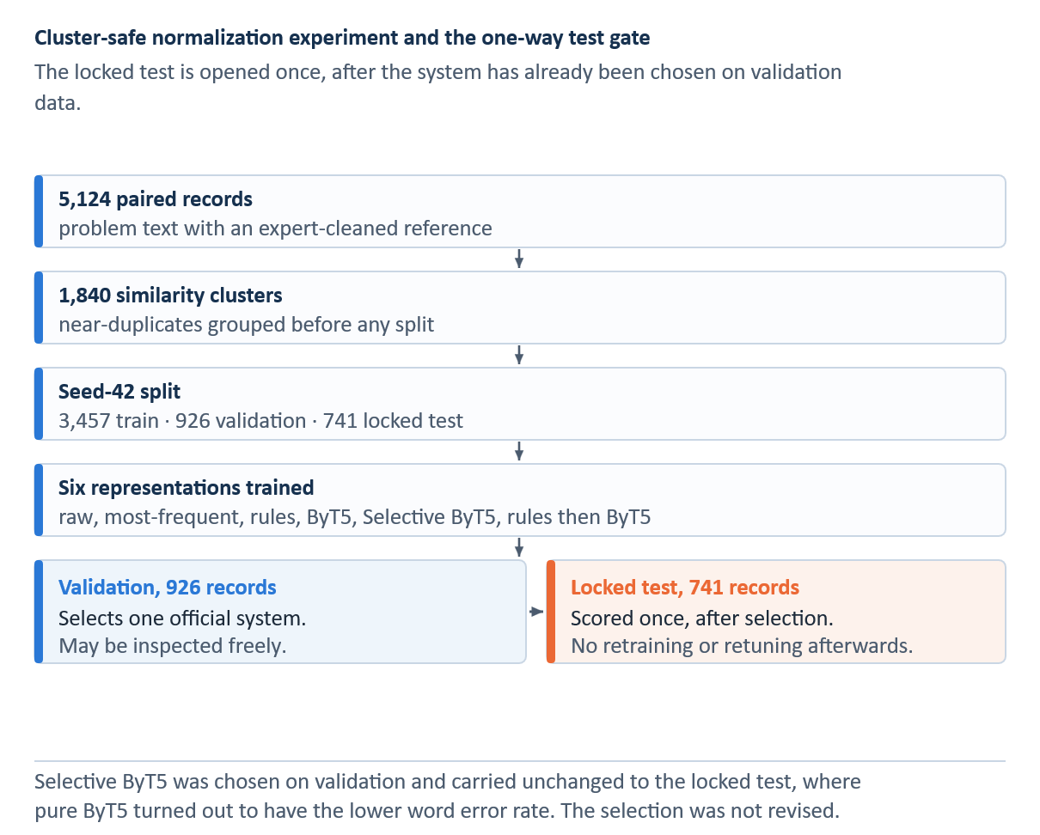
Figure 4.1 Cluster-safe normalization experiment and the one-way gate to the locked test

Rule-based normalizer
The rule system was constructed from the supplied expert resources and then audited for conflicting or potentially harmful mappings. Its lexicon contains 82 unambiguous abbreviation expansions, four ambiguous entries, ten symbol rules, 88 single-token misspellings, and 19 multi-word misspellings. Seven mappings were suppressed, and 26 abbreviations were protected. Longer and multi-word patterns are applied before shorter token rules, and every expansion is logged.
Rules are used to make specific and traceable changes. A reviewer can identify the mapping responsible for a change, protect organization-specific terms, or approve a revised expansion. They have two major limitations: finite coverage and weak context sensitivity. A global substitution cannot reliably determine which expansion of an abbreviation is intended, and unseen misspellings remain unchanged. Consequently, ambiguous entries are preserved rather than expanded without supporting evidence.

Rule ordering and protected forms
The deterministic normalizer first identifies tokens and substrings that must remain unchanged, then applies curated abbreviation and misspelling mappings. The order of these operations is crucial because applying a general rule before a specific technical exception may corrupt that exception. To prevent this, the implementation treats the keep-list as a constraint, records which rule fired, and evaluates whether preservation occurred.
Frequency replacement is an intentionally simple method. For each observed out-of-vocabulary subword, it substitutes the most frequently observed reference replacement in the training data. This baseline tests whether dictionary frequencies alone are sufficient to solve the task. Its locked-test WER of 0.3582, which is higher than the raw-text WER of 0.2994, demonstrates that context-free replacement can introduce more word errors than it removes.

ByT5 normalizer
The learned normalization model employs google/byt5-small, which is trained and fine-tuned at the byte level and can model spelling and punctuation without requiring a fixed subword vocabulary [21]. The source and target lengths are capped at 256 bytes. The model is trained with a learning rate of 1 × 10^−4, a weight decay of 0.01, a warm-up ratio of 0.05, a batch size of 1, gradient accumulation over 16 steps, Adafactor, bfloat16 arithmetic, and gradient checkpointing. Training runs for at most 20 epochs with an early-stopping patience of 3, and the checkpoint is selected based on the best validation WER.

ByT5 optimization and model selection
ByT5 treats both the noisy input and the clean target as byte sequences. The settings reported above yield an effective batch size of 16 examples through gradient accumulation, during which the model parameters are not updated after every batch. Gradient checkpointing reduces memory demand by recomputing selected activations during backpropagation, while Adafactor limits optimizer-state memory. Early stopping with a patience of three uses validation WER to prevent the locked test set from influencing either training duration or checkpoint selection.
Byte-level modelling is useful for handling misspellings and uncommon symbols because it does not require every form to exist in a fixed subword vocabulary. However, this flexibility creates a risk that, during decoding, an already correct part number or abbreviation may be altered. Therefore, Selective ByT5 combines the learned proposal with a confidence and safety gate rather than accepting every generated string.
The Rules then ByT5 condition applies deterministic normalization before the learned model. This composition alters the input distribution because abbreviations and misspellings may already be expanded before reaching ByT5. The condition tests whether the two stages complement each other; no monotonic improvement is assumed.

Evaluation measures
The locked evaluation reports WER, CER, exact match, change F1, and protected-token preservation. Together, these measures capture word- and character-level agreement, complete-record agreement, recovery of intended edits, and unintended alterations to protected aviation forms. However, none of these measures independently establishes semantic or technical correctness.

Sequence-level error measures
Word error rate compares the predicted and reference word sequences. It counts the minimum substitutions, deletions, and insertions needed to transform one sequence into the other, as formalized in Equation 4.1.
 | $$\text{WER}=\frac{S_{w}+D_{w}+I_{w}}{N_{w}}$$ | (4.1)

S, D, and I denote substitutions, deletions, and insertions. The subscript w marks word-level counts, and N is the number of reference words. Lower WER is better, and zero means exact word-sequence agreement. Because the reference length is the denominator, many insertions can produce a WER above one.
Character error rate applies the same alignment principle at character level, as formalized in Equation 4.2.
 | $$\text{CER}=\frac{S_{c}+D_{c}+I_{c}}{N_{c}}$$ | (4.2)

Here, S, D, and I again denote substitutions, deletions, and insertions. The subscript c marks character-level counts, and N is the number of reference characters. CER detects small spelling differences that may count as a full word error under WER. It complements WER because even a small character change can alter a critical technical token.
Exact match is the strictest record-level measure, as defined in Equation 4.3.
 | $$\text{EM}=\frac{1}{n}\sum_{i=1}^{n}{1}\left\{{\overset{ˆ}{y}}_{i}=y_{i}\right\}$$ | (4.  3)

Across n records, the indicator equals one only when the complete prediction for record i matches its reference exactly. Exact match is easy to interpret, but it gives the same zero credit to a one-character difference and a completely different output. WER and CER provide the required graded comparison.
The 741-record test was scored after validation selection. WER and CER measure edit distance at the word and character levels, respectively. Exact match requires the complete system output to equal the reference. Change F1 evaluates the intended modifications, while protected-token preservation records whether designated aviation forms remain unchanged.

Change detection and preservation
Change precision measures whether edited positions actually required an edit, while change recall measures whether the required edits were found. Their harmonic mean is change F1, as formalized in Equation 4.4.
 | $$\begin{aligned}P_{Δ}&=\frac{{\text{TP}}_{Δ}}{{\text{TP}}_{Δ}+{\text{FP}}_{Δ}}, R_{Δ}=\frac{{\text{TP}}_{Δ}}{{\text{TP}}_{Δ}+{\text{FN}}_{Δ}} \\ F_{1,Δ}&=\frac{2P_{Δ}R_{Δ}}{P_{Δ}+R_{Δ}}\end{aligned}$$ | (4.4)
TPΔ counts required changes made correctly, FPΔ counts unnecessary or incorrect changes, and FNΔ counts required changes left unresolved. Change F1 therefore penalizes both under-normalization and over-normalization. It is more informative than accuracy when unchanged tokens dominate the corpus.
The keep-list isolates the safety-oriented constraint by preserving protected tokens, as formally encoded in Equation 4.5.
 | $$\text{Preserve}=\frac{\sum_{i=1}^{n}{\sum_{t∈K_{i}}{1}}\left\{\overset{ˆ}{t}=t\right\}}{\sum_{i=1}^{n}{\left|K_{i}\right|}}$$ | (4.5)
Kᵢ is the set of protected-token occurrences in record i. The numerator counts occurrences that remain unchanged in the system output. Selective ByT5 reached 1.0000 on this measure, while unconstrained ByT5 reached 0.9663. Preservation does not prove that every protected form is semantically correct; it shows that the defined protected set was respected.
Lexical-normalization benchmarks, such as MultiLexNorm [18], typically express improvement using the relative error-reduction measure, which quantifies improvement relative to a named baseline error. This measure is formalized in Equation 4.6.
 | $$\text{ERR}\left(s;b\right)=\frac{e\left(b\right)-e\left(s\right)}{e\left(b\right)}$$ | (4.6)
Here, e(raw) is the raw-text error and e(system) is the system error. ByT5 reduced WER from 0.2994 to 0.0147, an absolute reduction of 0.2847 and a relative reduction of approximately 95.1%. Against the stronger rules baseline, the absolute reduction was 0.0916 and the relative reduction approximately 86.2%. Relative reductions are therefore reported with their baseline.
WER and CER measure errors at different scales. Exact match provides a strict record-level criterion, while Change F1 isolates the edits the system was expected to make. Protected-token preservation captures over-normalization that aggregate error rates may conceal. Therefore, interpreting system performance requires considering the complete set of metrics.

Results
The validation population contains 926 records and was used for system selection, not for the final performance claim. On this population, ByT5 and Selective ByT5 each achieved a WER of 0.006177 and an exact-match score of 0.935205. Protected-token preservation was 0.998920 for unconstrained ByT5 and 1.000000 for Selective ByT5. These development measurements explain the figures reported in earlier project materials. The separate locked test reported below contains 741 records. Therefore, the two populations are not interchangeable, and the locked-test values constitute the reported result.
The locked 741-record normalization test produced the following results. Raw text had WER 0.2994, exact match 5.94%, and change F1 0.0000 because it proposes no edits and therefore has no true-positive edits. Most-frequent replacement reached WER 0.3582, exact match 2.29%, and change F1 0.1905. Curated rules reached WER 0.1063, exact match 29.96%, and change F1 0.4856. Unconstrained ByT5 produced WER 0.0147, exact match 93.66%, change F1 0.9542, and protected-token preservation 96.63%. The preselected Selective ByT5 system produced WER 0.0219, exact match 93.25%, change F1 0.9460, and preservation 100%. Rules followed by ByT5 produced WER 0.0178, exact match 91.36%, change F1 0.9425, and preservation 97.03%. These are frozen test observations, not six separate selection trials.
The representation-matched SpERT study trained all configurations on 1,275 records, used 100 records for development, and evaluated them on the same test set of 225 records. Raw text achieved entity and relation micro-F1 scores of 0.9455 and 0.8203, respectively. Selective ByT5 performed slightly worse, achieving entity and relation micro-F1 scores of 0.9424 and 0.8167, respectively. However, its relation macro-F1 score of 0.7781 exceeded the raw-text score of 0.7511. This contrast prevented the intrinsic WER result from being misreported as an improvement in downstream extraction.
Table 4.2 Locked normalization-test results
Representation | WER ↓ | CER ↓ | Exact ↑ | Change F1 ↑ | Protected ↑ | WER 95% CI
Raw | 0.2994 | 0.2238 | 0.0594 | 0.0000 | 1.0000 | 0.2870–0.3114
Most frequent | 0.3582 | 0.1516 | 0.0229 | 0.1905 | 1.0000 | 0.3471–0.3691
Rules | 0.1063 | 0.0623 | 0.2996 | 0.4856 | 1.0000 | 0.0983–0.1143
ByT5 | 0.0147 | 0.0091 | 0.9366 | 0.9542 | 0.9663 | 0.0096–0.0205
Selective ByT5 (selected) | 0.0219 | 0.0143 | 0.9325 | 0.9460 | 1.0000 | 0.0148–0.0298
Rules then ByT5 | 0.0178 | 0.0111 | 0.9136 | 0.9425 | 0.9703 | 0.0124–0.0246
Note. Locked 741-record test, opened once after validation selection. All values are proportions; the prose reports exact match as a percentage of the same quantity. Intervals are 95% bootstrap confidence intervals, and the ByT5 and Selective ByT5 intervals overlap.
After validation-only selection had been frozen, the same scorer evaluated all six systems on the locked test of 741 records.
Table 4.3 Representation-matched SpERT ablation
Representation | Entity micro-F1 | Entity macro-F1 | Relation micro-F1 | Relation macro-F1 | Δ relation macro vs raw
Raw | 0.9455 | 0.9056 | 0.8203 | 0.7511 | —
Rules | 0.9432 | 0.8889 | 0.8151 | 0.7466 | −0.0045
ByT5 | 0.9353 | 0.8753 | 0.8034 | 0.7476 | −0.0035
Selective ByT5 | 0.9424 | 0.8940 | 0.8167 | 0.7781 | +0.0270
Rules then ByT5 | 0.9378 | 0.8715 | 0.8136 | 0.7622 | +0.0111
Note. Five separately trained SpERT models on one frozen 225-record test.
A representation-matched SpERT ablation was conducted using 1,275 training records, 100 development records, and 225 frozen test records. Entity and relation scores were evaluated using strict typed evaluation.

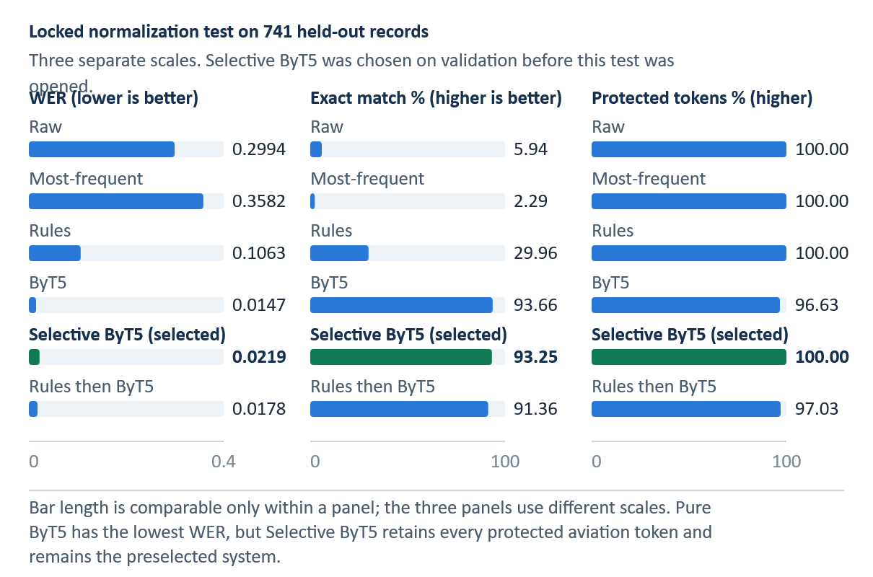
Figure 4.2 Word error rate, exact match and protected-token retention of six representations on the locked 741-record test
WER is a lower-is-better metric, whereas exact match is a higher-is-better metric. Selective ByT5 is the system selected through validation, whereas pure ByT5 is the descriptive test winner.
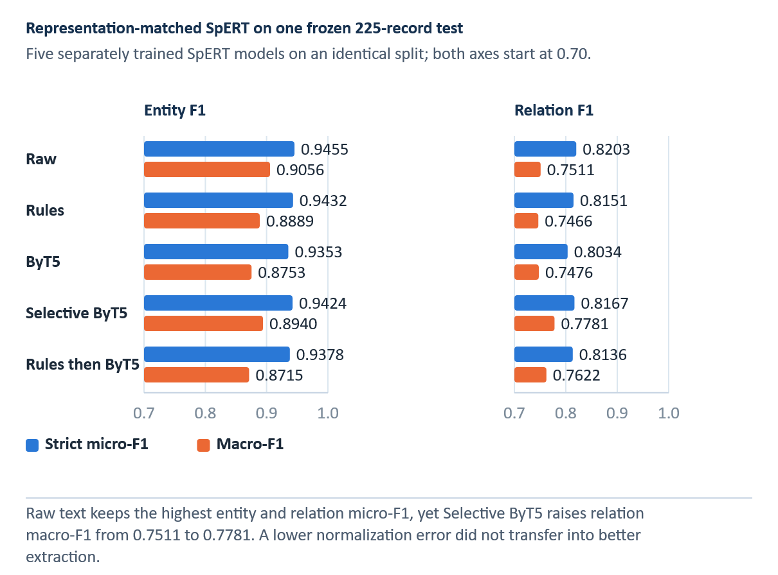
Figure 4.3 Entity and relation F1 of five representation-matched SpERT models on the frozen 225-record test
The matched SpERT comparison uses the same 225-record test set for every representation. Higher bars indicate higher strict micro-F1 scores.

Error analysis and interpretation
WER was 0.2994 for the raw text, while exact match was 0.0594. Most-frequent replacement increased WER to 0.3582, whereas rules reduced it to 0.1063. The learned systems performed substantially better. ByT5 achieved WER 0.0147 and exact match 0.9366, while Selective ByT5 achieved WER 0.0219 and exact match 0.9325 and preserved all protected tokens. Table 4.2 and Figure 4.2 present the locked intrinsic results. Table 4.3 and Figure 4.3 present the separate representation-matched SpERT ablation.
ByT5 showed the strongest agreement with the reference descriptions. Compared with the rule-based system, it reduced the word error rate by 0.0916, representing an 86.2% relative reduction, and increased the exact-match score by 0.6370, or 63.7 percentage points. This advantage is consistent with ByT5’s byte-level contextual modeling of spelling patterns and forms that cannot be handled through one-to-one replacement.
ByT5 had the lowest point estimates for WER, CER, exact match, and change F1, but preserved only 96.63% of protected tokens. The 95% bootstrap intervals for ByT5 and Selective ByT5 overlap on the three agreement measures. For WER, the intervals are 0.0096 to 0.0205 and 0.0148 to 0.0298. For exact match, they are 0.9190 to 0.9541 and 0.9150 to 0.9514. For change F1, they are 0.9396 to 0.9678 and 0.9305 to 0.9609. The difference in reference agreement is therefore unresolved at this sample size, whereas the difference in protected-token preservation is absolute. Selective ByT5 preserved 100% and remains the preselected RQ1 system. Rules followed by ByT5 fell between the two systems on WER and preservation. Reporting the descriptive leader separately from the preselected system preserves the validation decision.

Formal selective-normalization rule
A ByT5 proposal is accepted by the system only when its confidence reaches the validation-selected normalization threshold θ_norm and the protected-token safety check passes. Otherwise, as stated in Equation 4.7, the system returns the original input.
 | $$f_{\text{sel}}\left(x\right)=\left\{\begin{matrix}f_{B}\left(x\right), & c\left(x\right)≥θ_{\text{norm}} ∧ S\left(x,f_{B}\left(x\right)\right)=1 \\ x, & \text{otherwise}\end{matrix}\right.$$ | (4.7)
In this rule, f_B(x) is the ByT5 proposal, c(x) is the confidence criterion, and θ_norm is the validation-selected threshold of 0.90. S(x, f_B(x)) equals one when the proposal preserves the protected tokens in the input. If the condition fails, the system returns x and keeps the known noisy string instead of accepting an unsupported alteration.
On the locked test, unconstrained ByT5 was the descriptive leader, with a WER of 0.0147 and an exact-match score of 0.9366. Selective ByT5 obtained a WER of 0.0219 and an exact-match score of 0.9325 while preserving every protected token. This difference must not be used to replace the selected system after the test is opened. Doing so would convert the test into another model-selection set.
Rules remain a useful transparent baseline. They achieved WER 0.1063, exact match 0.2996, and complete protected-token preservation through deterministic, auditable edits. Their lower reference agreement reflects limited coverage and context, while their preservation behaviour shows why accuracy and source fidelity must be assessed together.

Normalization threats to validity
The two main threats to validity are reference construction and resource circularity. First, the expert-cleaned release was created for downstream language processing and may reconstruct text more aggressively than a record-preservation policy would allow. The same release also provides both the target strings and the lexical material for the rule system, thereby creating circularity in the resources. Although the held-out split prevents ByT5 from training on test records, it does not make the expert resource independent of the corpus.
The third threat is domain specificity: a public corpus and a cleaned reference cannot establish semantic validity across organizations or fleets. The fourth is selection interpretation. ByT5 is descriptively strongest on the opened test, but the preselected result remains Selective ByT5. Finally, the matched ablation shows that lower normalization error does not imply higher downstream entity or relation micro-F1.
Further evaluation should include blinded review of meaning preservation, explicit treatment of truncated endings, independently developed protected vocabularies, and testing across organizations. The downstream ablation is complete, so future studies should replicate it with independent annotations and additional extraction architectures rather than selecting again on the opened test.

Information Schema and Gold-Corpus Construction

Schema design principles
The schema is designed around questions that a planner or retrieval system can ask about a short record. What item is affected? What static fault or abnormal process is described? What action was taken, on which item, and for which issue? What measurement, location, operating context, outcome, or reference is explicitly recorded? The schema includes only information visible in the text. It does not infer an unmentioned component, outcome, causal mechanism, or procedure.
Entity mentions use minimal informative spans. Relations are typed and directed, with permitted source and target signatures. Orphan entities remain valid when the text contains no suitable counterpart, which prevents annotators from creating a relation merely because two entities appear in one record. A missing outcome is recorded as unknown rather than positive. ACTION_ON_ITEM identifies the target of an action but does not imply that the action corrected a problem. ACTION_ADDRESSES_ISSUE and ACTION_INVESTIGATES_ISSUE remain separate relations. Tables A.1 and A.2 in Appendix A define the entity inventory and the directed relation inventory with their binding signatures.

Entity inventory
The FAULT–ABN_PROC distinction separates the static state of an item from dynamic behaviour. This matters for retrieval because ‘cracked bracket’ and ‘engine running rough’ may involve the same broad system but lead to different evidence. TECH_OBS distinguishes a measurement from its interpretation. A compression reading can be recorded neutrally even when the surrounding text identifies a low-compression fault. OUTCOME is linked to an action and requires explicit result language. Its absence is not evidence of success.

Relation inventory
Directed type signatures make invalid silver predictions detectable. ISSUE_ON_ITEM must begin at a FAULT or ABN_PROC and point to a MAINT_ITEM. Reversing the argument order changes the relation. Offline graph validation excludes unknown entity types and incompatible edges from structured case fields while retaining source identifiers for audit. The deployed query path does not run a live extraction service.

Annotation workflow
Corpus construction begins with a randomly selected pilot of 300 records. Weak pre-annotations are imported into Label Studio and corrected manually to produce gold annotations. Reviewers may delete false spans, adjust boundaries or types, add missing spans, and create or remove relations. In later rounds, a CRF trained on corrected data supplies new pre-annotations. These predictions improve annotation efficiency but become gold only after human review.

Formal annotation object
An annotated record consists of typed spans and directed typed relations, as formalized in Equation 5.1.
 | $$\begin{aligned}A\left(d\right)&=\left(E_{d},R_{d}\right), E_{d}=\left\{\left(s_{i},e_{i},t_{i}\right)\right\} \\ R_{d}&=\left\{\left(i,r_{ij},j\right)∣\left(t_{i},r_{ij},t_{j}\right)∈P\right\}\end{aligned}$$ | (5.1)

Each entity is a triple containing start offset sᵢ, end offset eᵢ, and type tᵢ. The second set contains a directed relation rᵢⱼ between entity indices i and j for an allowed pair in P. This formalization explains why exact span boundaries matter: a correct type attached to the wrong character interval is not the same annotation object. It also explains why relation scoring requires both argument spans and direction to match.
Pre-annotation made the annotation process faster but did not determine the gold label. A human reviewer corrected span boundaries, entity types, and relation links before each record entered the gold corpus. Rare-class enrichment improved coverage for analysis, while the development and test partitions remained frozen so that iterative sampling could not change the evaluation population.
Two random rounds bring the corpus to 800 records, comprising a 300-record pilot and a 500-record random expansion. The development and test partitions are frozen at this point and come only from these random batches. The frozen test therefore contains 225 randomly sampled records rather than rare-class-enriched cases. Later active-learning rounds rank the remaining pool using uncertainty and rare-class signals and add selected records only to training. The final corpus contains 1,600 records, divided into 1,275 training records, 100 development records, and 225 test records.
Three later rare-class rounds add 300, 300, and 200 records to training, taking the cumulative totals to 1,100, 1,400, and 1,600. Of the 1,275 training records, 475 come from the random population and 800 from rare-class enrichment. Early planning figures targeted approximately 1,500 records, but the completed gold corpus contains 1,600.

Active learning and frozen evaluation sets
Rare-class acquisition addresses the strong skew observed in the pilot. Uncertainty sampling alone tends to select ambiguous examples near the current decision boundary, whereas rare-class weighting also searches for likely examples of underrepresented types. This improves training coverage but changes the distribution of selected records. Keeping the random development and test sets fixed prevents the enriched training distribution from becoming the reported evaluation distribution.
Active learning can still introduce bias. The current model decides which unlabelled records appear uncertain or likely to contain rare labels, so systematic blind spots may remain undiscovered. Rare-class enrichment may also concentrate unusual wording. Learning curves and per-class support therefore supplement the final scores, and the thesis does not claim that active learning alone caused the improvement.

Gold-corpus composition
Table 5.1 Gold-corpus entity support
Entity | Mentions
MAINT_ITEM | 4,460
ACTION | 2,840
LOC | 1,902
ABN_PROC | 993
TECH_OBS | 764
FAULT | 683
OUTCOME | 497
OP_CTX | 420
REFERENCE | 67
Note. Mentions across all 1,600 gold records, not 225-record test support.
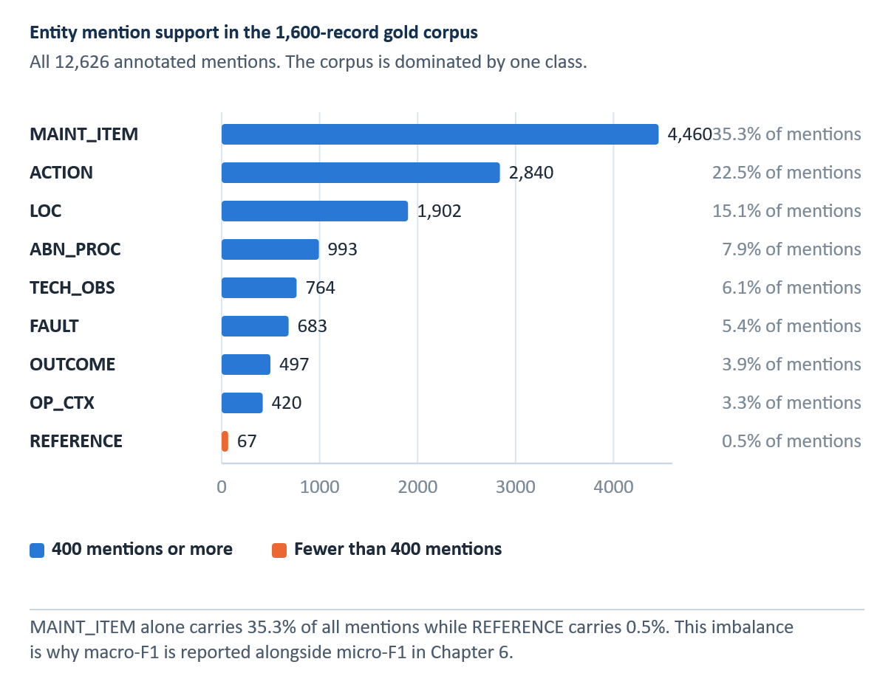
Figure 5.1 Distribution of entity mentions across the nine types in the 1,600-record gold corpus
Counts refer to entity mentions in the complete gold corpus of 1,600 records, not to records containing at least one cue.
Table 5.2 Gold-corpus relation support
Relation | Instances
ACTION_ON_ITEM | 2,852
HAS_LOCATION | 1,912
ISSUE_ON_ITEM | 1,645
HAS_PART | 939
ACTION_INVESTIGATES_ISSUE | 898
ACTION_ADDRESSES_ISSUE | 865
OBSERVATION_OF_ITEM | 667
ACTION_RESULTS_IN_OUTCOME | 533
OCCURS_UNDER_CONTEXT | 391
ACTION_FOLLOWS_REFERENCE | 70
ACTION_USES_ITEM | 62
Note. Instances across all 1,600 gold records, not knowledge-graph support.
Figure B.1 presents the complete support visualization. Relation counts are directed, typed instances.
The complete gold corpus of 1,600 records is strongly imbalanced. MAINT_ITEM contributes 4,460 annotated mentions, whereas REFERENCE contributes 67. ACTION_ON_ITEM has 2,852 annotations, while ACTION_USES_ITEM has 62. These values are whole-corpus support counts rather than test metrics. The frozen 225-record test contains very few REFERENCE and ACTION_FOLLOWS_REFERENCE instances, so an F1 score based on only a handful of cases cannot be treated as stable evidence. Table 5.1 and Figure 5.1 report entity support, while Table 5.2 reports relation support.

Annotation limitations
The main annotation limitation is the absence of an independently double-annotated subset and an inter-annotator agreement estimate. The available materials document corrections, schema constraints, and corpus growth, but they do not measure reviewer consistency. Several distinctions require judgment, especially FAULT versus ABN_PROC, ACTION_ADDRESSES_ISSUE versus ACTION_INVESTIGATES_ISSUE, and TECH_OBS versus OUTCOME. The model's F1 score is conditional on these annotation decisions.

Agreement that should be measured in follow-up work
A future double-annotation study should compare two independently produced annotation sets before adjudication. One suitable span-level measure is the F1-style overlap defined in Equation 5.2.
 | $$F_{1}\left(a,b\right)=\frac{2\left|M\left(a,b\right)\right|}{\left|A\left(a\right)\right|+\left|A\left(b\right)\right|}$$ | (5.2)

A(a) and A(b) are the annotation objects produced by reviewers a and b, and M(a,b) is the set of exact matches under a predefined span, type, and—when applicable—relation-direction rule. This equation is included as a proposed evaluation method, not as a reported result. The current corpus has one correction workflow and therefore provides no measured inter-annotator agreement.
Pre-annotation can also anchor the reviewer. Missing predictions may be less noticeable than incorrect spans, and the model's current ontology may influence relation creation. Domain and source dependence create a further limitation. The schema is designed for short English aviation records and does not yet model negation scope, temporal order, conditionality, applicability, or document-level context. A future corpus release should include blind double annotation, adjudication logs, boundary and relation agreement, and explicit quality sampling of omitted pre-annotations.

Information Extraction Methods and Results

Extraction task
The information-extraction task has two outputs: named-entity recognition and relation extraction. Named-entity recognition identifies exact spans and assigns each one of nine entity types. Relation extraction assigns one of eleven directed relation types to compatible entity pairs. Entity scoring requires both the span boundaries and the entity type to match. Relation scoring additionally requires the correct source entity, target entity, direction, and relation type. Therefore, a relation error can originate either in entity detection or in pair classification.
Micro-F1 aggregates decisions across classes and is influenced most by frequent labels. In contrast, macro-F1 gives every class equal weight and is more sensitive to rare labels. Both metrics are reported because the test distribution is strongly imbalanced, and the rarest entity and relation classes contain only two instances.

CRF and logistic regression
A conditional random field (CRF) performs sequence-level label selection rather than identifying entity names from a dictionary. At each token, it combines observable cues, such as lowercase spelling, capitalization, digits, punctuation, prefixes, suffixes and nearby words, with learned preferences for adjacent BIO tags. The Viterbi algorithm finds the highest-scoring complete tag sequence; it can discourage an I-tag after an incompatible O-tag. The separate logistic classifier then scores permissible ordered entity pairs, including entity types, distance and intervening words. A CRF therefore resolves tag consistency, but it does not repair an entity it never detected [8, 23].
The first architecture combines a conditional random field (CRF) for entity sequences with logistic regression for relation classification. The CRF uses token, orthographic, lexical, contextual, and sequence features, while the relation classifier uses features of candidate entity pairs. This interpretable, low-compute pipeline provides a strong engineered baseline for assessing whether neural models add value on a small labelled corpus.

CRF decoding and relation baseline
For a token sequence of length T, the CRF score adds the learned transition score A from the previous label to the current label and the emission score P supplied for the current token and label, as formalized in Equation 6.1.
 | $$s\left(x,y\right)=\sum_{t=1}^{T}{\left(A_{y_{t-1},y_{t}}+P_{t,y_{t}}\right)}$$ | (6.1)

The highest-scoring label sequence is obtained with dynamic programming. Hand-engineered lexical, orthographic, and contextual features provide the emissions in the feature-based baseline. After entity prediction, logistic regression classifies candidate entity pairs using their types, surface features, distance, order, and intervening context. Because relation classification is downstream of entity detection, a missed entity also removes every relation that depends on it.

BiLSTM CRF and neural relation classifier
The input, forget, and output gates of an LSTM decide what information to store in memory, discard from memory, and report at each token [24]. Two LSTMs read the same sentence in opposite directions, and their states are combined at each token so that the token’s representation can reflect the words before and after it. A CRF still decodes the BIO sequence. Compared with feature-engineered CRFs, the recurrent layers learn contextual features, but their sequential computation and sparse supervision remain relevant limitations [32, 33].
The recurrent architecture combines bidirectional LSTM representations with CRF decoding and employs a neural classifier for entity pairs. The NER model is trained for at most 60 epochs with a patience of 8, while the relation model is trained for at most 40 epochs with a patience of 6. Both models use development-set performance for early stopping.

Bidirectional context
The sequence is read in both directions, and the two hidden states are concatenated, as formalized in Equation 6.2.
 | $$h_{t}=\left[\overset{→}{\text{LSTM}}\left(x_{t},\underset{t-1}{\overset{→}{h}}\right);\overset{←}{\text{LSTM}}\left(x_{t},\underset{t+1}{\overset{←}{h}}\right)\right]$$ | (6.2)

xₜ is the representation of token t. The forward state summarizes preceding context, the backward state summarizes following context, and their concatenation hₜ supports token classification. A CRF then imposes sequence-level label consistency. This architecture can represent local technical patterns without manually specifying every feature, but its sequential computation and limited data efficiency can make it less effective than a pretrained transformer on sparse relation classes.
This architecture tests learned sequential representations without transformer pretraining. The small corpus and severe relation imbalance increase the risk of overfitting, so training curves and recorded seed variation are treated as diagnostics rather than substitutes for the frozen comparison.

Transformer and joint span models
Self-attention lets each token compare itself with other tokens in the same record; a pretrained BERT encoder supplies contextual vectors rather than one fixed vector per word [10, 26]. DistilBERT transfers this behavior through a smaller distilled encoder [34]. The evaluated DistilBERT system remains a pipeline: an incorrect entity boundary can remove a correct downstream pair. SpERT instead scores candidate spans and then ordered span pairs with shared contextual representations, learning entity and relation objectives jointly [11]. A joint encoder improves sharing, but cannot make an unsupported rare relation reliable by itself.
The transformer pipeline uses DistilBERT for contextual entity representations and span-pooled relation classification [34]. The fourth architecture, SpERT, jointly classifies candidate spans and their relations with a BERT-base-cased encoder. The comparison therefore separates a transformer pipeline from a joint span-based formulation rather than treating all transformer models as one tier. Table 6.1 compares the four extraction architectures and their training roles.

Span and relation representations
SpERT forms a candidate span feature from max-pooled contextual token embeddings and a learned span-width embedding. For entity classification, it adds the sentence-level [CLS] embedding. The ordered relation classifier instead uses span features and pooled local context between the two candidates. Equation 6.3 defines the span and entity features.
 | $$\begin{aligned}e\left(s\right)&=\left[\max_{t∈s}{h_{t}};ϕ\left(\left|s\right|\right)\right] \\ g\left(s\right)&=\left[e\left(s\right);h_{\text{CLS}}\right]\end{aligned}$$ | (6.3)

Here e(s) joins the componentwise maximum of the span’s contextual token vectors with the width embedding, and g(s) additionally includes the sentence-level [CLS] vector for entity classification. The model assigns each candidate span an entity type or a non-entity label. Ordered pairs of the retained spans are then classified using the intervening local context, as formalized in Equation 6.4.
 | $${\overset{ˆ}{r}}_{ij}=σ​\left(W_{r}\left[e\left(s_{i}\right);c_{ij};e\left(s_{j}\right)\right]+b_{r}\right)$$ | (6.4)
Wᵣ and bᵣ are learned relation-classification parameters, cᵢⱼ pools the tokens between the two spans, and σ provides a separate sigmoid score for each relation type. Reversing the order of e(sᵢ) and e(sⱼ) changes the input, so directed relations remain distinguishable. Joint training shares the BERT encoder, but a relation still depends on correct span proposals and adequate examples for its type [11]
Table 6.1 Information-extraction model tiers
Architecture | Entity component | Relation component | Role
CRF + LR | Feature-based CRF | Logistic-regression pair classifier | Transparent baseline
BiLSTM | BiLSTM sequence model | Neural pair classifier | Recurrent-neural comparison
DistilBERT | Transformer token/span model | Transformer pair classifier | Pipeline transformer
SpERT | Joint span classifier | Joint relation classifier | Operational joint span-based model
Note. Architectural roles only; no ranking is implied.

Training and evaluation protocol
All four architectures use the same 1,275 training records, 100 development records, and 225-record frozen test set. The test set contains exactly 1,693 gold entity mentions and 1,419 gold relations. This shared population permits direct descriptive comparison, although confidence intervals and class support remain necessary when differences are small or labels are rare.

Micro, macro, and uncertainty measures
In a confusion matrix, decisions are counted according to the true label in the rows and the predicted label in the columns. A cell on the diagonal represents agreement, whereas an off-diagonal cell shows which labels were confused. For class c in a one-versus-rest view, TP is a correctly predicted c, FP is a predicted c that is absent from the reference, FN is a gold c that was missed by the system, and TN is a non-c correctly left as non-c. Precision, recall, and F1 for strict span-level IE are derived from TP, FP, and FN, but TN is not included because the number of possible non-entity spans and non-relations is enormous and depends on candidate generation. For an entity, an incorrect boundary or type counts as both one FP and one FN. For a directed relation, the argument spans, direction, and relation label must all match.
Micro averaging sums TP, FP and FN across types first and then computes F1; frequent labels consequently exert more influence. Macro averaging computes one F1 for each evaluated type and takes their unweighted mean. Both must name the same class set and the same exact-match policy. For instance, a model can gain on rare relations and improve macro-F1 while losing a few frequent relation instances and reducing micro-F1. Per-class support—the number of gold examples for a type—must accompany either interpretation.
Precision, recall, and F1 are computed from exact true positives, false positives, and false negatives, as formalized in Equation 6.5.
 | $$\begin{aligned}P&=\frac{\text{TP}}{\text{TP}+\text{FP}}, R=\frac{\text{TP}}{\text{TP}+\text{FN}} \\ F_{1}&=\frac{2PR}{P+R}\end{aligned}$$ | (6.5)

Precision answers how many predicted objects were correct; recall answers how many gold objects were recovered; F1 is their harmonic mean. For entities, correctness requires both the span and type. For relations, it additionally requires the correct directed argument pair and relation type.
Micro-F1 pools the counts across all classes before computing the score, as formalized in Equation 6.6.
 | $$F_{1,\text{micro}}=\frac{2\sum_{c∈C}{{\text{TP}}_{c}}}{2\sum_{c∈C}{{\text{TP}}_{c}}+\sum_{c∈C}{{\text{FP}}_{c}}+\sum_{c∈C}{{\text{FN}}_{c}}}$$ | (6.6)

Because frequent classes contribute more TP, FP, and FN counts, micro-F1 summarizes overall instance-weighted performance. Macro-F1 instead averages class-level F1 scores, as formalized in Equation 6.7.
 | $$F_{1,\text{macro}}=\frac{1}{\left|C\right|}\sum_{c∈C}{\frac{2{\text{TP}}_{c}}{2{\text{TP}}_{c}+{\text{FP}}_{c}+{\text{FN}}_{c}}}$$ | (6.7)

C is the evaluated class set. Each class contributes equally to macro-F1, so rare-class failure is visible rather than absorbed by dominant labels. This distinction explains why Selective ByT5 could improve downstream relation macro-F1 while raw text retained the best relation micro-F1.
Bootstrap intervals quantify sampling variability by repeatedly resampling evaluation units and recomputing a statistic theta-hat-star [37], as formalized in Equation 6.8.
 | $${\text{CI}}_{1-α}=\left[Q_{α/2}\left({\overset{ˆ}{θ}}^{*}\right), Q_{1-α/2}\left({\overset{ˆ}{θ}}^{*}\right)\right]$$ | (6.8)

Q denotes an empirical quantile of the bootstrap distribution and alpha is the tail probability. The interval describes uncertainty under resampling of the observed evaluation population; it does not incorporate annotation disagreement, distribution shift, or model-training randomness unless those sources are explicitly resampled.
Confidence intervals were estimated using 1,000 nonparametric bootstrap resamples of the test predictions [37]. They quantify sampling uncertainty conditional on the supplied models and records. They do not account for annotation uncertainty, domain shift, or the full effect of training randomness. Because the canonical artifact does not provide a complete paired significance matrix for all four architectures, the final ranking is reported descriptively.

Overall performance
Table 6.2 Overall frozen-test information-extraction results
Model | Entity micro-F1 | Entity macro-F1 | Relation micro-F1 | Relation macro-F1
CRF + LR | 0.9402 | 0.8822 | 0.8036 | 0.7409
BiLSTM | 0.9385 | 0.8935 | 0.6323 | 0.6165
DistilBERT | 0.9449 | 0.8874 | 0.8296 | 0.6739
SpERT | 0.9520 | 0.9063 | 0.8537 | 0.7898
Note. Frozen 225-record test; descriptive point estimates, not significance tests.
The frozen random test comprises 225 records, including 1,693 gold entities and 1,419 gold relations. Strict typed scoring is used, and all four models are evaluated on the same population.
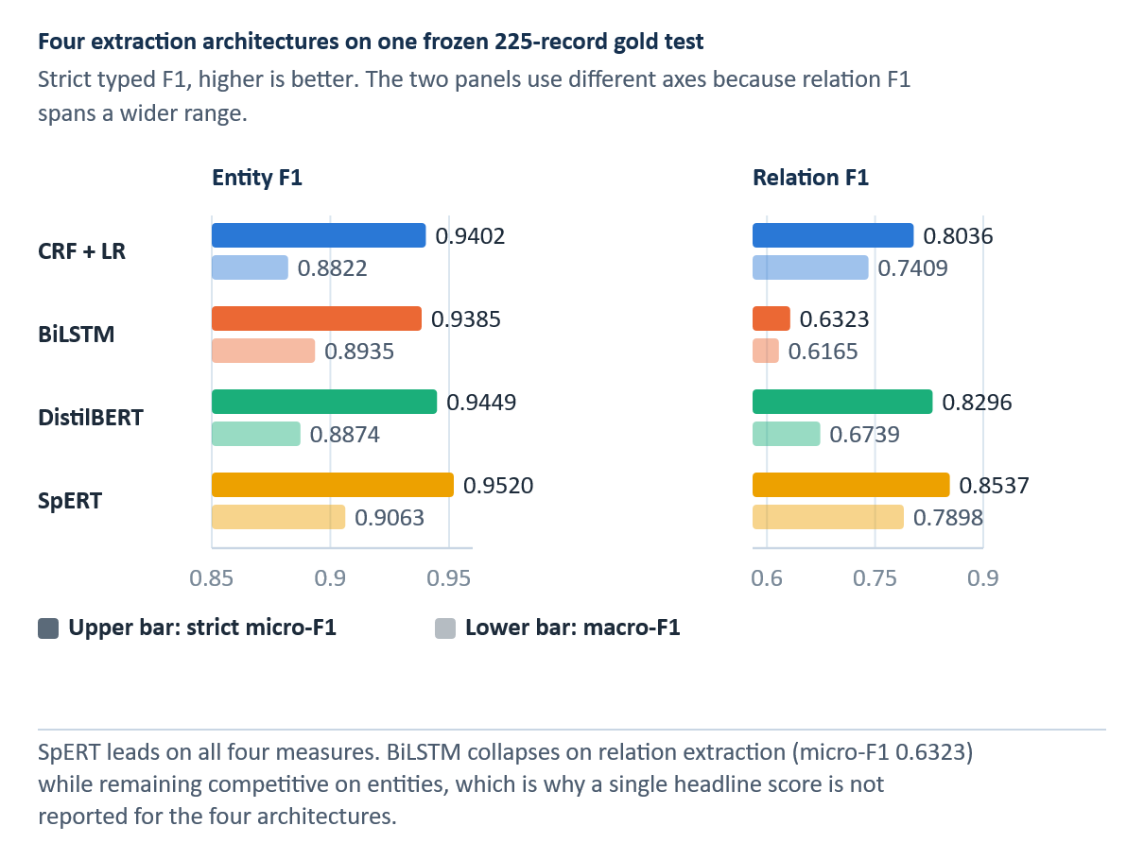
Figure 6.1 Entity and relation F1 of four extraction architectures on the frozen 225-record test
SpERT has the highest point estimates, although its small differences and rare-class scores require interpretation that accounts for uncertainty and support.
Entity micro-F1 exceeded 0.93 for every architecture. SpERT had the highest point estimate at 0.9520, followed by DistilBERT at 0.9449, CRF with logistic regression at 0.9402, and BiLSTM at 0.9385. Entity macro-F1 ranged from 0.8822 to 0.9063, indicating a narrower ranking that remains sensitive to rare classes. Table 6.2 and Figure 6.1 compare overall entity and relation performance on the common frozen test.
Relation extraction produced a clearer separation between the methods. SpERT achieved the highest micro-F1 score at 0.8537, followed by DistilBERT at 0.8296, CRF with logistic regression at 0.8036, and BiLSTM at 0.6323. The joint span-based model therefore performed best in this frozen comparison, although its test performance cannot be transferred directly to every prediction in the operational silver graph.

Per-class performance
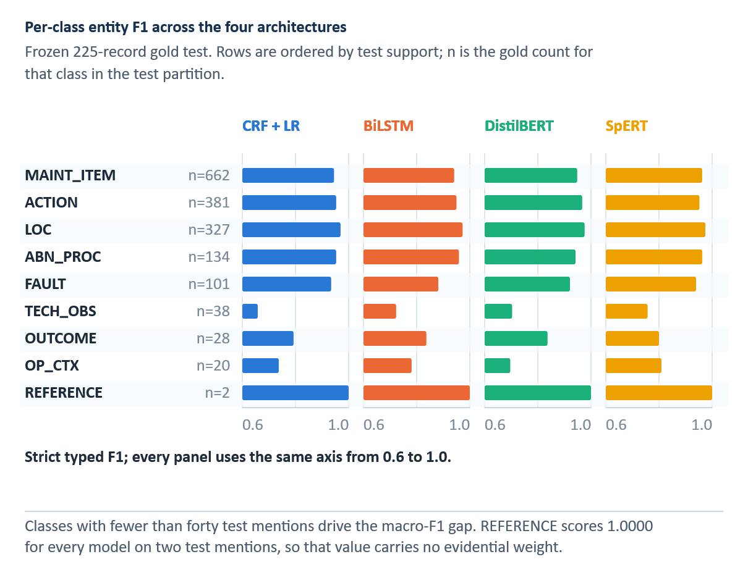
Figure 6.2 Per-class entity F1 of the four architectures against gold test support
Per-class support is uneven; REFERENCE has only two test instances, so perfect F1 is not a stability result.
TECH_OBS and OP_CTX varied across architectures, while F1 scores for frequent entity types remained high. SpERT achieved an F1 score of 0.7568 for TECH_OBS and 0.8095 for OP_CTX. Each model achieved an F1 score of 1.0000 on REFERENCE. Since the test set contained only two such instances, this perfect value is not informative about stability. Figure 6.2 depicts the entity-class pattern, and Figure 6.3 illustrates relation-class instability for rare labels.
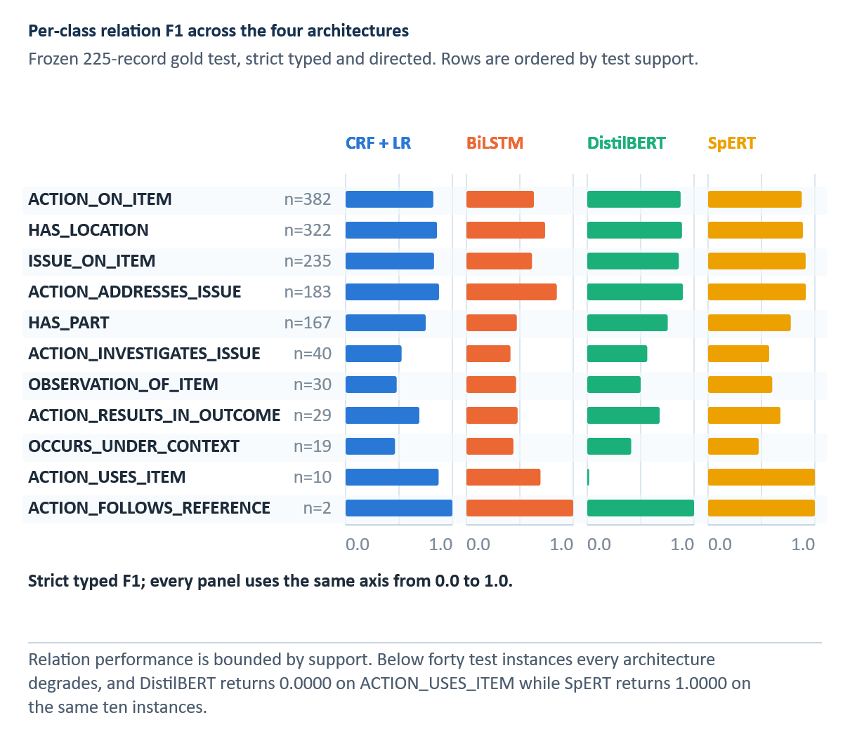
Figure 6.3 Per-class relation F1 of the four architectures against gold test support
The relation task compounds span and pair-classification errors. Detailed F1 values for all four models are reported in Table B.2.
SpERT led on several frequent relations, including ACTION_ADDRESSES_ISSUE (0.9146), ISSUE_ON_ITEM (0.9130), and HAS_LOCATION (0.8872). Scores for rare relations often varied greatly. However, DistilBERT scored 0 on ACTION_USES_ITEM, whereas SpERT scored 1.0000, and every model scored 1.0000 on ACTION_FOLLOWS_REFERENCE, which had only two test instances. These cases clarify why per-class F1 must be studied alongside support.
The class-level pattern generally favoured SpERT, but the feature-based baseline remained competitive on frequent, lexically regular relations. BiLSTM was consistently weaker at relation extraction. Macro-F1 summarizes these differences, but it can change materially when a few rare classes shift, so it should be interpreted alongside per-class support.

Internal and external comparison
For orientation, the frozen internal entity and relation system’s micro-F1 scores were 0.9402 and 0.8036 for CRF with logistic regression, 0.9385 and 0.6323 for BiLSTM-CRF with a neural relation classifier, 0.9449 and 0.8296 for the DistilBERT pipeline, and 0.9520 and 0.8537 for SpERT. These results were measured on the common internal 225-record test set and are not estimates of quality for every silver production prediction.
The point estimates in Table 6.2 provide descriptive summaries of the common frozen test. They should not be interpreted as pairwise significance results.
Table 6.3 External MaintIE benchmark results
Model | MaintIE entity micro-F1 | MaintIE entity macro-F1 | MaintIE relation micro-F1 | MaintIE relation macro-F1
CRF + LR | 0.7629 | 0.8312 | 0.5101 | 0.5206
BiLSTM | 0.7007 | 0.6114 | 0.2767 | 0.2102
DistilBERT | 0.8288 | 0.8822 | 0.5847 | 0.2808
SpERT | 0.8828 | 0.9045 | 0.6817 | 0.7024
Note. Separately trained MaintIE models on its own split and schema; not zero-shot transfer.
MaintIE uses a separate 860/108/108 training-development-test split with five entity types and six relation types. Each architecture is trained on this benchmark, and the comparison constitutes an external replication rather than zero-shot transfer.
SpERT had the highest entity and relation micro-F1 in the internal corpus and in MaintIE. DistilBERT ranked second, the CRF-based system third, and BiLSTM fourth on relation micro-F1 in both settings. This repeated ordering supports the architectural comparison, while different schemas, corpora, and training runs prevent direct equality claims across benchmarks. Table 6.2 reports the internal frozen-test result, and Table 6.3 reports the separately trained MaintIE comparison.
The benchmark freeze also isolates the extraction formulation itself. Holding the encoder fixed and replacing BIO tagging with span-based extraction raises entity micro-F1 for both neural architectures and increases recall on the thirty-nine nested gold entities far more sharply. Under BIO tagging, an entity nested inside another cannot be represented at all, which caps entity recall at a theoretical 0.9424 and relation recall at 0.9145 on this benchmark; SpERT reaches 0.9222 and 0.7735, respectively. Table 6.4 reports the ablation and explains why the span-based model leads the comparison rather than simply achieving a higher score.
Table 6.4 Span-based against BIO entity extraction on the MaintIE benchmark
Extraction formulation | Entity micro-F1 | Nested entity recall
BiLSTM, BIO tagging | 0.7007 | 0.4615
BiLSTM, span-based | 0.7435 | 0.6923
Transformer, BIO tagging | 0.8288 | 0.4103
Transformer, span-based | 0.8556 | 0.8462
Note. MaintIE test partition; nested recall is measured on the thirty-nine nested gold entities.
Previous pipeline-specific artifacts include memorization, OOV, context, seed, and train-test diagnostics. They are retained as development history but are not combined numerically with the canonical four-model results because the reporting pipelines and final model snapshots differ.

Learning-curve analysis
Historical annotation-acquisition diagnostic. Its endpoints are not the canonical four-model scores in Table 6.2.
The acquisition-stage learning curves show that adding labelled records did not yield monotonic improvements at every stage. They describe the annotation and model-development process rather than the final RQ3 ranking, which is based on the common four-model test in Table 6.2. The archived diagnostics do not provide a comparable multi-stage trajectory for all four final models, so no learning-curve claim is made.
These neural curves also reveal that the entity and relation components were learned at different rates, with the relation results varying more. They are diagnostic tools that support fixed-test monitoring and class-aware acquisition rather than replacing the canonical final scores.

Operational SpERT layer
SpERT serves two roles. First, it is one of the four architectures evaluated on the 225-record gold test. Second, its operational configuration produces predictions for all 6,169 records. The first role provides comparative evidence, while the second creates a silver corpus whose individual predictions remain unverified.
On the internal test, SpERT achieved an entity micro-F1 score of 0.9520 and a relation micro-F1 score of 0.8537. The representation-matched experiment then trained and evaluated SpERT using five input representations. These artifacts close the earlier comparative-scoring gap but do not convert the operational graph into gold data.

IE findings
Three findings answer RQ3. All four architectures performed strongly on entity extraction, with SpERT producing the highest point estimate. Relation extraction separated the models more clearly: SpERT and DistilBERT led, while the BiLSTM relation classifier was substantially weaker. The same broad ordering appeared in MaintIE, although rare labels and benchmark-specific training limit the generalizability of these results.
The matched normalization experiment adds a cross-stage result. Although Selective ByT5 increased relation macro-F1 by 0.0270, no normalized representation improved SpERT entity or relation micro-F1 over raw text. This result confirms that reference-level normalization gains cannot be assumed to improve downstream extraction.

Silver Knowledge Graph and Historical Case Library

From extraction output to cases
The operational version of the SpERT model is applied to all 6,169 normalized records. Each prediction preserves the source identifier, original or display text, tokens, entity spans, entity types, relation endpoints, and confidence values. The conversion code validates that relation endpoints exist, that types belong to the nine-entity inventory, and that source-target signatures are compatible with the eleven-relation schema. Invalid or unknown structures can be retained for audit but are excluded from structured scoring.
The transformation generates two associated views. The knowledge graph aggregates normalized entity strings as nodes and typed, directed relations as edges. The case library retains record boundaries and keeps the complete problem and action sides together. The graph supports dashboard inspection and an exploratory structured channel, neither of which enters the locked canonical-BM25 ranking. The case is the unit of provenance and recommendation rendering. A graph edge can summarize repeated observations, but a displayed action always points back to one source case.

Knowledge-graph construction
Entity surface strings are normalized within type before aggregation. The final exported graph contains 3,197 typed nodes and 9,331 aggregated edges derived from 45,771 predicted entity mentions and 41,469 relation record-support instances. These counts describe the final silver artifact and are not interchangeable with raw extraction-mention totals; the 43,149 relation mentions the model emitted before graph aggregation reduce to 41,469 record-support associations. Table 7.1 reports the final silver graph counts and their evidence status. Figure 7.1 shows one complete work order as a case and as a silver subgraph.
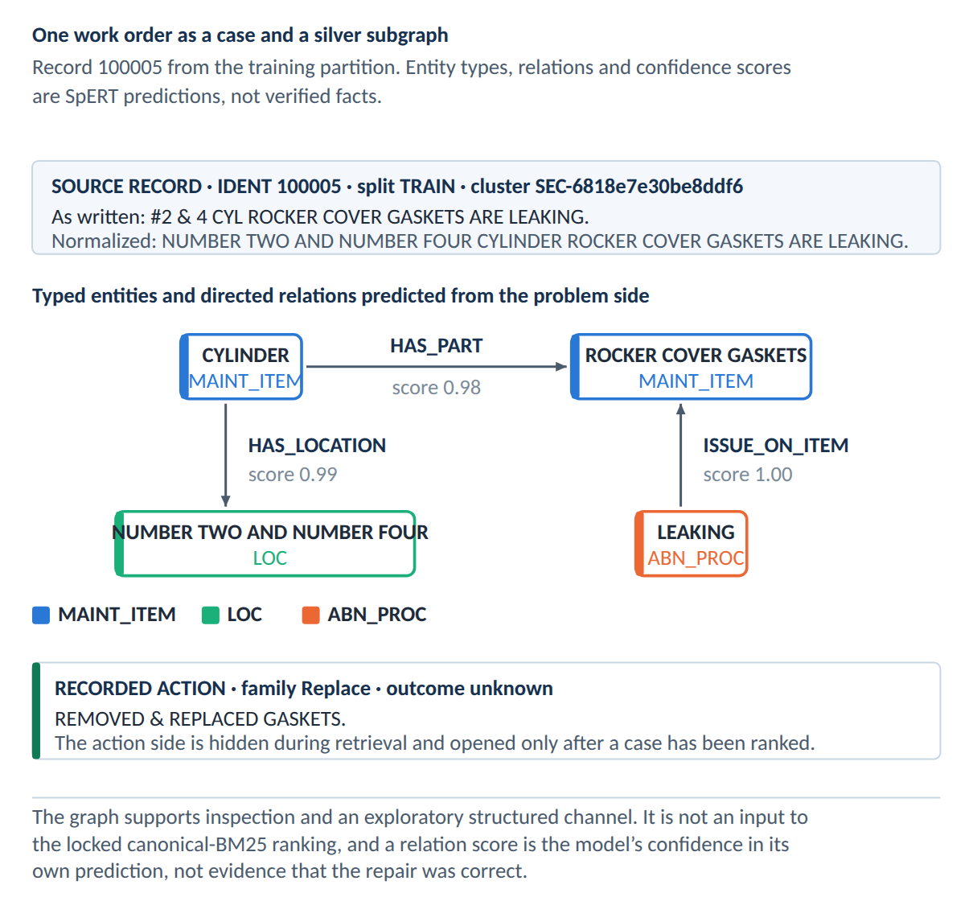
Figure 7.1 One work order represented as a case and as a silver subgraph of typed entities and directed relations
The graph is not an ontology of approved maintenance knowledge; it records what the model extracted from historical text. High-frequency nodes, such as engine, cylinder, intake gasket, gasket, and rocker-cover gasket, reflect the source corpus and extraction behaviour. Edge frequency represents recorded and extracted co-occurrence or binding, not causal strength, failure probability, or procedure effectiveness.

Typed, weighted, provenance-bearing graph
The operational knowledge graph is represented as specified in Equation 7.1.
 | $$G=\left(V,E,τ_{V},τ_{E},w,π\right)$$ | (7.1)

V is the node set, E the directed edge set, ℓV and ℓE the node- and edge-type functions, w an evidence-support weight, and pi a provenance mapping back to source records. The graph is silver because V and E are derived from model predictions over the full corpus. Type constraints can reject structurally invalid edges, but they cannot guarantee that an accepted prediction is semantically correct.
Repeated occurrences of the same typed triple are aggregated with record support (Equation 7.2):
 | $$w\left(u,r,v\right)=\sum_{d∈D}{1}\left\{\left(u,r,v\right)∈E\left(d\right)\right\}$$ | (7.2)

D is the record collection and E(d) is the edge set predicted for record d. The weight counts distinct supporting records, not causal confirmations or successful repairs. This distinction resolves the two valid corpus totals: 43,149 extraction relation mentions are model outputs before aggregation, whereas 41,469 is the relation record-support count stored by the graph construction.
Table 7.1 Silver knowledge-graph statistics
Quantity | Count | What was counted
Source records | 6,169 | Original problem–action cases used for silver extraction.
Entity mentions | 45,771 | Model-predicted mentions before node aggregation.
Extraction relation mentions | 43,149 | Model outputs before graph aggregation.
Typed nodes | 3,197 | Distinct typed node identities in the operational graph.
Aggregated edges | 9,331 | Distinct typed graph edges.
Relation record-support | 41,469 | Supporting record–relation associations after graph construction.
Invalid entities / relations | 0 / 0 | Skipped by the frozen graph exporter.
Note. Silver model output, not expert-verified graph facts.
Counts are reproduced from the final operational KG summary. Relation record support is distinct from the total number of raw extraction relation mentions.

Case representation
A case stores the source problem and solution text, extracted problem entities and relations, extracted action entities and relations, derived problem-graph features, action sequence, action family, outcome category, provenance, and evidence-cluster identity. The representation separates observed fields, model predictions, and deterministic derived fields. It also indicates why a candidate matched and which parts of the displayed action came from the source.

Case object and evidential completeness
The historical case associated with record i is represented as specified in Equation 7.3:
 | $$c_{i}=\left(p_{i},a_{i},z_{i},G_{i},o_{i},π_{i}\right)$$ | (7.3)
pᵢ is the original problem text, aᵢ the complete recorded action, zᵢ the structured entity–relation representation, Gᵢ the record-local graph, oᵢ the extracted or derived outcome status, and piᵢ the provenance metadata. Keeping the original problem and action intact prevents the interface from composing a new procedure out of fragments from unrelated records.
The case object stores both raw text and inferred structure because the text serves as the primary audit evidence. The structure supports retrieval and filtering. When a structured field is absent, the record is neither silently discarded nor completed through generation. Instead, lexical retrieval can still operate, while the missing structure remains visible as uncertainty.
When an explicit schema relation is available, action information is extracted directly from it. When no such relation is available, a conservative verb-based fallback is used instead. The extraction route is recorded for each case, allowing reviewers to distinguish schema-supported evidence from fallback evidence. Legacy case-summary percentages are not used as final performance claims.

Provenance, duplicates, and outcome policy
Near-duplicate records can make a frequent action appear to have independent support when it may be a repeated transcription or template. The case library therefore assigns evidence clusters. Retrieval may return record-level candidates, but aggregation and support counts operate over distinct clusters. A repeated record can strengthen evidence that a pattern is common in the source data, yet it does not create multiple independent demonstrations of effectiveness.
Outcome handling is deliberately asymmetric. If the outcome of an action is explicitly negative, indicates no effect, is deferred, or remains unresolved, the action cannot become a positive suggestion. Nevertheless, it may be displayed as relevant historical evidence, because an unsuccessful attempt may help a planner avoid repetition. An explicitly positive outcome can support a case, but it does not certify causality or current applicability. No outcome means unknown, not success.
The renderer preserves fidelity to the complete source. It may convert a past-tense action phrase into a concise imperative, but it does not add a verification step that was absent, merge an enabling step from one record with a corrective step from another, or replace a specific target with a broader component. When several records support similar action families, the system can present a pattern summary while retaining each exact sequence as separate evidence.

Silver-layer statistics
The offline extraction stage processed 6,169 paired source records and produced 45,771 entity mentions and 43,149 extraction relation mentions. The resulting graph contains 3,197 typed nodes and 9,331 aggregated edges. Its 41,469 relation record-support count uses a different unit from the 43,149 extraction relation mentions: the former records support after graph construction rather than a corrected extraction count. All graph objects are silver evidence, not expert-verified facts.
The node inventory consists of 1,398 MAINT_ITEM, 455 ACTION, 359 TECH_OBS, 259 LOC, 235 ABN_PROC, 202 OP_CTX, 127 FAULT, 122 OUTCOME, and 40 REFERENCE nodes. Distinct nodes and mention support are different quantities: recurring surface evidence can contribute many mentions but one normalized typed node.
The largest record-support groups are ACTION_ON_ITEM (11,495), HAS_LOCATION (9,524), ISSUE_ON_ITEM (6,539), ACTION_ADDRESSES_ISSUE (5,409), and HAS_PART (5,074). Smaller groups include ACTION_INVESTIGATES_ISSUE (1,229), OBSERVATION_OF_ITEM (768), ACTION_RESULTS_IN_OUTCOME (616), OCCURS_UNDER_CONTEXT (459), ACTION_USES_ITEM (244), and ACTION_FOLLOWS_REFERENCE (112).
Corrective, investigative, and outcome signals can overlap within one record. Derived action families and roles are retrieval conveniences rather than original annotations, and their frequencies must not be interpreted as independent repairs, success rates, or observed ground truth.

Limitations of the silver layer
Every downstream structured match inherits extraction error. The scored SpERT result reduces uncertainty about the architecture on the frozen gold test, but it does not make the 6,169-record graph gold. Confidence weighting, original-text display, provenance, and reviewer correction mitigate errors without validating the graph record by record.
Entity-string normalization can merge distinct concepts or split variants that should be treated as identical. The graph lacks fleet configuration, part-number applicability, manual revision, temporal validity, and organization-specific approval status. It should therefore be treated as a navigation index into historical text. A production knowledge base would require expert validation, controlled vocabularies, temporal provenance, change management, and links to authoritative maintenance data.

Evidence-Grounded Recommender and Planning Dashboard

Decision-support contract
The recommender retrieves cases historically associated with a new problem, explains the match, preserves the source evidence, and withholds promoted actions when the evidence criterion is not met. It does not identify an approved procedure or certify that a historical action applies to the new asset. Any displayed action is a deterministic rendering of one complete source record.
The query contains only the new problem and optional planner-entered context; its recorded solution is hidden. The final protocol uses canonical BM25 for problem-text ranking, followed by cluster-expanded evidence aggregation and an action-family support vote tempered by the fixed exponent τ_rank = 0.15. Candidate actions remain attached to their source cases and are presented as historical evidence rather than instructions.

Query structuring
The figures should be interpreted in relation to the online-offline boundary. Entity and relation recognition with SpERT is part of the offline construction of the historical silver case library. When a new query reaches the deployed system, it follows the fixed lexical ranking pathway. Any figure presented here must be captured from the current deployed version and must not reflect an obsolete live-extraction service.
In the current deployed dashboard, a newly entered problem is processed by the lightweight query and retrieval path; it does not call SpERT for live entity or relation extraction. SpERT is used offline to build the silver historical corpus and graph. The reviewer may enter or amend context in the interface, but the frozen RQ4 ranking uses the problem text and canonical BM25 rather than live query-side SpERT predictions. The historical structure retains its provenance and remains inspectable.
The locked evaluation uses the Selective ByT5-normalized problem text as the canonical lexical query. The original problem text remains linked to each case for provenance. Optional structured fields can help the reviewer inspect or filter evidence in the wider prototype, but they do not contribute to the frozen BM25 RQ4 score. Figure 8.1 is a schematic of the fields that enter and are withheld from a query, and Figure 8.2 separates the offline historical structure from the two online query paths. Neither is a capture of the deployed interface. The silver graph is not an input to the locked canonical-BM25 rank score.
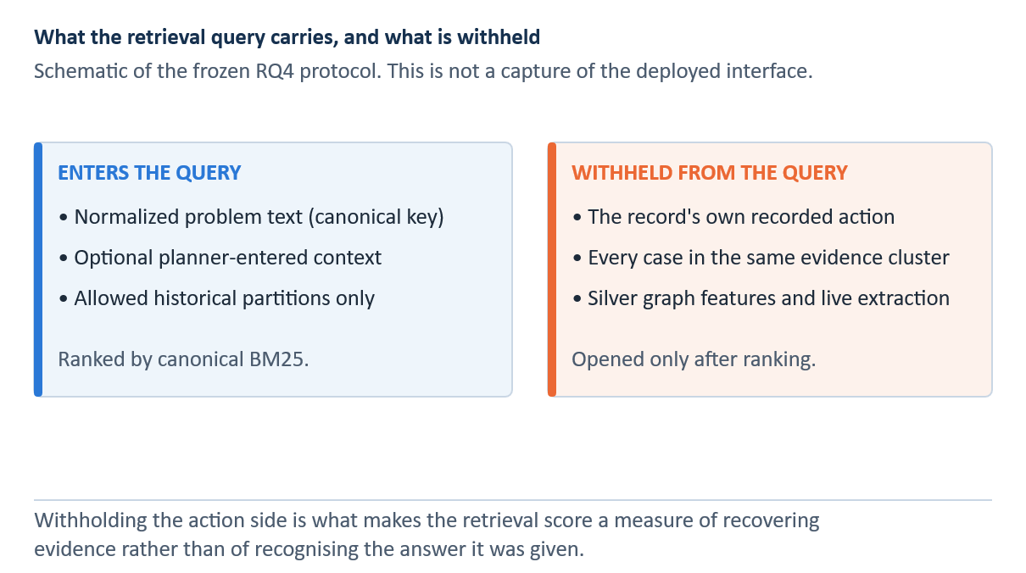
Figure 8.1 Fields that enter a retrieval query and fields withheld from it under the frozen protocol
The schematics describe the non-generative evidence workflow. Displayed actions are historical records, not approved instructions.
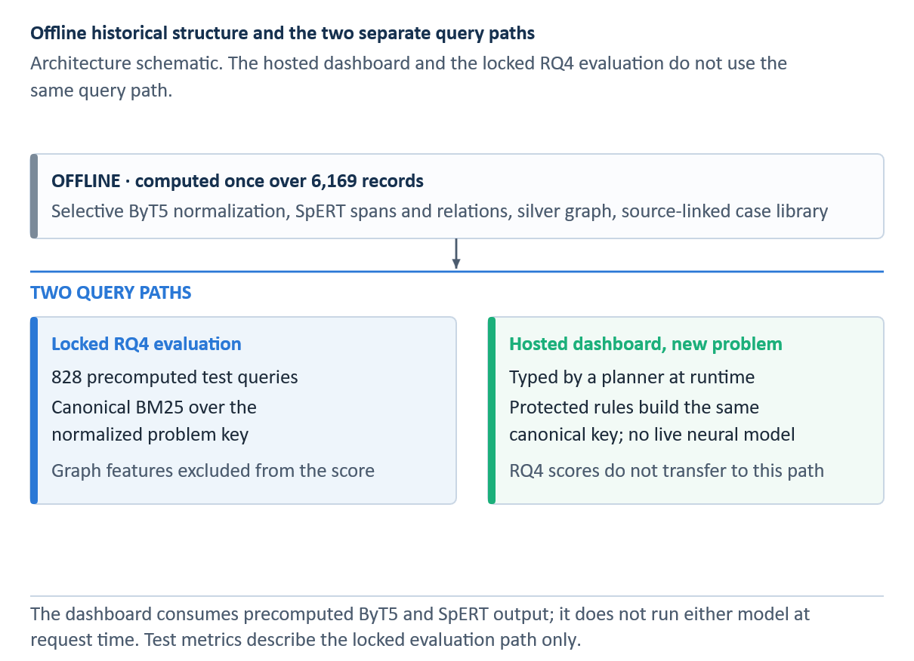
Figure 8.2 Offline historical extraction and the two separate online query paths

Candidate retrieval
The research platform implements BM25, word- and character-level TF-IDF, dense similarity, and structured matching. These channels support experimentation, but the final RQ4 result uses canonical BM25 rather than a compound union of multiple retrieval channels. This separation prevents the breadth of the implementation from being mistaken for evidence that every channel improved performance on the locked test. The graph remains available for exploring and filtering the historical case library, but it does not contribute to the selected RQ4 ranking or its test metrics.

Sparse and dense similarity
The canonical final retriever uses BM25. For query q and candidate document d, the score is defined by Equation 8.1:
 | $$\text{BM25}\left(q,d\right)=\sum_{t∈q}{\text{IDF}}\left(t\right)\frac{f\left(t,d\right)\left(k_{1}+1\right)}{f\left(t,d\right)+k_{1}\left(1-b+b\left|d\right|/\overline{\left|d\right|}\right)}$$ | (8.1)

f(t,d) is the frequency of term t in d, IDF(t) downweights common terms, |d| is candidate length, avgdl is average candidate length, k₁ controls term-frequency saturation, and b controls length normalization [9]. Exact component names, abbreviations, and rare tokens therefore receive strong evidence, while repeated terms yield diminishing returns.
A dense experimental channel represents a query and a candidate as vectors and compares their directions using cosine similarity, as formalized in Equation 8.2.
 | $$\text{cos}\left(q,d\right)=\frac{v_{q}⋅v_{d}}{\left\|v_{q}\right\| \left\|v_{d}\right\|}$$ | (8.2)

The numerator is the dot product and the denominator normalizes both vector lengths. Cosine similarity can connect paraphrases with little word overlap, but it may also blur technically decisive lexical differences. Dense scores were investigated during development; they are not the basis of the final locked RQ4 claim.
The final protocol searches only permitted historical partitions, excludes the query’s evidence cluster, and expands cluster members after lexical ranking. These controls prevent near-duplicate leakage while preserving access to record-level evidence within a retrieved cluster. Table 8.1 distinguishes the final canonical retrieval path from the additional experimental channels.

Rank fusion and reranking
Reciprocal-rank fusion combines ranked lists using rank positions rather than incompatible raw scores [42], as formalized in Equation 8.3.
 | $$\text{RRF}\left(d\right)=\sum_{m∈M}{\frac{1}{k+r_{m}\left(d\right)}}$$ | (8.3)

M is the set of retrieval channels, rₘ(d) is the rank of candidate d in channel m, and k is a stabilizing constant. A candidate ranked highly by several channels receives a larger fused score. The final locked protocol nevertheless selected canonical BM25, so RRF, dense retrieval, graph matching, and cross-encoder reranking are described as development components rather than credited with the reported final result.
Table 8.1 Retrieval and ranking stages
Step | Input / action | Scope and safeguard
1. Query | Problem text only | Hide the query's recorded action.
2. Candidate ranking | Canonical BM25 over allowed historical cases | Selected frozen RQ4 ranker; dense and graph channels are developmental.
3. Split guard | Exclude shared evidence cluster | Prevent duplicate-related train/test leakage.
4. Aggregation | Cluster-expanded evidence | Preserve distinct cluster support and complete source cases.
5. Family vote | Divide support by training prior to exponent τ_rank = 0.15 | Ranking tempering, not a score cutoff or a display gate.
6. Evidence display | Source case, alternatives, outcome, provenance | Do not promote negative/unknown outcome as positive evidence.
7. Planning | Human-selected case and user-entered fields | Qualified reviewer checks current approved maintenance data.
Note. The silver graph does not enter the locked BM25 ranking.

Evidence clustering and aggregation
Canonical BM25 ranks cases using only the problem text. The hidden query action is not included in either the retrieval or evaluation input. Earlier experiments with cross-encoders and multi-channel approaches document model development, but they do not determine the final RQ4 result.
The manual assessment separates problem relevance from evidence of usable actions. Therefore, a similar historical problem is not automatically treated as evidence that its recorded action is usable. The assessment covers 100 queries and 500 query-candidate pairs, all judged by a single reviewer. No inter-rater reliability estimate is available.
After lexical ranking, the evidence is aggregated across distinct clusters and grouped by derived strategy, target, and issue. Exact action sequences remain separate. When the retrieved evidence supports multiple diagnostic, corrective, inspection, replacement, or service patterns, the interface can display them, while the planner retains responsibility for selection.

Outcome-aware filtering and selective abstention
Candidates undergo provenance and outcome checks before display. Actions explicitly identified as having no effect, failed, deferred, or unresolved are excluded from positive suggestions and retained in a separate evidence ledger. Missing outcomes remain unknown. Record frequency is not converted into a success rate because repeated documentation is neither independent evidence nor a controlled outcome study.
After canonical-BM25 retrieval, the fixed exponent τ_rank = 0.15 tempers each action-family vote by its training-set prior. Distinct supporting evidence clusters are divided by that prior raised to τ_rank. This is a ranking adjustment, not a cutoff. The dashboard presents a positive historical option only when an eligible, source-linked pattern exists; otherwise, it shows an abstention state and leaves records available for review. The deployed dashboard orders displayed action patterns primarily by distinct-cluster support and location consistency, using adjusted support only later in its tie-breaking order. The order of presentation should not be confused with the frozen research ranking. Neither the ranking nor the order of display indicates the probability of a safe or successful repair.

Promotion rule and negative outcomes
In Equation 8.4, the post-retrieval family vote tempers support for a distinct cluster by the training prior. The display of a positive suggestion is a separate decision concerning outcome eligibility. Negative or mixed histories cannot produce positive suggestions, and the interface abstains if no eligible pattern remains. Neither operation compares a retrieval score with 0.15.
 | $$\begin{aligned}v_{f}\left(q\right)&=\frac{n_{f}\left(q\right)}{π_{f}^{τ_{\text{rank}}}} \\ P_{f}\left(q\right)&=1\left\{∃h∈H_{f}\left(q\right):E\left(h\right)=1\right\}\end{aligned}$$ | (8.4)

Let n_f(q) count distinct retrieved evidence clusters supporting action family f, π_f its smoothed training prior, H_f(q) the historical patterns for that family, and E(h) the binary positive-outcome eligibility of a historical pattern. The first line ranks families using the fixed exponent τ_rank = 0.15; it does not reject candidates with a retrieval score below 0.15. The second line sets P_f(q) to one only when at least one eligible pattern exists. This is a separate display-eligibility check: explicitly negative, mixed, unresolved, or unknown outcomes are not promoted as positive patterns. If no eligible pattern remains, the interface abstains while retaining source records for inspection.
With τ_rank = 0 the prior-tempering factor is one and the family vote is based on unadjusted distinct-cluster support; this comparator reached Hit@1 0.7959. The validation-selected τ_rank = 0.15 setting reached 0.7899, a difference of −0.0060 on the locked test. Development selection balanced near-baseline Hit@1 and Hit@3 with macro-family recall; it did not optimize the opened test or define an abstention threshold. The paired comparison did not resolve the Hit@1 difference.

Planning workspace
The dashboard stores the selected evidence case and planner-entered fields, including priority, asset, target dates, parts, tools, personnel, duration, cost, applicability, references, notes, and workflow status. The readiness view identifies incomplete fields. These functions support coordination and auditing; they do not change the models or authorize maintenance.
Historical insights pages separately summarize record and cluster frequencies, entity and relation completeness, and source cases. Record counts and cluster counts are displayed as distinct quantities. Percentages use explicit denominators, so changing the context filter changes the population rather than presenting a global rate as local evidence.

Evaluation design
A Wilson interval can summarize uncertainty for a single observed hit proportion without relying on the most naive symmetric normal approximation [54]. Hit@1 intervals are percentile bootstrap intervals, and the paired difference uses the basic bootstrap, both with 2,000 repetitions and seed 20260907. The Wilson interval is reported alongside the Hit@1 bootstrap because the two methods fall on opposite sides of the majority baseline. An interval for one model does not by itself constitute a paired test of superiority over another model.
The final evaluation uses a cluster-safe split of 4,319 training, 925 development, and 925 test records. The 6,169 records form 3,363 exact-match evidence clusters and 1,820 near-duplicate leakage groups at a character 3-to-5-gram cosine threshold of 0.87. Whole leakage groups are assigned to a single partition, and the two groups larger than five percent of the corpus, containing 1,176 and 908 records, were placed in training before allocation. No leakage group and no evidence cluster spans two partitions. After excluding queries without evaluable evidence, the locked test contains 828 queries. The preselected configuration is canonical BM25 with cluster-expanded aggregation and a prior-tempering exponent of τ_rank = 0.15 for the family vote, while the query action remains hidden throughout retrieval.

Ranked-retrieval measures
Hit@k records whether at least one relevant historical evidence item appears within the first k results, as formalized in Equation 8.5.
 | $$\text{Hit@}k=\frac{1}{N}\sum_{i=1}^{N}{1}\left\{r_{i}≤k\right\}$$ | (8.5)

N is the number of evaluable queries and rank is the position of the first relevant result for query i. Hit@1 measures immediate recovery, while Hit@5 measures whether the reviewer can find evidence after examining a short list. It does not reward placing a relevant result first rather than fifth.
Mean reciprocal rank supplies that rank sensitivity, as formalized in Equation 8.6.
 | $$\text{MRR}=\frac{1}{N}\sum_{i=1}^{N}{\frac{1}{r_{i}}}$$ | (8.6)

The reciprocal is one for a first-ranked relevant result, one half for rank two, and so forth. MRR therefore emphasizes the first relevant item but assumes a single first-relevance position rather than graded evidence quality.
Normalized discounted cumulative gain (nDCG) evaluates graded relevance, as formalized in Equation 8.7.
 | $$\begin{aligned}\text{DCG@}k&=\sum_{j=1}^{k}{\frac{2^{{\text{rel}}_{j}}-1}{\log_{2}\left(j+1\right)}} \\ \text{nDCG@}k&=\frac{\text{DCG@}k}{\text{IDCG@}k}\end{aligned}$$ | (8.7)

relⱼ is the relevance grade at rank j and IDCG@k is the score of the ideal ordering for the same query. Logarithmic discount gives more credit to evidence placed near the top. nDCG@5 of 0.9067 therefore indicates an ordering close to the ideal historical-evidence ranking under the evaluation labels, not a 90.67% probability of correct maintenance.
Macro action-family recall assigns equal weight to each action family, as formalized in Equation 8.8.
 | $$R_{\text{family,macro}}=\frac{1}{\left|F\right|}\sum_{f∈F}{\frac{H\left(f\right)}{N\left(f\right)}}$$ | (8.8)

F is the evaluated family set, H(f) the number of queries from family f with a hit at the defined cutoff, and N(f) its number of evaluable queries. The resulting value of 0.2802 is substantially lower than the overall Hit@1 of 0.7899 because common Replace cases dominate the instance-weighted result and several rare families remain weak.
Earlier retrieval experiments were retained as part of the development history. The thesis answers RQ4 using the locked final Selective test and addresses the empirical component of RQ5 using the final calibration and manual-review artifacts. No training or retuning occurred after the final test was opened.

Locked final Selective retrieval results
Table 8.2 Locked final-protocol retrieval results
Configuration | Hit@1 | Hit@3 | Hit@5 | MRR | nDCG@5 | Macro recall
Selected: canonical BM25; τ_rank = 0.15 | 0.7899 | 0.9686 | 0.9952 | 0.8766 | 0.9067 | 0.2802
Majority family (Replace) | 0.7609 | 0.7609 | - | 0.7609 | - | 0.1429
Canonical BM25; τ_rank = 0 (comparator) | 0.7959 | 0.9698 | 0.9952 | 0.8798 | 0.9091 | 0.2523
Representative-only aggregation ablation | 0.7983 | 0.9698 | 0.9867 | 0.8793 | 0.9063 | 0.2911
Note. Locked 828-query test. Hit@1 bootstrap CI 0.7620–0.8188; Wilson 0.7608–0.8163; macro-recall CI 0.2484–0.3122 excludes the 0.1429 baseline. Paired difference −0.0060, exact McNemar p = 0.4049. Bootstrap 2,000 repetitions, seed 20260907.
Locked final test n = 828 evaluable queries. The target is recorded historical action-family evidence, not technical applicability or maintenance correctness.
On 828 evaluable queries, the selected protocol achieved Hit@1 of 0.7899, Hit@3 of 0.9686, Hit@5 of 0.9952, an MRR of 0.8766, and an nDCG@5 of 0.9067. The 95% confidence interval for Hit@1 was 0.7620 to 0.8188. These metrics quantify the recovery of recorded historical evidence. Table 8.2 reports the locked final-protocol retrieval metrics and their baseline comparison, while Table 8.5 reports Hit@1 for each action family.
The majority-action baseline achieved Hit@1 0.7609 but macro action-family recall 0.1429. The selected system's macro recall was 0.2802. The bootstrap Hit@1 interval (0.7620–0.8188) lies marginally above the majority baseline of 0.7609, whereas a Wilson interval computed on the same 828 observations gives (0.7608–0.8163), whose lower bound lies marginally below it. Because two standard interval methods fall on opposite sides of the baseline, the Hit@1 difference is not reliably resolved at this sample size. The macro-recall interval (0.2484–0.3122) excludes the baseline value of 0.1429 outright, so the increase in macro action-family recall from 0.1429 to 0.2802 is the statistically resolved advantage of the selected system. The Replace family still dominated and several rare families had low or zero Hit@1. Removing prior tempering (τ_rank = 0) raised Hit@1 by 0.0060; McNemar's test did not resolve this difference (p = 0.4049).

Robustness, calibration, and evidence review
The fixed-protocol perturbation experiment was a supplementary post-hoc analysis of 828 evaluable queries, rather than another round of confirmatory model selection. Under the most adverse tested condition, 10% synthetic spelling noise, Hit@1 fell from 0.7899 to 0.7560, a decrease of approximately 3.4 percentage points. The tested perturbations do not represent all real-world maintenance noise or establish field reliability.
Table 8.3 Fixed-protocol robustness results
Condition | Hit@1 | Hit@3 | Hit@5 | MRR | nDCG@5 | Hit@1 drop | Macro recall | Rank changed
Clean | 0.7899 | 0.9686 | 0.9952 | 0.8766 | 0.9067 | - | 0.2802 | 0.0000
10% truncation | 0.7766 | 0.9650 | 0.9879 | 0.8652 | 0.8958 | 0.0133 | 0.2491 | 0.0990
20% truncation | 0.7754 | 0.9626 | 0.9879 | 0.8625 | 0.8937 | 0.0145 | 0.2504 | 0.1329
30% truncation | 0.7814 | 0.9614 | 0.9867 | 0.8643 | 0.8948 | 0.0085 | 0.2563 | 0.1618
5% spelling noise | 0.7729 | 0.9662 | 0.9928 | 0.8638 | 0.8965 | 0.0169 | 0.2658 | 0.1135
10% spelling noise | 0.7560 | 0.9577 | 0.9915 | 0.8555 | 0.8896 | 0.0338 | 0.2442 | 0.1630
Missing structure | 0.7899 | 0.9686 | 0.9952 | 0.8766 | 0.9067 | 0.0000 | 0.2802 | 0.0000
Note. Post-hoc analysis under the unchanged frozen protocol; no retuning; perturbation seed 42. Truncation is not monotonic. Rank changed is the fraction of queries whose recorded action family moves position.
The unchanged, frozen final protocol was followed; no training or retuning was performed.
Performance changed modestly under the tested perturbations. Ten-percent spelling noise produced the largest decrease in Hit@1, from 0.7899 to 0.7560, while Hit@5 remained high at 0.9915. Thirty-percent truncation reduced Hit@1 by 0.0085. Rank position is more sensitive than top-one agreement: under ten-percent spelling noise, the recorded action family changed rank for 16.30% of queries, and the top family changed for 8.09% of queries, while macro action-family recall fell from 0.2802 to 0.2442. The missing-structure condition matched the clean lexical result by design, because canonical BM25 does not require structured query input. Table 8.3 reports the fixed-protocol perturbation results, and Table 8.4 separates calibration from the one-reviewer evidence assessment.

Perturbation robustness and paired comparison
For any retrieval metric m and perturbation delta, degradation is reported as the clean score minus the perturbed score, as formalized in Equation 8.9.
 | $$Δ_{m}\left(δ\right)=m_{\text{clean}}-m_{\text{perturbed},δ}$$ | (8.9)

A positive value indicates worse performance after perturbation. Ten-percent spelling noise produced the largest observed Hit@1 decrease: a 0.0338 decline when computed from unrounded frozen scores (the displayed four-decimal values differ by 0.0339). Hit@5 remained 0.9915. Thirty-percent truncation reduced Hit@1 by 0.0085. These are robustness results for the tested synthetic conditions, not guarantees for every real documentation failure.
The selected τ_rank = 0.15 and untempered τ_rank = 0 predictions were compared on the same queries. There were nine queries correct only for the selected setting and fourteen correct only for τ_rank = 0. The two-sided exact-binomial McNemar calculation is expressed in Equation 8.10; the continuity-corrected chi-squared approximation is not the source of the reported p-value [55].
 | $$p_{\text{exact}}=\min{​}\left\{1, 2\sum_{j=0}^{\min\left(b,c\right)}{\left({b+c \atop j}\right)}\left(\frac{12}{\backslash right})^{b+c}\right\}\right.$$ | (8.10)

b counts queries correct only under the first system and c counts queries correct only under the second. The test uses the discordant pairs because the two systems are evaluated on identical cases. The exact two-sided p = 0.4049 does not prove equivalence; it means the observed discordance did not provide sufficient evidence to reject equal marginal accuracy under the specified test.
Table 8.4 Calibration and one-reviewer evidence assessment
Evidence | Value | Interpretation boundary
Calibration ECE (10 bins) | 0.0505 | Empirical historical-agreement calibration; not a safety probability.
Calibration Brier score | 0.1195 | Fitted on development data and evaluated once on the locked test.
Manual review population | 100 queries / 500 judged pairs | One reviewer; inter-rater agreement cannot be estimated.
Problem relevance (query level) | Hit@1 0.92 / Hit@3 0.95 / Hit@5 0.97 | Reviewer-rated relevance of the retrieved historical problem.
Problem relevance (pair level) | 86.6% relevant or partial; 57.4% clearly relevant; mean nDCG@5 0.9053 | All 500 pairs judged in the blinded first phase.
Usable-action evidence (query level) | Hit@1 0.92 / Hit@3 0.95 / Hit@5 0.97 | Usability of the historical action as evidence, not its technical correctness.
Usable-action evidence (pair level) | 433 problem-relevant pairs revealed; 98.85% applicable or partial; 78.98% clearly applicable | Judged only on pairs already rated problem-relevant in the first phase.
Note. One reviewer, 100 queries and 500 pairs; no inter-rater estimate available.
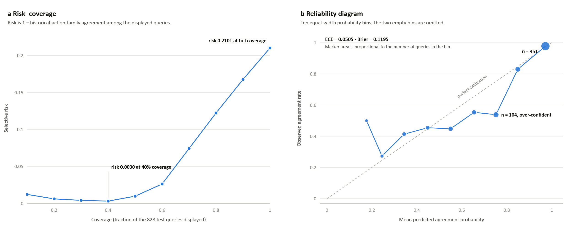
Figure 8.3 Risk against coverage and the reliability of the calibrated historical-agreement estimate
Note. Locked test of 828 evaluable queries. Panel a plots selective risk, defined as one minus historical-action-family agreement among the displayed queries, against coverage. Panel b plots observed agreement against mean predicted probability in ten equal-width bins; marker area is proportional to bin count and the two empty bins are omitted.
Table 8.5 Per-family locked-test Hit@1
Action family | Test queries | Share of test queries | Hit@1
Replace | 630 | 76.1% | 0.9556
Adjust | 66 | 8.0% | 0.4242
Diagnose | 45 | 5.4% | 0.4444
Inspect | 40 | 4.8% | 0.0500
Repair | 23 | 2.8% | 0.0000
Service | 23 | 2.8% | 0.0870
Calibrate | 1 | 0.1% | 0.0000
Macro average (all seven families) | 828 | 100% | 0.2802
Note. Macro recall is the unweighted mean of these seven values; Calibrate holds one query.
Table 8.6 Reporting thresholds and evidence-tier agreement
Stratum | What it selects | Queries | Share of 828 | Agreement rate
Probability ≥ 0.5 | Every test query whose calibrated historical-agreement probability reaches the stated threshold. Reporting only: the dashboard does not hide results below it. | 751 | 90.70% | 0.8282
Probability ≥ 0.6 |  | 693 | 83.70% | 0.8600
Probability ≥ 0.7 |  | 637 | 76.93% | 0.8870
Probability ≥ 0.8 |  | 533 | 64.37% | 0.9550
Probability ≥ 0.9 |  | 451 | 54.47% | 0.9778
Rung B | Near-duplicate problem description | 15 | 1.81% | 0.8667
Rung C | Same component and fault anchors | 684 | 82.61% | 0.8231
Rung D | Closest text or structure matches only | 129 | 15.58% | 0.6047
Note. Agreement rises monotonically as coverage falls, and rung D has a materially lower rate than rungs B and C.
Historical-agreement calibration produced ECE 0.0505 and Brier score 0.1195. Figure 8.3 shows the risk–coverage curve and the reliability diagram for that estimate: selective risk falls from 0.2101 at full coverage to 0.0030 at forty-percent coverage, which is the ordering condition Section 2.7 identifies as the precondition for a meaningful coverage-against-risk trade-off. Table 8.6 reports what a probability reporting threshold would yield and how agreement varies across the three displayed evidence rungs; the weakest rung has a materially lower agreement rate, so the displayed tier carries information rather than restating the score. In the one-reviewer assessment, both problem relevance and usable-action evidence reached Hit@1 0.92 and Hit@5 0.97. The scores describe evidence retrieval under this review protocol; they do not measure technical action applicability or safety.

Calibration quantities
Calibration compares a score interpreted as confidence with the observed frequency of the historical-agreement label. Expected calibration error partitions predictions into B bins [49], as formalized in Equation 8.11.
 | $$\text{ECE}=\sum_{j=1}^{B}{\frac{\left|I\left(j\right)\right|}{N}}\left|\text{acc}\left(I\left(j\right)\right)-\text{conf}\left(I\left(j\right)\right)\right|$$ | (8.11)
I(j) is the set of predictions in bin j, acc(I(j)) the observed agreement rate, and conf(I(j)) the average confidence. The absolute gap is weighted by the bin population. ECE 0.0505 means that the weighted bin-wise difference was about 5.05 percentage points under this binning; ECE depends on the binning scheme and does not measure discrimination.
The Brier score is the mean squared error of probabilistic predictions [50], as formalized in Equation 8.12.
 | $$\text{Brier}=\frac{1}{N}\sum_{i=1}^{N}{{\left(p_{i}-y_{i}\right)}^{2}}$$ | (8.12)

pᵢ is the predicted historical-agreement confidence and yᵢ is the binary observed label. The reported Brier score of 0.1195 penalizes both overconfident errors and underconfident correct predictions. Neither ECE nor Brier turns the score into a probability of technical applicability, safety, or repair success because those outcomes were not the calibration target.

Software verification
Software verification covers split locks, data contracts, provenance, complete-case rendering, negative-outcome handling, retrieval configuration, evaluation locks, planning persistence, and dashboard behavior. The frozen evidence package separately verifies all 28 expected result files. Software-test counts are not treated as scientific performance measures.
This constitutes evidence of implementation, not production qualification, usability validation, or regulatory assurance.
The implementation checks confirm that query actions remain hidden, open evaluation data are protected by locks, negative attempts are not promoted, action sequences are not assembled across cases, and provenance is retained. Security, usability, human factors, and regulatory validation remain separate requirements.

Interface walkthrough
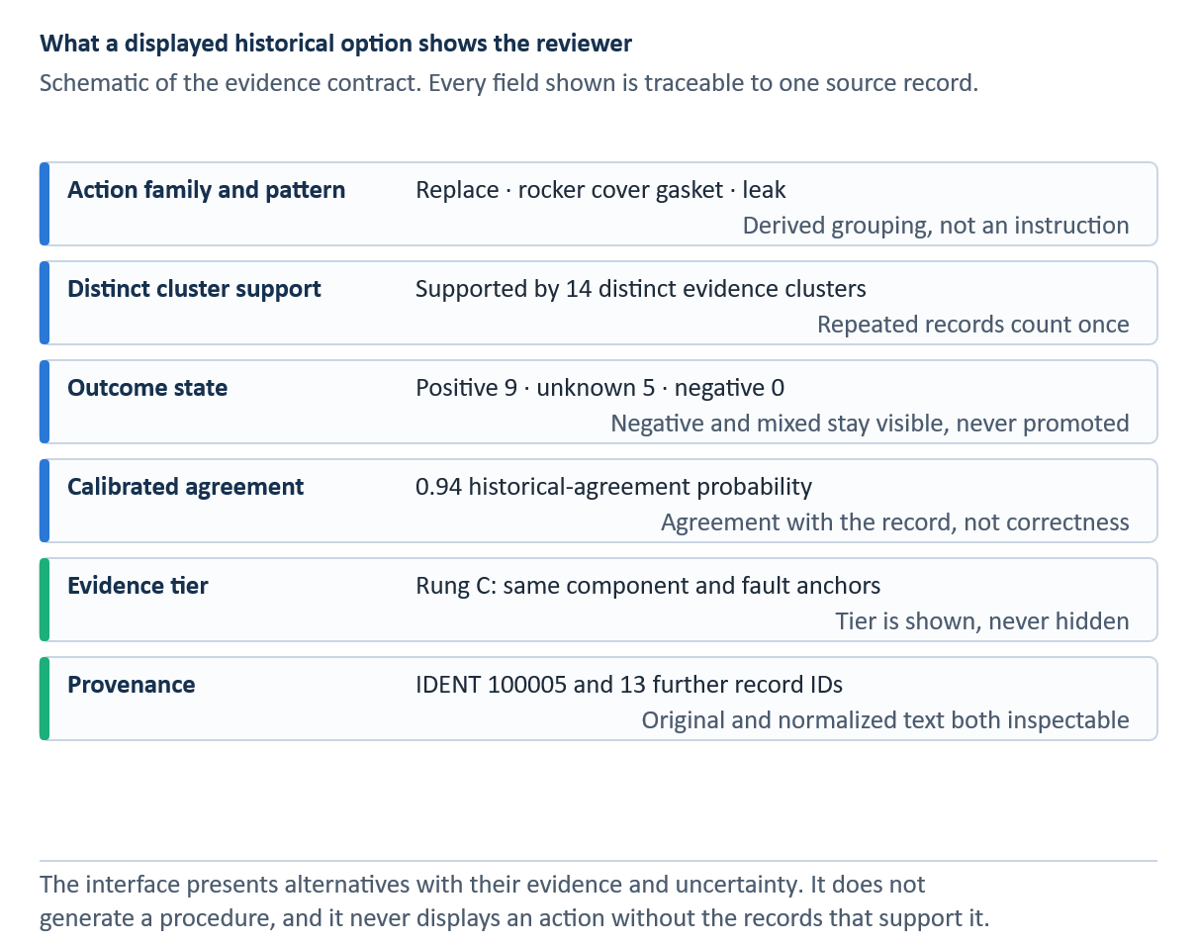
Figure 8.4 Fields shown with a historical action option and the provenance behind each one
Each option is a complete source case and is not merged with other options. Scores rank evidence; they are not probabilities of repair success.
Each option presents the rendered historical action, derived strategy and target, retrieval score, source case, and expandable evidence. The alternatives remain separate, and the interface labels the selection as a planner decision. Provenance is therefore available at the point of review rather than only in a back-end audit record. Figure 8.4 illustrates separate, provenance-bearing alternatives, while Figure 8.5 illustrates the eligibility gate and the abstention path.
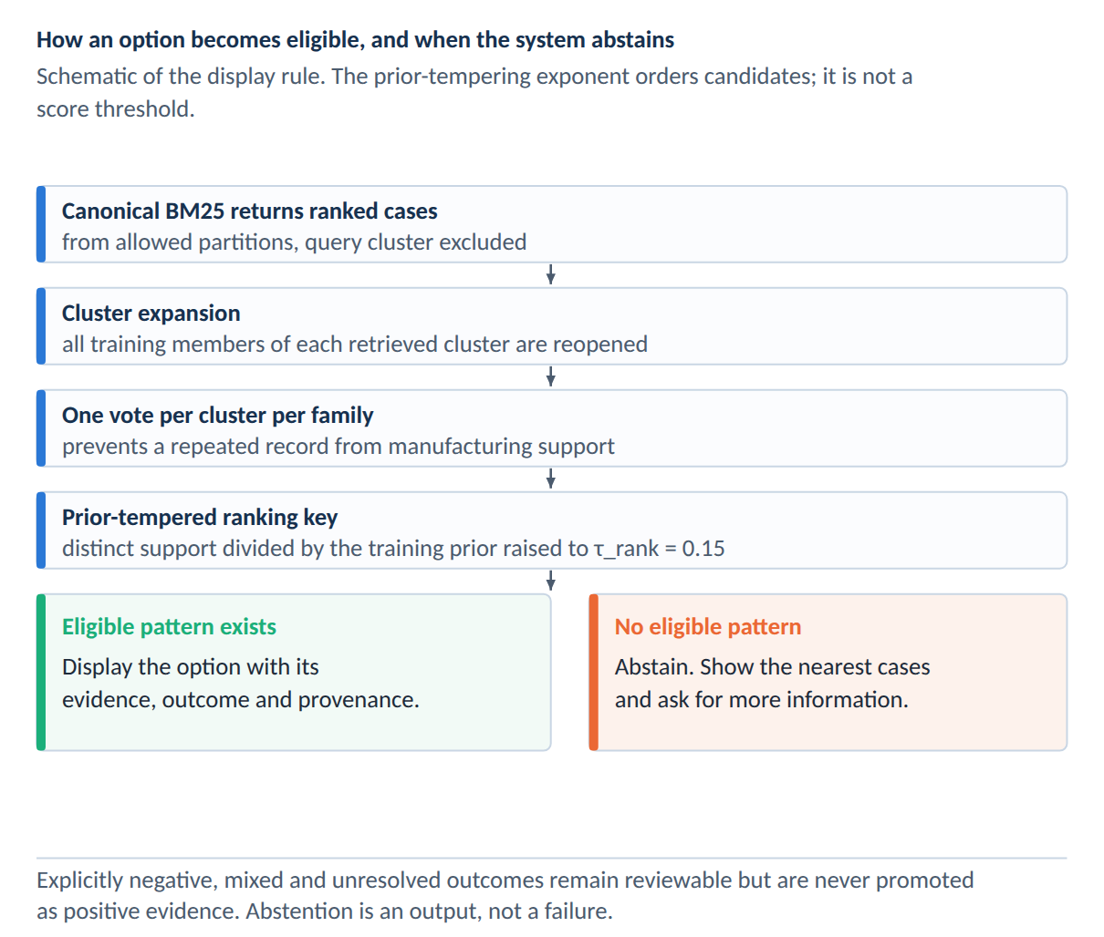
Figure 8.5 Eligibility gate that decides between displaying an option and abstaining
The system exposes relevant negative evidence without promoting it as a recommendation. The displayed evidence criterion does not represent the probability of safety or repair success.
When the evidence criterion is not met, the interface states that no action is promoted and explains why. It does not substitute the most frequent action. Unsuccessful historical cases remain visible in a separate ledger, allowing reviewers to inspect prior failures without turning their frequency into a prescription.

Discussion

Answers to the research questions
Table 9.1 Consolidated answers to the research questions
RQ | Evidence-based answer | Qualification
RQ1 | ByT5 has the best descriptive test agreement (WER 0.0147; exact 0.9366), but Selective ByT5 remains the official validation-selected system (WER 0.0219; exact 0.9325) and preserves 100% of protected tokens. | Agreement with one expert-cleaned reference is not proof of semantic or technical correctness.
RQ2 | Raw has the highest entity micro-F1 (0.9455) and relation micro-F1 (0.8203). No normalized representation improves either micro score. Selective ByT5 raises relation macro-F1 from 0.7511 to 0.7781. | Results are representation-matched and descriptive on one frozen 225-record test.
RQ3 | SpERT is strongest internally (entity micro-F1 0.9520; relation micro-F1 0.8537) and on MaintIE (0.8828; 0.6817), reproducing the broad ranking pattern. | MaintIE models were trained on its split; this is external replication, not zero-shot transfer.
RQ4 | On 828 evaluable queries, the selected protocol reaches Hit@1 0.7899, Hit@3 0.9686, Hit@5 0.9952, and MRR 0.8766. The largest tested Hit@1 drop is 0.0338 under 10% spelling noise. | Macro family recall is 0.2802; rare families remain weak. Metrics concern recorded historical evidence, not technical applicability.
RQ5 | The prototype preserves source cases, alternatives, outcome state, calibration information, abstention, and manual selection. One-reviewer assessment reports usable-action-evidence Hit@1 0.92 and Hit@5 0.97. | Usability, inter-rater reliability, safety, security, deployment, and regulatory validation remain open.
Note. Each answer is bounded by its named evaluation population.
Table 9.1 summarizes the direct answers. The following subsections explain how each answer follows from its evaluation population and where the claim must stop. Across the five questions, the evidence supports historical-case retrieval and an auditable planning interface, while maintenance authority remains with qualified personnel using current approved data. Table 9.1 is the compact evidence map; Sections 9.1.1–9.1.5 provide the complete answers.

RQ1 Normalization accuracy and preservation
ByT5 produced the lowest word error rate (WER) of 0.0147 and the highest exact match of 0.9366 on the locked 741-record test. Selective ByT5, selected before the test from the 926-record validation set, achieved a WER of 0.0219 and an exact match of 0.9325 while preserving 100% of protected tokens. RQ1 is therefore answered by retaining Selective ByT5 as the preselected system and reporting ByT5 as the descriptive accuracy leader. These results measure agreement with one expert-cleaned reference, not the technical correctness of every edit.
The extent of the improvement is substantial: relative to the rules baseline, ByT5 reduced WER by about 86.2% and increased exact match by 63.7 percentage points. Nevertheless, the official choice was not determined by the ranking on the open test. Selective ByT5 was selected on the 926-record validation population and was therefore carried unchanged to the 741-record test. Because the reference-agreement intervals overlap, the selected system does not trade measurable accuracy for protection and achieves perfect protected-token preservation without a resolved loss in reference agreement.
The answer is consequently multi-objective. If the objective is solely to minimize intrinsic WER on this locked test, ByT5 leads. If the objective includes preregistered selection and the defined protected-token constraint, Selective ByT5 is the defensible system. Neither objective demonstrates that the reference or prediction is technically correct in every maintenance context.

RQ2 Downstream effects of normalization
Raw text achieved the highest SpERT entity micro-F1 (0.9455) and relation micro-F1 (0.8203) in the representation-matched experiment. None of the normalized representations improved either micro score. Selective ByT5 increased relation macro-F1 from 0.7511 to 0.7781, indicating a possible benefit for the class-balanced average. Thus, RQ2 shows that greater normalization agreement does not necessarily improve downstream extraction and that micro- and macro-F1 effects can differ.
The changes from the Raw to Selective models are small but directionally different: entity micro-F1 decreases from 0.9455 to 0.9424 and relation micro-F1 decreases from 0.8203 to 0.8167, while relation macro-F1 increases from 0.7511 to 0.7781. This pattern is consistent with normalization helping some less frequent relation classes while introducing changes that slightly harm the instance-weighted total.
Because the experiment retrained and evaluated SpERT on each representation using identical 1,275/100/225 partitions, it isolates representation more cleanly than preprocessing only the test set. The result rejects a simple monotonic pipeline assumption: a representation can be closer to a normalized reference without becoming a better input for a downstream extractor.

RQ3 Information extraction architectures
SpERT produced the highest internal entity and relation micro-F1 scores (0.9520 and 0.8537). DistilBERT ranked second, the CRF-based baseline remained competitive, and the BiLSTM relation component was markedly weaker. The same broad ordering of approaches appeared in MaintIE. SpERT reached an entity micro-F1 of 0.8828 and a relation micro-F1 of 0.6817. RQ3 is answered for the two supplied frozen splits; the MaintIE result is a separately trained external replication rather than zero-shot transfer.
SpERT outperformed DistilBERT by 0.0071 entity micro-F1 and 0.0241 relation micro-F1 on the internal split. On the separately trained MaintIE split, the margins increased to 0.0540 and 0.0970, respectively. The consistent ordering strengthens the architectural comparison but does not establish zero-shot external validity, since each model was trained on the corresponding corpus.
Macro and class-level results qualify the headline ranking. The MaintIE REFERENCE and ACTION_FOLLOWS_REFERENCE classes each have support two, so one prediction can change their F1 sharply. SpERT's leading point estimates justify its use for the operational silver layer, while the low-support classes justify confidence filtering, provenance, and a stratified human audit rather than treating every prediction as fact.

RQ4 Retrieval performance and robustness
The selected problem-only, cluster-safe protocol achieved Hit@1 0.7899, Hit@3 0.9686, Hit@5 0.9952, MRR 0.8766, and nDCG@5 0.9067 on 828 evaluable queries. The largest tested Hit@1 reduction was 0.0338 under 10% spelling noise. Macro action-family recall was only 0.2802, revealing weak coverage of rare families despite high top-k performance. RQ4 is therefore answered for recovery of recorded historical evidence, not for the technical applicability of retrieved actions.
The metric pattern is important. A Hit@5 of 0.9952 shows that recorded action-family evidence was almost always present in a five-item list, while an MRR of 0.8766 shows that relevant evidence tended to occur early. The majority baseline’s Hit@1 of 0.7609, however, reveals a strong class prior. The selected system’s main advantage over that baseline is not a dramatic overall Hit@1 gain but an increase in macro family recall from 0.1429 to 0.2802.
Robustness is correspondingly bounded. The maximum tested reduction in Hit@1 was approximately 3.38 percentage points under 10% synthetic spelling noise, while top-five recovery remained high. Missing structure produced clean-equivalent performance because canonical BM25 does not consume structured features. This is a property of the selected lexical protocol, not evidence that extraction quality is irrelevant to the broader prototype.

RQ5 Auditable planning support
The prototype preserves the source cases, alternatives, outcome status, uncertainty information, and manual selection. Historical-agreement calibration produced an ECE of 0.0505 and a Brier score of 0.1195. One reviewer assessed 100 queries and reported usable-action-evidence Hit@1 of 0.92 and Hit@5 of 0.97. RQ5 is answered as an implementation and evidence-presentation result. Usability, inter-rater reliability, technical safety, security, regulatory acceptance, and deployment effectiveness remain unvalidated.
The implementation answer rests on controls rather than on a single predictive score: the action is hidden during retrieval; split and artifact locks prevent post-test tuning; complete cases preserve provenance; negative outcomes are quarantined; alternatives remain separate; and the system may abstain. These mechanisms make the interface auditable because a reviewer can trace every displayed option to its source and contest the intermediate structure.
The empirical user-facing evidence is preliminary. A single reviewer assessed 100 queries and 500 query–candidate pairs, producing problem-relevance and usable-action-evidence Hit@1 of 0.92 and Hit@5 of 0.97. Without a second reviewer, inter-rater agreement, task-time comparison, or technical-applicability judgments, these figures support evidence presentation only. They do not establish usability, safety, or organizational effectiveness.

What the results do and do not establish
The normalization experiment shows that ByT5 best matches the expert-cleaned target, whereas Selective ByT5 preserves all protected tokens and remains the validation-selected system. The matched SpERT experiment shows that neither system improves entity or relation micro-F1 over raw text. A normalization metric is therefore insufficient as a proxy for extraction performance.
The retrieval study demonstrates high top-k recovery of recorded evidence and limited degradation under the tested spelling and truncation perturbations. A macro action-family recall of 0.2802 indicates that this performance is concentrated in common families. Calibration and assessment by one reviewer provide additional evidence regarding historical agreement and evidence usability, but neither evaluates whether an action is technically applicable.
The prototype establishes traceability rather than technical correctness. A reviewer can inspect the source text, extracted structure, evidence cluster, score, outcome state, and source record associated with an option. This audit trail makes model errors contestable, but it cannot determine whether the historical work was performed correctly, caused the recorded outcome, remains current, or applies to another aircraft configuration.

Design trade-offs
Text normalization exposes a trade-off between reference agreement and protected-token fidelity. While ByT5 minimizes WER, Selective ByT5 retains every protected token. A downstream experiment introduces a second trade-off: raw text achieves the highest micro-F1 scores, whereas Selective ByT5 produces the highest relation macro-F1. No single representation dominates all objectives.
Text and structure provide different forms of evidence. Structured features reveal matches between issues, items, and contexts, but they inherit extraction errors and disappear when relations are missing. Lexical retrieval is transparent and effective for exact technical terms, but it may miss paraphrases. The final evaluation selected canonical BM25, while the other channels remain experimental components rather than proven improvements.
Outcome quarantine, distinct-cluster support, and retention of alternatives restrict what the interface portrays as positive historical evidence. The τ_rank exponent balances common-family support with rare-family visibility; it is not the display gate. These design choices avoid promoting explicitly unsuccessful evidence while keeping the underlying records inspectable. The result is a review tool rather than an automatic action selector.
Complete-case rendering prioritises provenance over fluent adaptation. A generated composite procedure could combine useful fragments, but its source boundaries and unsupported additions would be difficult to audit. AviMaint-DSS instead keeps each option tied to a single record and leaves adaptation to the qualified planner.

Safety, governance, and human oversight
Historical maintenance work orders are not approved maintenance data. FAA 14 CFR 43.13 and the European continuing-airworthiness framework require applicable, current methods and data [1, 2]. A deployed system would need to link each historical case to current manuals, instructions for continued airworthiness, configuration data, and organizational procedures. Historical evidence can guide a search for authoritative sources, but it cannot itself provide that authority.
A qualified reviewer must check the extracted query structure, compare alternatives and unsuccessful attempts, confirm asset identity and applicability, locate current approved data, and document the basis for the planning decision. Corrections and selections should be logged, but user clicks should become training labels only through a governed review process.
Operational governance would require versioned case libraries, model and split fingerprints, immutable evaluation records, drift monitoring, access controls, security testing, and retirement rules for obsolete records. Frequency and outcome displays need explicit denominators. Human-factors evaluation must also test for anchoring, confirmation bias, and inappropriate reliance on retrieved cases. Table 9.2 consolidates the principal validity threats and the controls or follow-up studies they require.

Threats to validity
Table 9.2 Principal threats to validity and mitigations
Threat | Potential effect | Mitigation / required next step
Expert reference and truncation | Reference agreement can reward a plausible reconstruction. | Retain raw text; add meaning-preservation and truncation review.
Validation-selected versus descriptive winner | Choosing ByT5 after test inspection would bias RQ1. | Keep Selective ByT5 as official; report ByT5 descriptively.
Single-reviewer IE corpus | Annotation inconsistency and anchoring are unmeasured. | Blind double annotation and adjudication.
Rare-class support | Per-class F1 and macro averages are unstable. | Report support; add a separately reported rare-class challenge set.
Silver operational graph | Full-corpus predictions may not match gold-test accuracy. | Treat graph as navigation evidence; validate a stratified sample.
Retrieval label meaning | Action-family agreement can be mistaken for technical applicability. | Keep historical-evidence language and require approved-data review.
Single manual reviewer | Usable-action scores have no inter-rater reliability. | Multi-reviewer, domain-expert adjudication.
Family imbalance | Replace dominates; rare-family macro recall is 0.2802. | Report per-family results and improve rare-family evidence.
One public corpus | Fleet, organization, language, and temporal generalization are unknown. | External multi-organization and drift evaluation.
Prototype deployment | Usability, automation bias, security, and regulatory fit are unknown. | Task-based human-factors and safety assurance before field use.
Note. Mitigations name the next study; they do not remove the threat.

Future evaluation plan
A multi-reviewer study with domain experts is therefore the next empirical priority. Reviewers should assess problem relevance, evidence usability, technical applicability, and compatibility with the current approved data as separate constructs. Blinded stages, adjudication, and inter-rater agreement are required. The existing 828-query test must not be reused to select the model, prior exponent, or future display threshold.
The scored SpERT comparison and matched normalization-to-IE experiment close the main representation gaps in the current thesis. Further work should test whether these results replicate across fleets and organizations, using independent annotation teams. It should also include blinded reviews of normalization meaning preservation and a stratified audit of the silver graph.
Corpus quality remains a separate priority. A stratified sample should be double annotated, with agreement reported for entity boundaries, entity types, and relations, followed by adjudication and guideline revision. External records should cover abbreviations, fleets, and organizations absent from MaintNet, while naturally sampled performance remains separate from a rare-class challenge set.
The low macro action-family recall of 0.2802 warrants a separate study of rare-family candidate retrieval, training support and expert-validated labels. A different question is whether uncertainty can be displayed with comparable coverage across families. Future work could evaluate class-conditional conformal prediction sets under exchangeability, using an independent calibration population [45, 56]. Ding et al. [56] note that the small number of labelled examples per class makes such coverage difficult to obtain usefully. The study should report per-family coverage and set size, as well as abstention on new held-out queries. Prediction-set coverage would neither automatically improve the underlying ranker’s macro recall nor certify that a retrieved maintenance action applies to an aircraft.
Qualified planners should complete realistic evidence-finding tasks with and without the dashboard. The study should measure retrieval success, time, the number of sources inspected, correction behavior, responses to abstention, trust calibration, and anchoring. Field use should not take place until approved data links, access controls, logging, security responsibilities, and organizational authority have been defined.

Conclusion

Summary
This thesis develops and evaluates a pipeline that converts noisy aviation maintenance records into structured historical evidence to support planning. The study compares six normalization representations, measures their downstream effects using matched SpERT training, evaluates four extraction architectures internally and on MaintIE, builds a silver graph and case library, and tests cluster-safe retrieval, perturbation robustness, calibration, and evidence presentation.
Mathematical measures place explicit boundaries on the conclusions. Agreement with normalized reference strings is quantified by WER, CER, exact match, and change F1. Micro- and macro-F1 quantify the recovery of gold annotations under different class weightings. Ranked recovery of historical evidence is measured by Hit@k, MRR, and nDCG. ECE and Brier quantify calibration agreement. None of these measures captures approved technical applicability, regulatory currency, repair causality, or airworthiness. Therefore, those constructs cannot be inferred from the reported values.
The experiments show that progress achieved at one stage of the pipeline does not necessarily carry over to the next. ByT5 best matches the cleaned normalization reference, while Selective ByT5 is the validation-selected system and preserves all protected tokens. Nevertheless, raw text achieves the highest downstream SpERT micro-F1 measures. SpERT leads both four-model extraction comparisons, but its predictions over the full corpus remain silver.
The final retrieval protocol achieved Hit@1 of 0.7899, Hit@3 of 0.9686, Hit@5 of 0.9952, an MRR of 0.8766, and an nDCG@5 of 0.9067 on 828 evaluable queries. The tested perturbations caused limited degradation in the top-k results, and one reviewer rated the retrieved evidence favourably. Macro action-family recall remained at 0.2802, and none of these metrics establishes technical applicability or repair correctness.

Contributions revisited
The main contributions are a validation-selected normalization comparison with a locked test, a planning-oriented nine-entity and eleven-relation schema, a matched normalization-to-extraction experiment, a four-architecture internal and MaintIE benchmark, a provenance-preserving silver case layer, and a frozen historical-evidence retrieval evaluation. The accompanying evidence ledger keeps validation, test, silver, calibration, and manual-review claims distinct.
The engineering contribution lies in controls that preserve evidential meaning: cluster-safe splits, hidden query actions, typed relation checks, complete-case rendering, outcome quarantine, alternatives, reviewer correction, and abstention. These mechanisms make each displayed option traceable and define where qualified judgment must enter the workflow.

Final conclusion
Noisy maintenance records can support the retrieval of useful historical evidence when normalization, extraction, case construction, and ranking are evaluated as separate problems. The study also identifies the limits of this evidence. The preselected normalizer is not the leader in the descriptive test, normalization does not improve downstream micro-F1, rare extraction and action families remain weak, and the operational graph is model-generated.
AviMaint-DSS should therefore be treated as a research planning aid that helps qualified personnel find, compare, and document historical cases while consulting current approved maintenance data. The next milestone is an independent evaluation involving multiple domain experts and organizations, including studies of technical applicability, usability, automation bias, security, and abstention. The locked tests should remain closed to further selection or tuning.

References
[1] Federal Aviation Administration: 14 CFR Part 43.13 - Performance rules (general). Code of Federal Regulations, Washington DC.
[2] European Commission: Commission Regulation (EU) No 1321/2014 on the continuing airworthiness of aircraft and aeronautical products, parts and appliances. Official Journal of the European Union, 2014.
[3] Akhbardeh, F.; Desell, T.; Zampieri, M.: MaintNet: A Collaborative Open-Source Library for Predictive Maintenance Language Resources. In: Proceedings of the 28th International Conference on Computational Linguistics (COLING): System Demonstrations, Barcelona, 2020, pp. 7-11.
[4] Brundage, M. P.; Sexton, T.; Hodkiewicz, M.; Dima, A.; Lukens, S.: Technical language processing: Unlocking maintenance knowledge. In: Manufacturing Letters, Vol. 27, 2021, pp. 42-46.
[5] Bikaun, T.; Hodkiewicz, M.; Liu, W.: MaintNorm: A corpus and benchmark model for lexical normalisation and masking of industrial maintenance short text. In: Proceedings of the Ninth Workshop on Noisy and User-generated Text (W-NUT 2024), San Giljan, 2024, pp. 68-78.
[6] Bikaun, T. K.; French, T.; Stewart, M.; Liu, W.; Hodkiewicz, M.: MaintIE: A Fine-Grained Annotation Schema and Benchmark for Information Extraction from Maintenance Short Texts. In: Proceedings of LREC-COLING 2024, Torino, 2024, pp. 10939-10951.
[7] Aamodt, A.; Plaza, E.: Case-Based Reasoning: Foundational Issues, Methodological Variations, and System Approaches. In: AI Communications, Vol. 7, No. 1, 1994, pp. 39-59.
[8] Lafferty, J.; McCallum, A.; Pereira, F. C. N.: Conditional Random Fields: Probabilistic Models for Segmenting and Labeling Sequence Data. In: Proceedings of the 18th International Conference on Machine Learning (ICML), 2001, pp. 282-289.
[9] Robertson, S.; Zaragoza, H.: The Probabilistic Relevance Framework: BM25 and Beyond. In: Foundations and Trends in Information Retrieval, Vol. 3, No. 4, 2009, pp. 333-389.
[10] Devlin, J.; Chang, M.-W.; Lee, K.; Toutanova, K.: BERT: Pre-training of Deep Bidirectional Transformers for Language Understanding. In: Proceedings of NAACL-HLT, 2019, pp. 4171-4186.
[11] Eberts, M.; Ulges, A.: Span-based Joint Entity and Relation Extraction with Transformer Pre-training. In: Proceedings of the 24th European Conference on Artificial Intelligence (ECAI), 2020, pp. 2006-2013.
[12] Akhbardeh, F.; Desell, T.; Zampieri, M.: NLP Tools for Predictive Maintenance Records in MaintNet. In: Proceedings of the 1st Conference of the Asia-Pacific Chapter of the ACL (AACL-IJCNLP): System Demonstrations, 2020, pp. 26–32. DOI: 10.18653/v1/2020.aacl-demo.5.
[13] Sundaram, S.; Zeid, A.: Technical language processing for Prognostics and Health Management: Applying text similarity and topic modeling to maintenance work orders. In: Journal of Intelligent Manufacturing, Vol. 36, 2025, pp. 1637–1657. DOI: 10.1007/s10845-024-02323-4.
[14] Sexton, T. B.; Brundage, M. P.; Hodkiewicz, M.; Smoker, T.: Benchmarking for keyword extraction methodologies in maintenance work orders. In: Proceedings of the Annual Conference of the Prognostics and Health Management Society, Philadelphia, 2018.
[15] Chandra, C.; Ojima, Y.; Bendarkar, M. V.; Mavris, D. N.: Aviation-BERT-NER: Named Entity Recognition for Aviation Safety Reports. In: Aerospace, Vol. 11, No. 11, 2024, Article 890.
[16] Yue, Y.; Wang, H.; Hou, Z.: A BERT-BiMamba-CRF Based Approach for Risk Entity Recognition and Knowledge Graph Construction in Civil Aviation Maintenance Texts. In: Proceedings of the 2025 5th International Conference on Big Data, Artificial Intelligence and Risk Management (ICBAR), Dongguan, 2025, pp. 267-272.
[17] Amin, N.: Cleaned MaintNet aviation maintenance corpus and lexical resources for low-resource aviation speech research. Online repository. URL: https://github.com/nadine-amin/Cleaned-MaintNet-Aviation-Maintenance-Dataset [accessed 5 September 2026].
[18] van der Goot, R.; Ramponi, A.; Zubiaga, A.; Plank, B.; et al.: MultiLexNorm: A Shared Task on Multilingual Lexical Normalization. In: Proceedings of the Seventh Workshop on Noisy User-generated Text (W-NUT), 2021.
[19] Samuel, D.; Straka, M.: UFAL at MultiLexNorm 2021: Improving Multilingual Lexical Normalization by Fine-tuning ByT5. In: Proceedings of the Seventh Workshop on Noisy User-generated Text (W-NUT), 2021.
[20] Raffel, C.; Shazeer, N.; Roberts, A.; Lee, K.; Narang, S.; Matena, M.; Zhou, Y.; Li, W.; Liu, P. J.: Exploring the Limits of Transfer Learning with a Unified Text-to-Text Transformer. In: Journal of Machine Learning Research, Vol. 21, 2020, pp. 1-67.
[21] Xue, L.; Barua, A.; Constant, N.; Al-Rfou, R.; Narang, S.; Kale, M.; Roberts, A.; Raffel, C.: ByT5: Towards a Token-Free Future with Pre-trained Byte-to-Byte Models. In: Transactions of the ACL, Vol. 10, 2022, pp. 291-306.
[22] Geifman, Y.; El-Yaniv, R.: SelectiveNet: A deep neural network with an integrated reject option. In: Proceedings of the 36th International Conference on Machine Learning, PMLR, Vol. 97, 2019, pp. 2151–2159. URL: https://proceedings.mlr.press/v97/geifman19a.html.
[23] Ramshaw, L. A.; Marcus, M. P.: Text Chunking using Transformation-Based Learning. In: Proceedings of the Third ACL Workshop on Very Large Corpora, 1995, pp. 82-94.
[24] Hochreiter, S.; Schmidhuber, J.: Long Short-Term Memory. In: Neural Computation, Vol. 9, No. 8, 1997, pp. 1735-1780.
[25] Bojanowski, P.; Grave, E.; Joulin, A.; Mikolov, T.: Enriching Word Vectors with Subword Information. In: Transactions of the ACL, Vol. 5, 2017, pp. 135-146.
[26] Vaswani, A.; Shazeer, N.; Parmar, N.; Uszkoreit, J.; Jones, L.; Gomez, A. N.; Kaiser, L.; Polosukhin, I.: Attention Is All You Need. In: Advances in Neural Information Processing Systems (NeurIPS), 2017.
[27] Gururangan, S.; Marasovic, A.; Swayamdipta, S.; Lo, K.; Beltagy, I.; Downey, D.; Smith, N. A.: Don't Stop Pretraining: Adapt Language Models to Domains and Tasks. In: Proceedings of the 58th Annual Meeting of the ACL, 2020, pp. 8342-8360.
[28] Xu, D.; Chen, W.; Peng, W.; Zhang, C.; Xu, T.; Zhao, X.; Wu, X.; Zheng, Y.; Wang, Y.; Chen, E.: Large language models for generative information extraction: a survey. In: Frontiers of Computer Science, Vol. 18, No. 6, 2024, Article 186357.
[29] Xie, T.; Li, Q.; Zhang, J.; Zhang, Y.; Liu, Z.; Wang, H.: Empirical Study of Zero-Shot NER with ChatGPT. In: Proceedings of the 2023 Conference on Empirical Methods in Natural Language Processing (EMNLP), 2023, pp. 7935-7956.
[30] Ji, Z.; Lee, N.; Frieske, R.; Yu, T.; Su, D.; Xu, Y.; Ishii, E.; Bang, Y.; Madotto, A.; Fung, P.: Survey of Hallucination in Natural Language Generation. In: ACM Computing Surveys, Vol. 55, No. 12, 2023, Article 248.
[31] Huguet Cabot, P.-L.; Navigli, R.: REBEL: Relation Extraction By End-to-end Language generation. In: Findings of the Association for Computational Linguistics: EMNLP 2021, 2021, pp. 2370-2381.
[32] Huang, Z.; Xu, W.; Yu, K.: Bidirectional LSTM-CRF Models for Sequence Tagging. arXiv:1508.01991, 2015.
[33] Lample, G.; Ballesteros, M.; Subramanian, S.; Kawakami, K.; Dyer, C.: Neural Architectures for Named Entity Recognition. In: Proceedings of NAACL-HLT, 2016, pp. 260-270.
[34] Sanh, V.; Debut, L.; Chaumond, J.; Wolf, T.: DistilBERT, a distilled version of BERT: smaller, faster, cheaper and lighter. arXiv:1910.01108, 2019.
[35] Fort, K.; Ehrmann, M.; Nazarenko, A.: Towards a methodology for named entities annotation. In: Proceedings of the Third Linguistic Annotation Workshop, 2009, pp. 142–145. URL: https://aclanthology.org/W09-3025/.
[36] Bayerl, P. S.; Paul, K. I.: What determines inter-coder agreement in manual annotations? A meta-analytic investigation. In: Computational Linguistics, Vol. 37, No. 4, 2011, pp. 699–725. DOI: 10.1162/COLI_a_00074.
[37] Efron, B.; Tibshirani, R. J.: An Introduction to the Bootstrap. Chapman and Hall, New York, 1993.
[38] Moreau, L.; Groth, P.: Provenance: An Introduction to PROV. Morgan and Claypool, 2013.
[39] Lin, R.; Wang, H.; Wang, N.; Wang, J.: Civil aircraft structural maintenance decision using case-based reasoning and LSI. In: Proceedings of the Institution of Mechanical Engineers, Part G: Journal of Aerospace Engineering, Vol. 239, No. 11, 2025. DOI: 10.1177/09544100251328581.
[40] Reimers, N.; Gurevych, I.: Sentence-BERT: Sentence Embeddings using Siamese BERT-Networks. In: Proceedings of EMNLP-IJCNLP, 2019, pp. 3982-3992.
[41] Robertson, S.; Zaragoza, H.; Taylor, M.: Simple BM25 Extension to Multiple Weighted Fields. In: Proceedings of the 13th ACM International Conference on Information and Knowledge Management, 2004, pp. 42–49. DOI: 10.1145/1031171.1031181.
[42] Cormack, G. V.; Clarke, C. L. A.; Buettcher, S.: Reciprocal Rank Fusion Outperforms Condorcet and Individual Rank Learning Methods. In: Proceedings of SIGIR, 2009, pp. 758-759.
[43] Jarvelin, K.; Kekalainen, J.: Cumulated Gain-based Evaluation of IR Techniques. In: ACM Transactions on Information Systems, Vol. 20, No. 4, 2002, pp. 422-446.
[44] El-Yaniv, R.; Wiener, Y.: On the Foundations of Noise-free Selective Classification. In: Journal of Machine Learning Research, Vol. 11, 2010, pp. 1605-1641.
[45] Shafer, G.; Vovk, V.: A Tutorial on Conformal Prediction. In: Journal of Machine Learning Research, Vol. 9, 2008, pp. 371-421.
[46] Parasuraman, R.; Riley, V.: Humans and Automation: Use, Misuse, Disuse, Abuse. In: Human Factors, Vol. 39, No. 2, 1997, pp. 230-253.
[47] European Union Aviation Safety Agency (EASA): EASA Concept Paper - Guidance for Level 1 and 2 Machine Learning Applications. Cologne, 2024.
[48] National Institute of Standards and Technology: Artificial Intelligence Risk Management Framework (AI RMF 1.0). NIST, Gaithersburg, 2023.
[49] Guo, C.; Pleiss, G.; Sun, Y.; Weinberger, K. Q.: On Calibration of Modern Neural Networks. In: Proceedings of the 34th International Conference on Machine Learning (ICML), 2017, pp. 1321-1330.
[50] Brier, G. W.: Verification of Forecasts Expressed in Terms of Probability. In: Monthly Weather Review, Vol. 78, No. 1, 1950, pp. 1-3.
[51] Settles, B.: Active Learning Literature Survey. Computer Sciences Technical Report 1648, University of Wisconsin-Madison, 2009.
[52] Artstein, R.; Poesio, M.: Survey Article: Inter-Coder Agreement for Computational Linguistics. In: Computational Linguistics, Vol. 34, No. 4, 2008, pp. 555-596.
[53] Lee, K.; Ippolito, D.; Nystrom, A.; Zhang, C.; Eck, D.; Callison-Burch, C.; Carlini, N.: Deduplicating Training Data Makes Language Models Better. In: Proceedings of ACL, 2022. URL: https://arxiv.org/abs/2107.06499.
[54] Wilson, E. B.: Probable Inference, the Law of Succession, and Statistical Inference. In: Journal of the American Statistical Association, Vol. 22, No. 158, 1927, pp. 209-212.
[55] McNemar, Q.: Note on the sampling error of the difference between correlated proportions or percentages. In: Psychometrika, Vol. 12, 1947, pp. 153–157. DOI: 10.1007/BF02295996.
[56] Ding, T.; Angelopoulos, A. N.; Bates, S.; Jordan, M. I.; Tibshirani, R. J.: Class-Conditional Conformal Prediction with Many Classes. In: Advances in Neural Information Processing Systems 36, 2023. URL: https://arxiv.org/abs/2306.09335.

Appendix A Complete Schema Catalogue
This appendix consolidates the nine-entity, eleven-relation AviMaint-DSS-IE schema used in the frozen internal comparison and operational dashboard. The examples are illustrative, and only explicit text is annotated. Table A.1 provides the complete entity catalogue, and Table A.2 provides the relation catalogue.
Table A.1 Entity catalogue with inclusion and exclusion guidance
Type | Include | Exclude / boundary rule | Illustrative form
MAINT_ITEM | Aircraft, engine, component, subcomponent, part, material, consumable, or tool explicitly involved. | Do not include locations, values, issues, or document references. Prefer the complete noun phrase. | engine; cylinder; rocker cover gasket
ACTION | Completed, planned, required, attempted, diagnostic, inspection, service, removal, installation, repair, or adjustment expression. | Do not infer an action from a result. Include the explicit action phrase, not surrounding rationale. | removed; replaced; inspected; tried to adjust
FAULT | Static damage, absence, defect, deficiency, or failed state. | Use ABN_PROC for dynamic abnormal behaviour. Do not label a neutral measurement as a fault. | cracked; missing; worn; failed
ABN_PROC | Dynamic event or behaviour outside normal operation. | Use FAULT for persistent static condition. Keep the process phrase concise. | running rough; leaking; vibrating
TECH_OBS | Reading, property, measurement, count, indication, interval, or neutral service datum. | Do not convert the value into a judgment or outcome. | 20/80 psi; low reading; 3 hours
LOC | Side, station, ordinal, zone, position, forward/aft, left/right, inner/outer designator. | Do not duplicate the component name. Annotate the positional expression. | number 4; left-hand; aft
OP_CTX | Operating phase, environmental condition, timing, or detection context. | Not the physical location of a component. | on takeoff; during inspection
OUTCOME | Explicit action result, finding, restored status, no-effect statement, or unresolved status. | Do not infer success from a recorded action or the absence of further text. | ops check good; no change; still leaking
REFERENCE | Named manual, service instruction, maintenance publication, or approved data followed. | A generic unidentifiable mention is insufficient. | per MM 72-00; SB 1234
Note. Annotation guidelines; examples are illustrative.
Table A.2 Relation catalogue with binding signatures
Relation | Source | Target | Decision rule
HAS_PART | MAINT_ITEM | MAINT_ITEM | Annotate explicit whole–part structure; do not infer from world knowledge.
ISSUE_ON_ITEM | FAULT / ABN_PROC | MAINT_ITEM | Bind the issue to the affected item when text supports the association.
ACTION_ON_ITEM | ACTION | MAINT_ITEM | Bind the direct target; this edge alone is not evidence of correction.
OBSERVATION_OF_ITEM | TECH_OBS | MAINT_ITEM | Bind a reading or property to the observed item.
HAS_LOCATION | MAINT_ITEM | LOC | Bind an item to its explicit location or ordinal.
OCCURS_UNDER_CONTEXT | FAULT / ABN_PROC | OP_CTX | Bind an issue to the phase or context in which it occurred or was detected.
ACTION_ADDRESSES_ISSUE | ACTION | FAULT / ABN_PROC | Use for corrective intent; do not equate with a successful result.
ACTION_INVESTIGATES_ISSUE | ACTION | FAULT / ABN_PROC | Use for diagnosis, inspection, test, or troubleshooting intent.
ACTION_USES_ITEM | ACTION | MAINT_ITEM | Bind an explicitly used material, part, or tool distinct from the action target.
ACTION_RESULTS_IN_OUTCOME | ACTION | OUTCOME | Require an explicit result or status attributable to the action.
ACTION_FOLLOWS_REFERENCE | ACTION | REFERENCE | Require explicit wording that the action followed the named reference.
Note. Each relation is directed; ACTION_ON_ITEM is not a success label.

Appendix B Detailed Information-Extraction Results
Table B.1 Per-class entity F1 and support
Entity | Test support | CRF + LR | BiLSTM | DistilBERT | SpERT
LOC | 327 | 0.9693 | 0.9727 | 0.9757 | 0.9744
MAINT_ITEM | 662 | 0.9445 | 0.9408 | 0.9480 | 0.9622
ACTION | 381 | 0.9525 | 0.9492 | 0.9663 | 0.9518
ABN_PROC | 134 | 0.9524 | 0.9585 | 0.9412 | 0.9624
FAULT | 101 | 0.9340 | 0.8812 | 0.9208 | 0.9394
TECH_OBS | 38 | 0.6575 | 0.7222 | 0.7027 | 0.7568
OUTCOME | 28 | 0.7925 | 0.8364 | 0.8364 | 0.8000
REFERENCE | 2 | 1.0000 | 1.0000 | 1.0000 | 1.0000
OP_CTX | 20 | 0.7368 | 0.7805 | 0.6957 | 0.8095
Note. Strict typed F1 on the frozen 225-record test; REFERENCE has n = 2.
Gold entity support for the frozen 225-record test was 1,693 overall. Rare-class scores should be interpreted in light of their corresponding support. The retained class-level scores are presented in Tables B.1 and B.2, while full-corpus relation support is shown in Figure B.1.
Table B.2 Per-class relation F1 and support
Relation | Test support | CRF + LR | BiLSTM | DistilBERT | SpERT
ACTION_ADDRESSES_ISSUE | 183 | 0.8743 | 0.8450 | 0.8943 | 0.9146
ACTION_ON_ITEM | 382 | 0.8215 | 0.6310 | 0.8731 | 0.8764
ISSUE_ON_ITEM | 235 | 0.8276 | 0.6131 | 0.8571 | 0.9130
HAS_LOCATION | 322 | 0.8551 | 0.7359 | 0.8860 | 0.8872
HAS_PART | 167 | 0.7500 | 0.4716 | 0.7532 | 0.7736
OBSERVATION_OF_ITEM | 30 | 0.4776 | 0.4651 | 0.5000 | 0.6000
ACTION_INVESTIGATES_ISSUE | 40 | 0.5225 | 0.4107 | 0.5607 | 0.5714
ACTION_RESULTS_IN_OUTCOME | 29 | 0.6897 | 0.4773 | 0.6780 | 0.6780
ACTION_FOLLOWS_REFERENCE | 2 | 1.0000 | 1.0000 | 1.0000 | 1.0000
ACTION_USES_ITEM | 10 | 0.8696 | 0.6923 | 0.0000 | 1.0000
OCCURS_UNDER_CONTEXT | 19 | 0.4615 | 0.4400 | 0.4103 | 0.4737
Note. Strict typed F1 on the frozen 225-record test; ACTION_FOLLOWS_REFERENCE has n = 2.
Strict typed, directed relation F1 was evaluated on the frozen 225-record test set. The overall gold relation support was 1,419, while ACTION_FOLLOWS_REFERENCE had only two test instances.
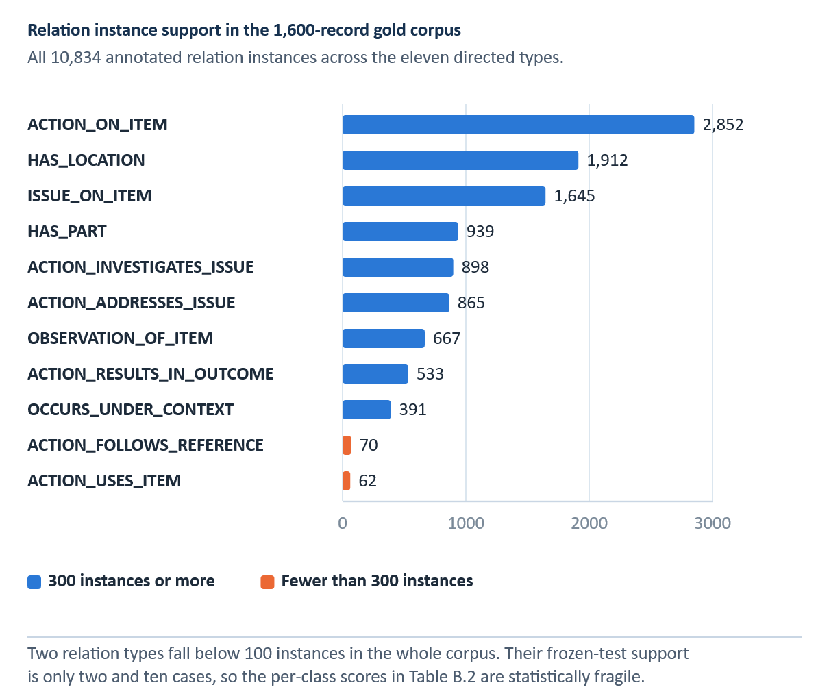
Figure B.1 Distribution of relation instances across the eleven types in the 1,600-record gold corpus
Full gold-corpus support, not frozen-test support; the overall frozen-test relation support is 1,419.

Appendix C Recommender Evidence and Evaluation Contract
The final selective contract freezes problem-only canonical BM25 retrieval, the prior-tempering exponent τ_rank = 0.15 for post-retrieval family aggregation, and cluster-expanded evidence, data splits, and evidence manifests before test evaluation. Earlier retrieval studies remain development evidence and are not the basis of the final RQ4 claim. Table C.1 documents the frozen retrieval contract, Table C.2 documents its claim boundary, and Table C.3 records all six retrieval modes scored on the locked test at the selected prior-tempering exponent. Three modes that were not selected achieved higher test Hit@1 scores than the selected configuration. Because mode selection was conducted on the development data according to the preregistered rule and the test was run only once, we report these values as evidence that the protocol was followed, not as grounds for revising the selected configuration.
Table C.1 Frozen final Selective retrieval contract
Contract item | Frozen final value
Evaluation version | selective_rq4_rq5_final
Representation | Selective ByT5
Input | Problem only; historical action hidden from query
Split | 4,319 train / 925 development / 925 test records; 828 evaluable test queries
Leakage control | Evidence-cluster exclusion and frozen split
Ranker | selective_canonical_bm25; no live SpERT query extraction
Family prior tempering | τ_rank = 0.15 exponent; not a score threshold
Aggregation | Cluster-expanded evidence
Evaluation rule | Frozen before test; no post-test tuning
Graph role | Exploratory navigation / structured development channel only
Note. The frozen contract; the interface may add metadata without changing the ranker.
Table C.2 Recommender claim boundary
Permitted claim | Prohibited interpretation
Reduces error against an expert-cleaned normalization reference | Does not prove that every edit is semantically or technically correct.
Recovers gold entities and relations on frozen tests | Does not prove that every full-corpus silver prediction is correct.
Retrieves recorded action-family and usable-action evidence | Does not establish technical action applicability, repair success, or approval.
Reports empirical calibration of historical agreement | Does not provide a safety probability.
Preserves source cases, alternatives, outcomes, and uncertainty | Does not replace qualified human judgment or current approved maintenance data.
Abstains when selected evidence criteria are not met | Does not constitute operational risk certification.
Note. Safety and authorisation stay outside the evaluated task.
Table C.3 All retrieval modes scored on the locked test at τ_rank = 0.15
Retrieval mode | Development Hit@1 | Test Hit@1 | Test Hit@3 | Test MRR | Test nDCG@5 | Test macro recall
Reciprocal-rank fusion | 0.8275 | 0.8092 | 0.9722 | 0.8882 | 0.9146 | 0.3235
Word TF-IDF | 0.8166 | 0.8056 | 0.9686 | 0.8849 | 0.9118 | 0.2967
Weighted hybrid | 0.8275 | 0.7995 | 0.9746 | 0.8835 | 0.9120 | 0.3109
Surface BM25 | 0.8275 | 0.7911 | 0.9698 | 0.8777 | 0.9072 | 0.2725
Canonical BM25 (selected on development) | 0.8311 | 0.7899 | 0.9686 | 0.8766 | 0.9067 | 0.2802
Structured matching | 0.8239 | 0.7826 | 0.9601 | 0.8697 | 0.8998 | 0.2880
Note. Ordered by test Hit@1. Selection was completed on development data before the test was opened.
C.1 Required external evaluation sequence
- Preserve the final Selective model, its split, prior-tempering exponent, aggregation, checksum, and evaluation manifests without further retuning on the locked test set.
- For future external studies, select new query clusters that do not overlap with existing training, validation, test, calibration, or manual-review populations.
- In Stage 1, collect blinded judgments of problem relevance without actions, system scores, or rankings. Lock the judgments.
- Stage 2: Collect evidence-usability and technical-applicability judgments separately, then lock and adjudicate them.
- Score all systems on the same judged pool using nDCG, MRR, Hit@k, macro family recall, calibration, and paired uncertainty.
- Report abstention, coverage, calibration, and risk–coverage behavior without selecting thresholds on the new test.
- The technical safety and applicability review should remain distinct from ranking relevance. No metric should be described as measuring accuracy against approved procedures.

Appendix D Reproducibility and Artifact Register
This appendix identifies the principal supplied artifacts used in the thesis. Filenames are preserved so numerical claims can be audited. UUID-named dashboard screenshots are copied into the build workspace under descriptive names, but the original files remain the source. Direct generative-action prototypes and later Gemma/LLM artifacts are excluded from the thesis scope. Table D.1 provides the auditable artifact register.
Table D.1 Artifact register
Artifact name | Supports which claim | Evidence status
normalization_selection_manifest.json | Pre-test 926-record system selection | Validation-only
PHASE2_THESIS_RESULTS.md | 741-record normalization and supplementary robustness | Locked test / post-hoc
matched_normalization_spert_ablation_v2.csv | Representation-matched IE | Frozen 225-record test
overall_metrics.csv (internal) | Four-model internal IE | Frozen 225-record test
overall_metrics.csv (MaintIE) | Four-model MaintIE replication | External 108-record test
summary.txt (final KG) | Final graph inventory | Silver full corpus
RQ4_FINAL_TEST.json | Historical-case retrieval | Locked 828-query test
RQ5_PLANNING_SUPPORT.json | Agreement calibration | Development fit; locked test
MANUAL_REVIEW_RESULTS.json | One-reviewer evidence usability | Single-reviewer supplement
final RQ4/RQ5 and Phase 2 checksum manifests | Artifact freeze and no-retuning checks | Reproducibility control
SELECTIVE_RQ4_RQ5_THESIS_RESULTS.md | Bootstrap intervals, per-family Hit@1, blinded manual review | Locked 828-query test
Note. Identify both overall_metrics.csv files by their label. The repository also retains a superseded eight-entity, ten-relation schema; every result reported in this thesis uses the final nine-entity, eleven-relation schema.
D.1 Reproduction sequence
Verify the evidence manifests, checksums, split locks, and canonical result register before modifying reported values. Do not retrain or retune frozen experiments.
Verify the 5,124-record paired subset, the 3,457/926/741 split, the validation-only selection manifest, and the six locked-test outputs. Retain Selective ByT5 as the officially selected system.
Import and validate the 1,600-record gold IE corpus, confirming the 1,275/100/225 train/dev/test counts and class inventories.
Verify the four-model 1,275/100/225 internal comparison and the separate 860/108/108 MaintIE benchmark from their frozen artifacts; do not reconstruct missing values from older three-tier reports.
Verify the scored SpERT test result and the representation-matched ablation while retaining the full-corpus operational graph as silver evidence.
Build cases and graph exports using original identifiers, relation-signature checks, outcome policies, and evidence clusters.
Rebuild the recommender index from allowed partitions; verify query-cluster exclusion and solution-side exclusion.
Retain earlier retrieval studies only as documented development history; do not use them as the final RQ4 result or retune on their opened data.
Verify the final Selective 828-query test, calibration, manual review, and supplementary robustness artifacts against the immutable evidence freeze.
Run the complete application test suite in the declared environment, including the Streamlit and Plotly smoke and architecture modules, and archive the dependency versions.

